Kastamonu

Taşköprü MYO

**İbrahim Ethem ATASOY**

**165911030**



**VERİ TABANI - II**

**1.SORU:Tablolar**

use okulu;

create table bolum(

bid int not null,

badi varchar(30),

aciklama varchar(50),

eposta varchar(30),

primary key(bid)

)

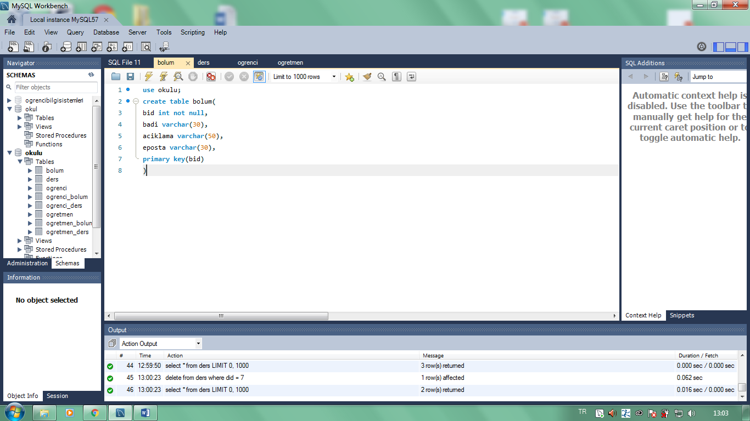

**___________________________________________________________________________**

use okulu;

create table ders(

did int not null,

dadi varchar(30),

dkodu varchar(50),

kredi int,

bid int,

primary key(did)

**)**

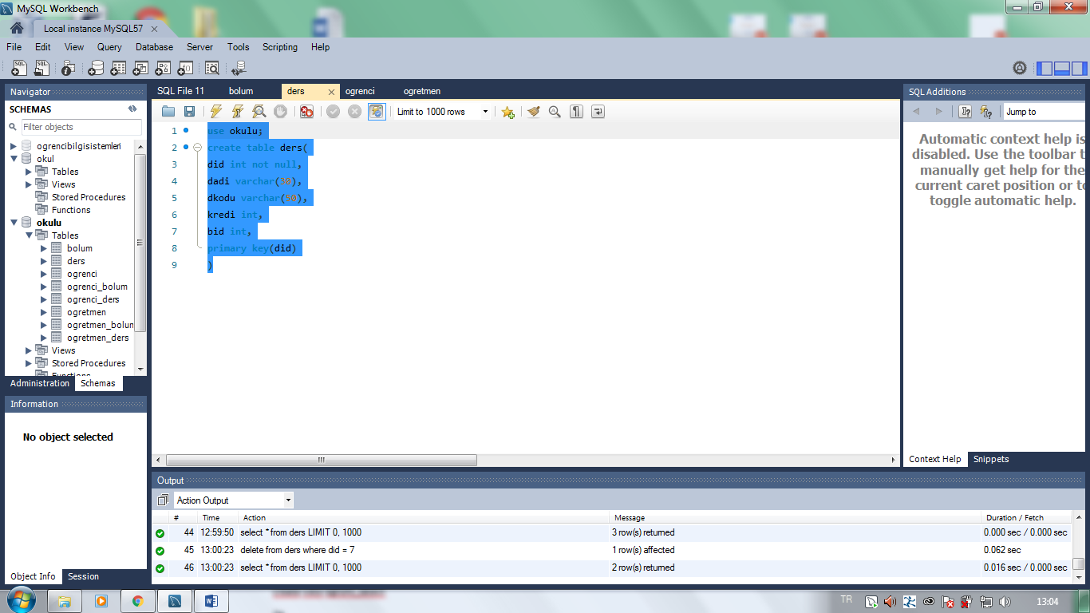

___________________________________________________________________________

use okulu;

create table ogrenci(

ono int not null,

adi varchar(30),

soyadi varchar(30),

dyeri varchar(50),

bid int,

primary key(ono)

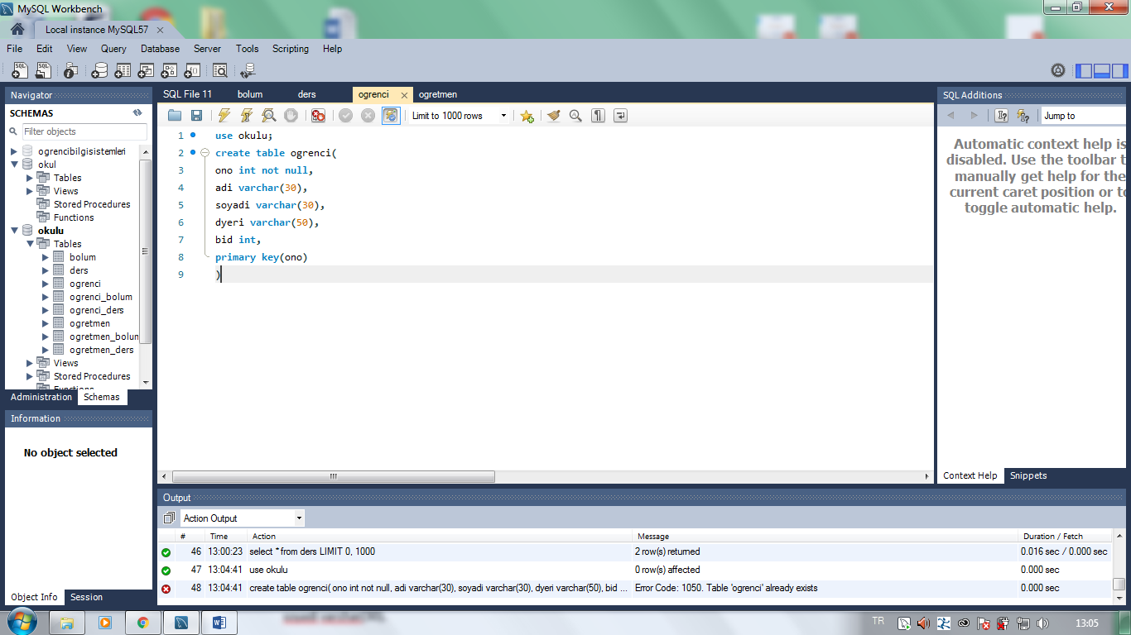

_______________________________________________________________________________________

use okulu;

create table ogretmen(

oid int not null,

adi varchar(30),

soyadi varchar(30),

dyeri varchar(30),

bid int,

primary key(oid)

);

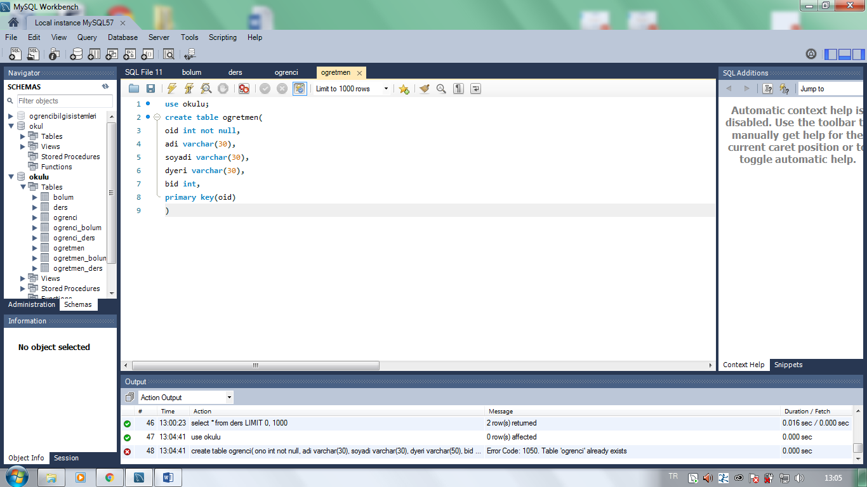

**____________________________________________________**

***2.SORU:iliskilendirme***

use okulu;

create table ogrenci_bolum (

ono int not null,

bid int not null,

primary key(ono,bid)

);

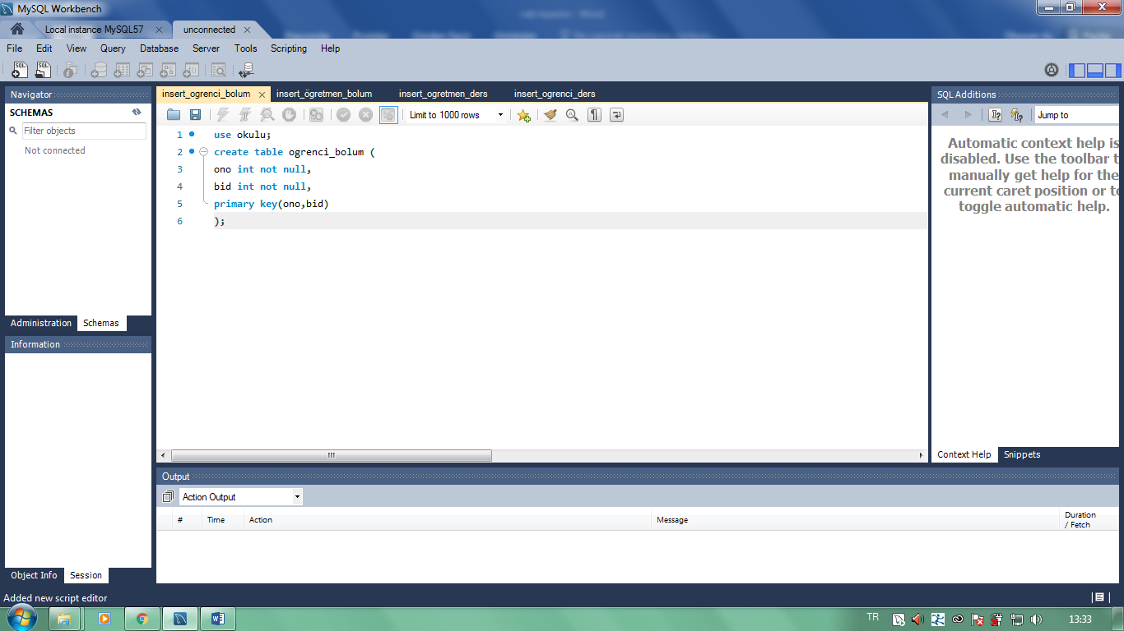

_________________________________________________________________________________________________________

use okulu;

create table ogretmen_bolum(

oid int not null,

bid int not null,

primary key(oid,bid)

);

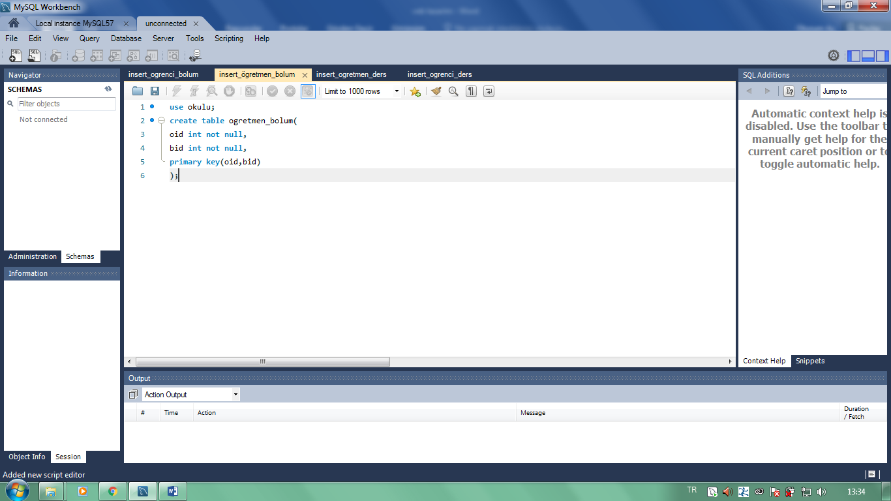

_________________________________________________________________________________________________________

use okulu;

INSERT INTO ogretmen_ders (oid, did)

VALUES (1, 1),

(3, 2),

(2, 3),

(4, 4),

(7, 5),

(4, 6),

(5, 7),

(6, 8),

(7, 9),

(5, 10),

(1, 11),

(4, 12);

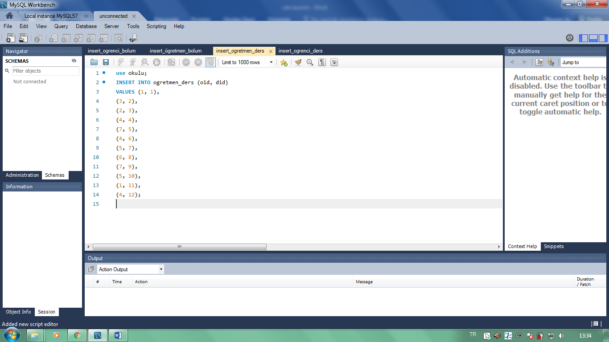

**____________________________________________________**

use okulu;

insert into ogrenci_ders(ono,did,notu)

values (1,1,3);

insert into ogrenci_ders(ono,did,notu)

values (1,3,2);

insert into ogrenci_ders(ono,did,notu)

values (1,4,3);

insert into ogrenci_ders(ono,did,notu)

values (1,6,3);

insert into ogrenci_ders(ono,did,notu)

values (1,9,4);

insert into ogrenci_ders(ono,did,notu)

values (1,10,3);

insert into ogrenci_ders(ono,did,notu)

values (2,1,4);

insert into ogrenci_ders(ono,did,notu)

values (2,2,4);

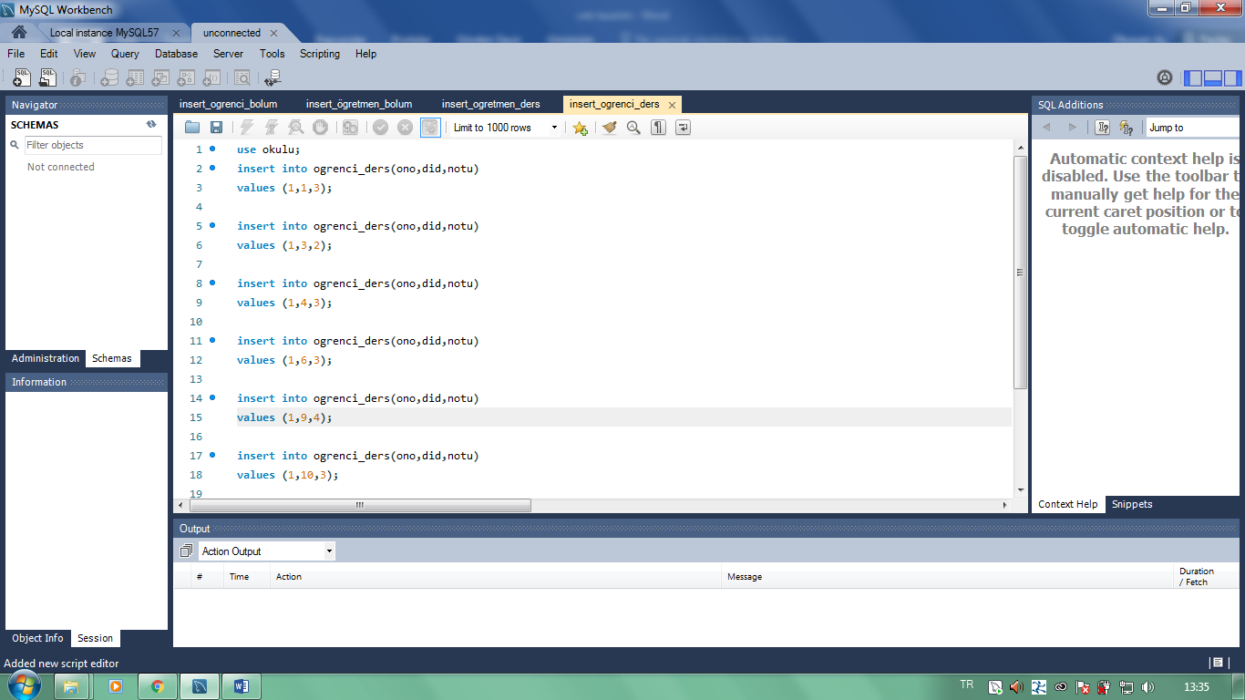

**___________________________________________________________________________**

**-Select deyimi:**

use okulu;

select * from ogretmen_ders;

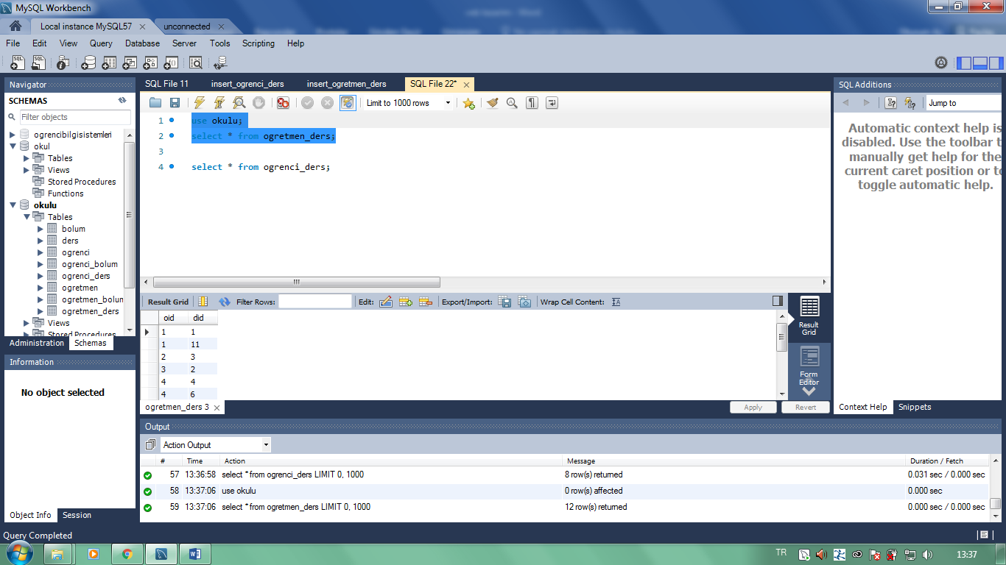

**______________________________________________________________________**

**select * from ogrenci_ders;**

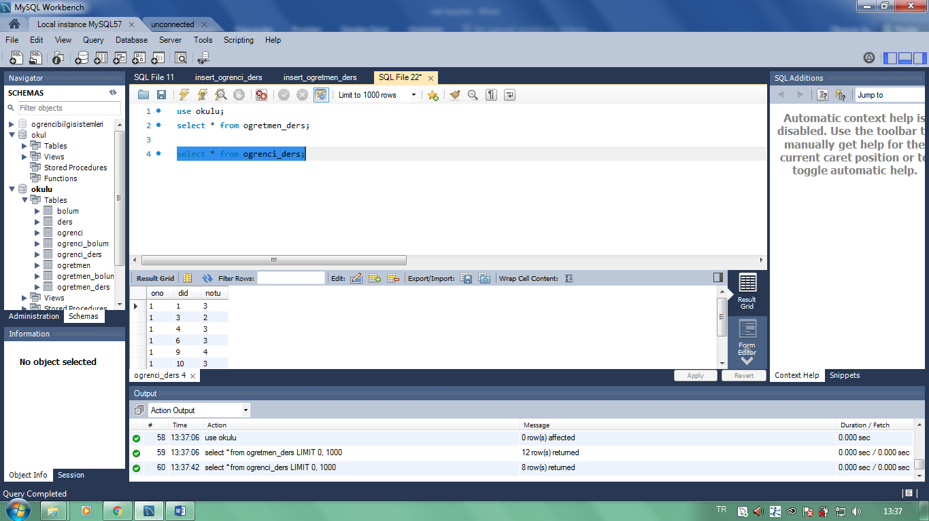

**____________________________________________________**

**3.SORU: View ilişkilendirme**

use okulu;

create table ogrenci_ders(

ono int not null,

did int not null,

notu int,

primary key(ono,did)

)

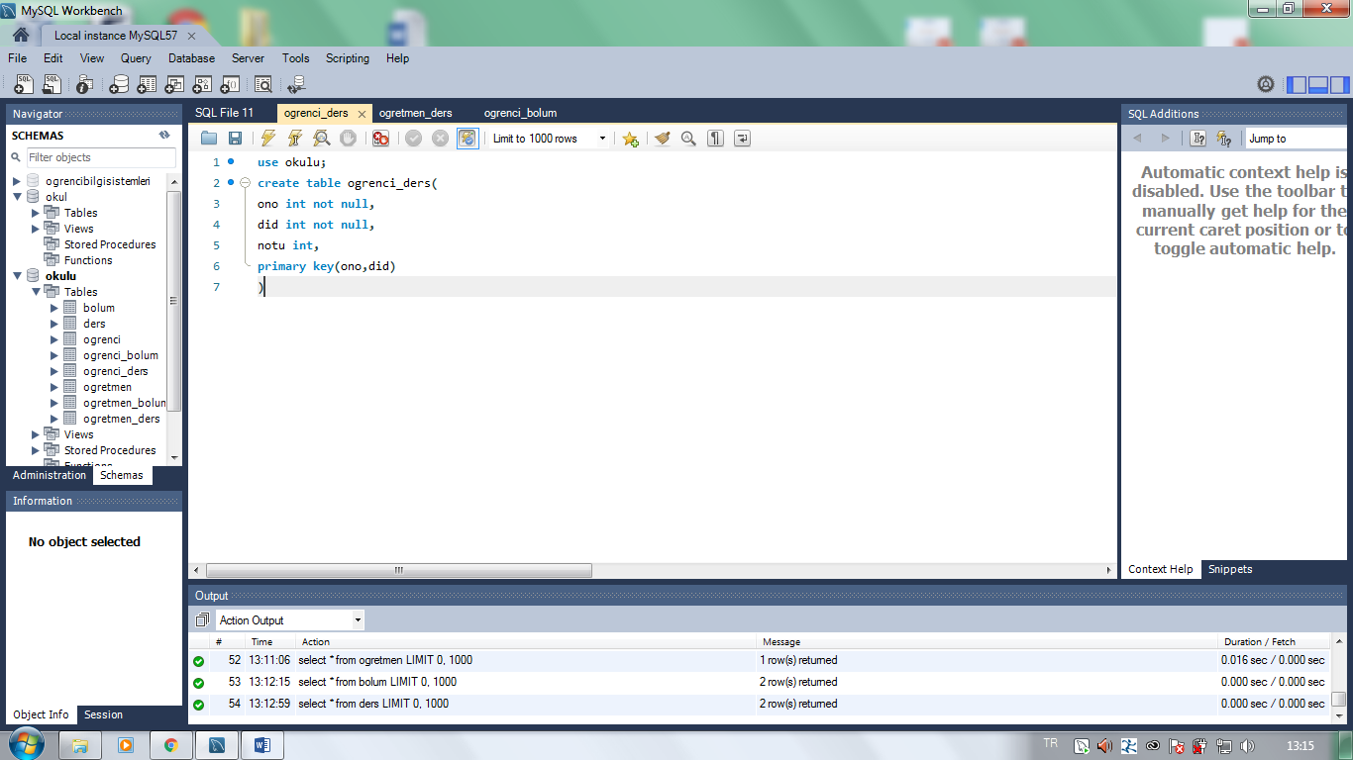

**____________________________________________________**

use okulu;

create table ogretmen_ders(

oid int not null,

did int not null,

primary key(oid,did)

)

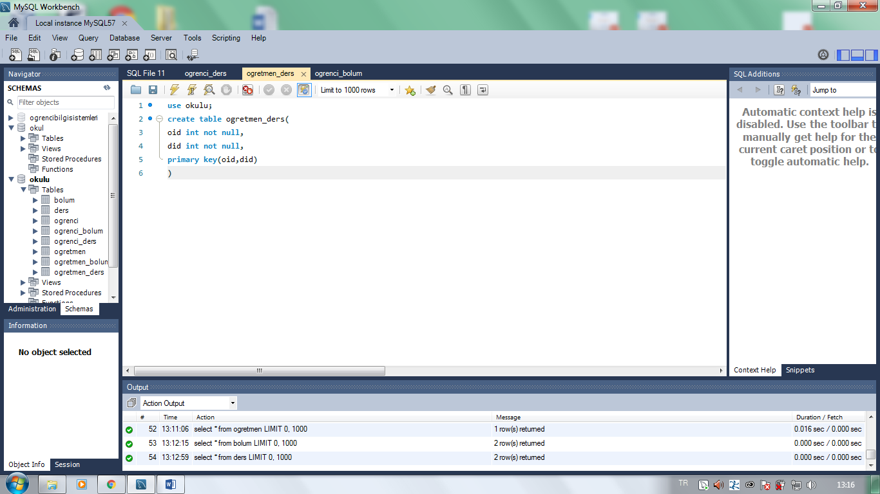

use okulu;

create table ogrenci_bolum (

ono int not null,

bid int not null,

primary key(ono,bid)

);

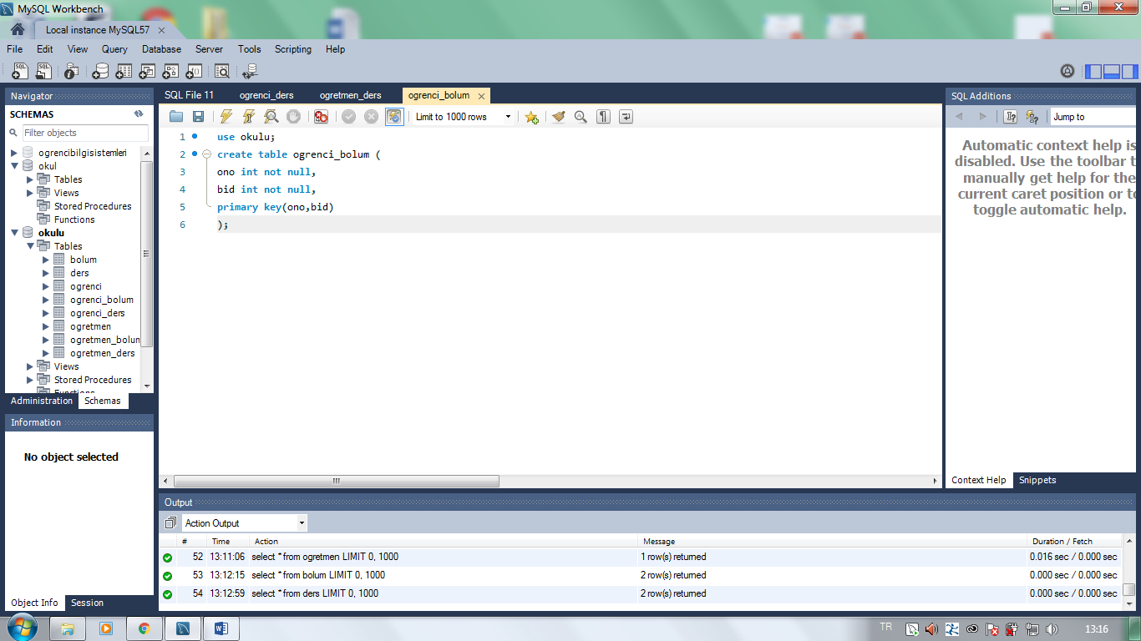

**____________________________________________________**

use okulu;

create view ogrDrs_select

As

select ders.dadi, ders.dkodu, ders.kredi, bolum.badi, bolum.aciklama

from ders, bolum, ogretmen_ders

where ders.bid = bolum.bid

and ders.did = ogretmen_ders.did;

SELECT * FROM ogrDrs_select;

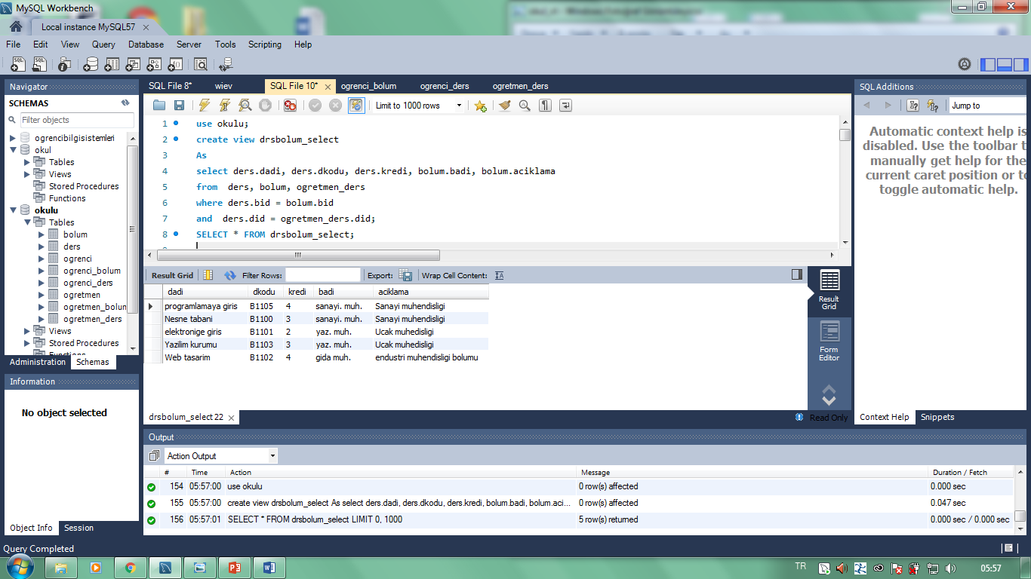

**______________________________________________________________________**

use okulu;

create view dersblm_select

As

from ders, bolum, ogrenci_ders

where ders.bid = bolum.bid

and ders.did = ogrenci_ders.did;

SELECT * FROM dersblm_select;

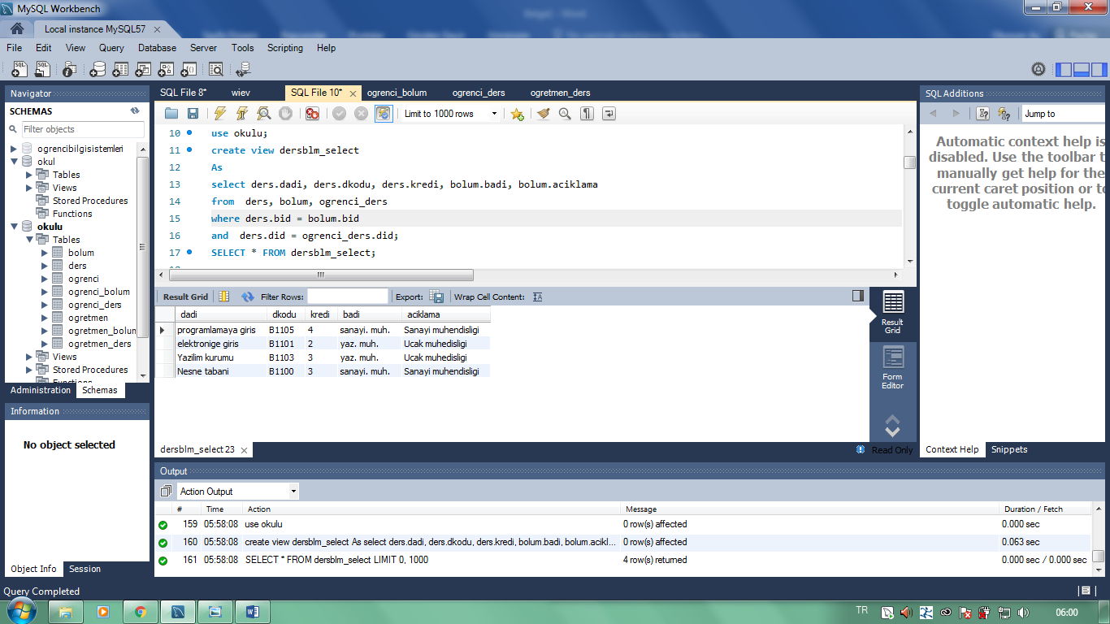________________________________________________________________________________________________________

create view ogretmenblm_select

As

select ogretmen.adi, ogretmen.soyadi, bolum.badi

from ogretmen, bolum, ogretmen_ders

where ogretmen.bid = bolum.bid

and ogretmen.oid = ogretmen_ders.oid;

SELECT * FROM ogretmenblm_select;

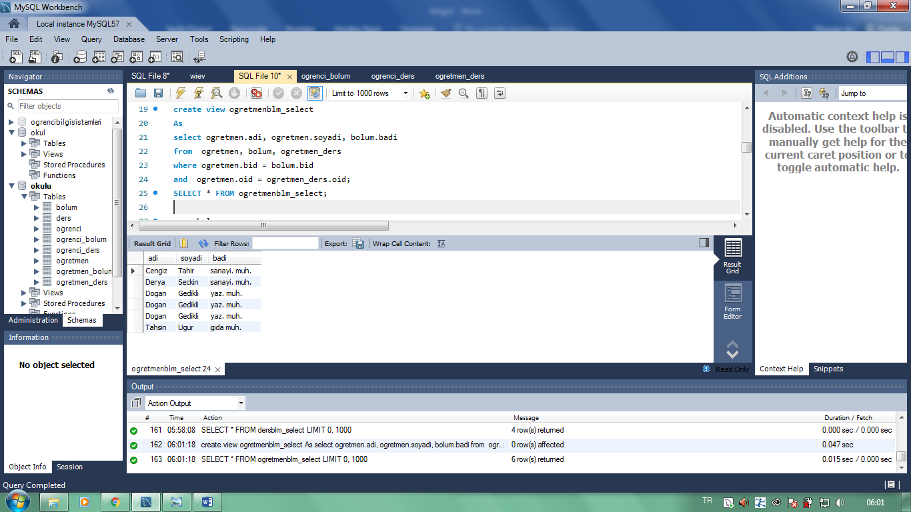

**_________________________________________________________________________________________________________**

create view ogrbolumlerim_select

As

select ogrenci.adi, ogrenci.soyadi, bolum.badi, bolum.aciklama

from ogrenci, bolum, ogrenci_ders

where ogrenci.ono = bolum.bid

and ogrenci.bid = ogrenci_ders.ono;

SELECT * FROM ogrbolumlerim_select;

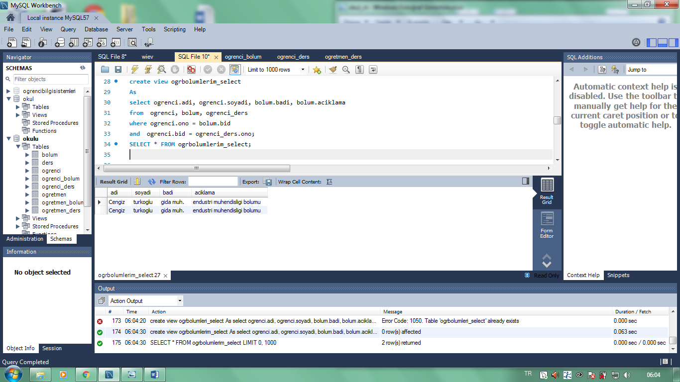

__________________________________________________________

use okulu;

create view ogrblmum_select

As

select ogrenci.adi, ogrenci.soyadi, ogrenci.dyeri, bolum.badi, bolum.aciklama

from ogrenci, bolum

where ogrenci.bid = bolum.bid;

SELECT * FROM ogrblmum_select;

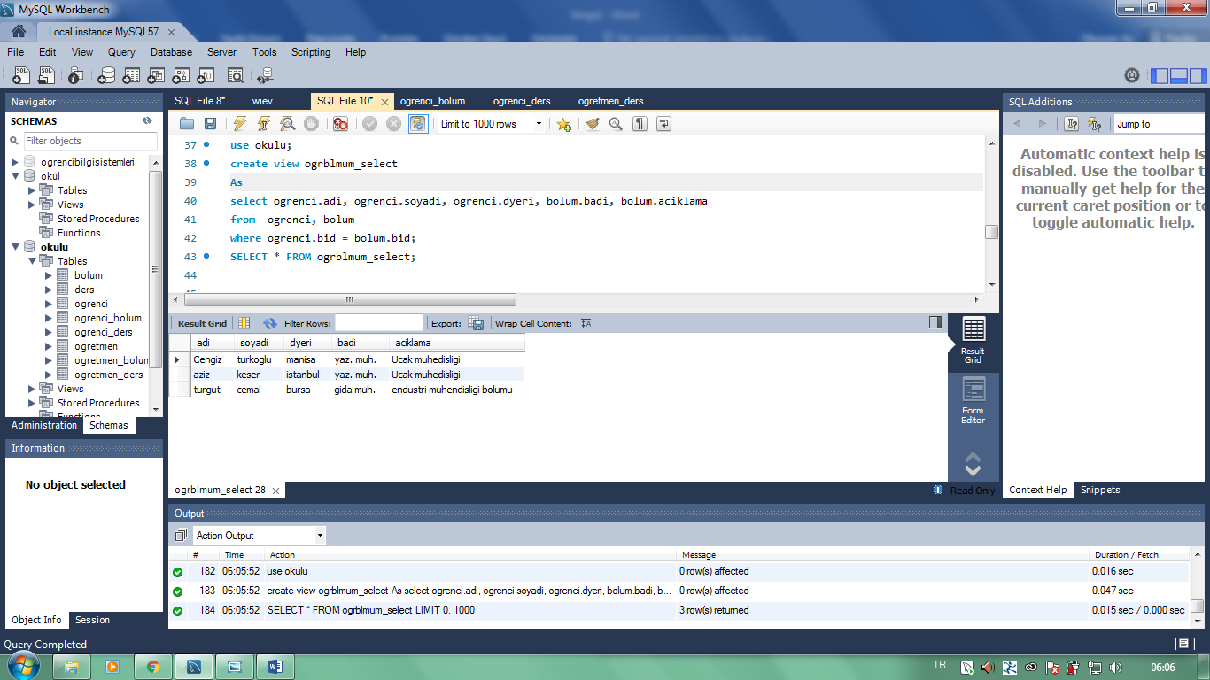

use okulu;

create view ogrdersiii_select

As

select ogrenci.adi, ogrenci.soyadi, ders.dadi, ders.dkodu, ders.kredi

from ogrenci , ders

where ogrenci.ono = ders.did;

SELECT * FROM ogrdersiii_select;

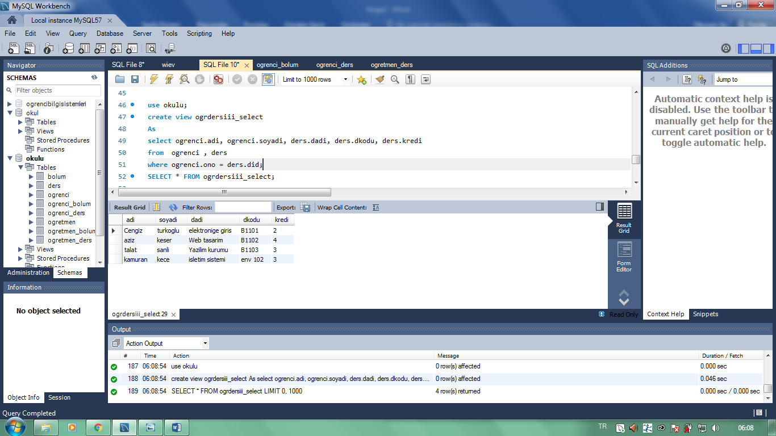

**_________________________________________________________________________________________________________**

use okulu;

create view drsOgrtmen_select

As

select ogretmen.adi, ogretmen.soyadi, ogretmen.dyeri, ders.dadi, ders.dkodu

from ogretmen , ders

where ogretmen.oid = ders.did;

SELECT * FROM drsOgrtmen_select;

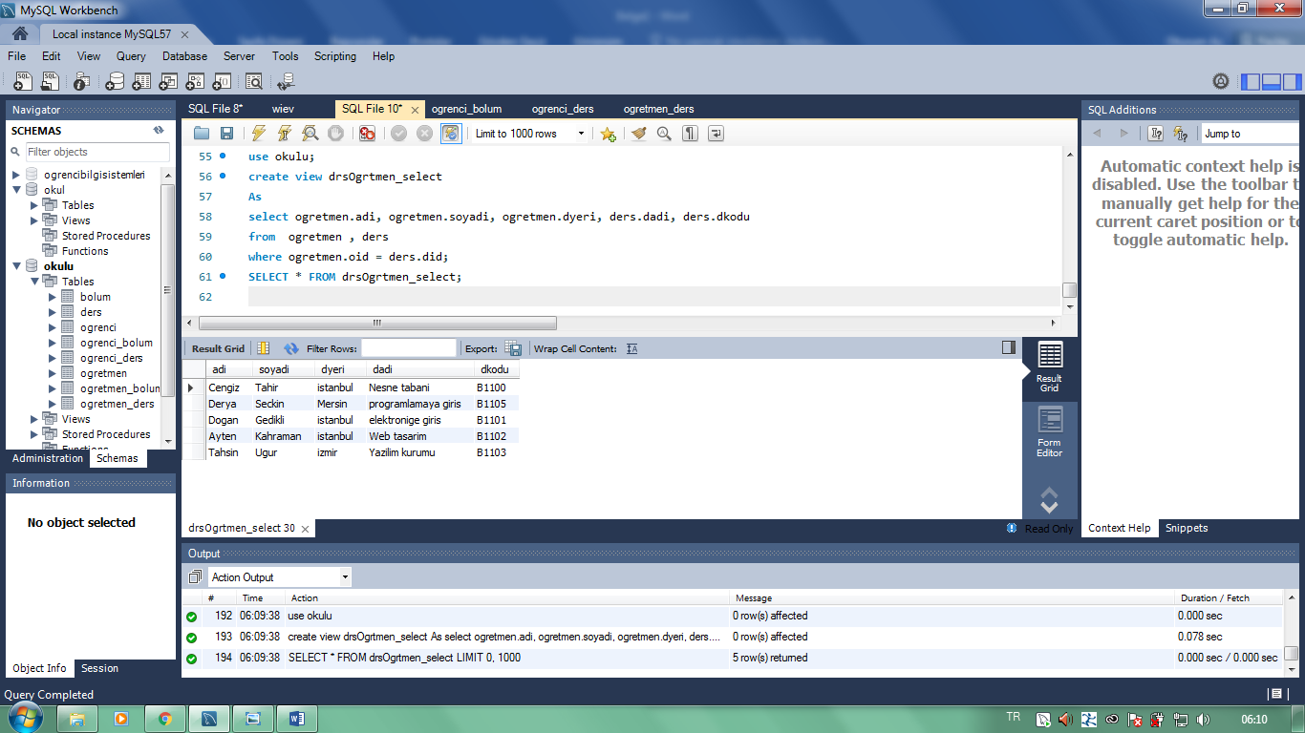

***____________________________________________________***

***4:SORU: Stoded Procedure***

use okulu

DELIMITER //

CREATE PROCEDURE ders_sp_select (IN IN_dadi VARCHAR(30))

BEGIN

SELECT * FROM ders WHERE dadi = IN_dadi;

END //

DELIMITER ;

CALL ders_sp_select ('veri tabani');

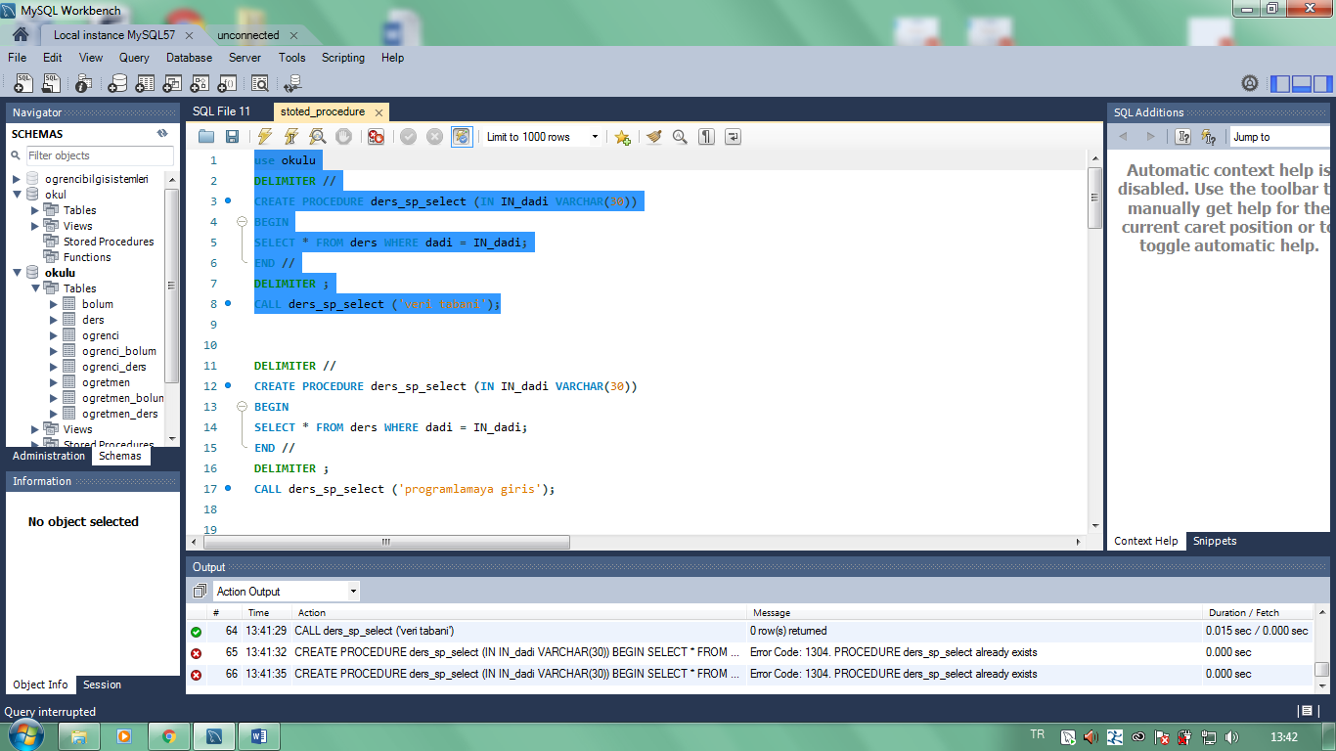

DELIMITER //

CREATE PROCEDURE ders_sp_select (IN IN_dadi VARCHAR(30))

BEGIN

SELECT * FROM ders WHERE dadi = IN_dadi;

END //

DELIMITER ;

CALL ders_sp_select ('programlamaya giris');

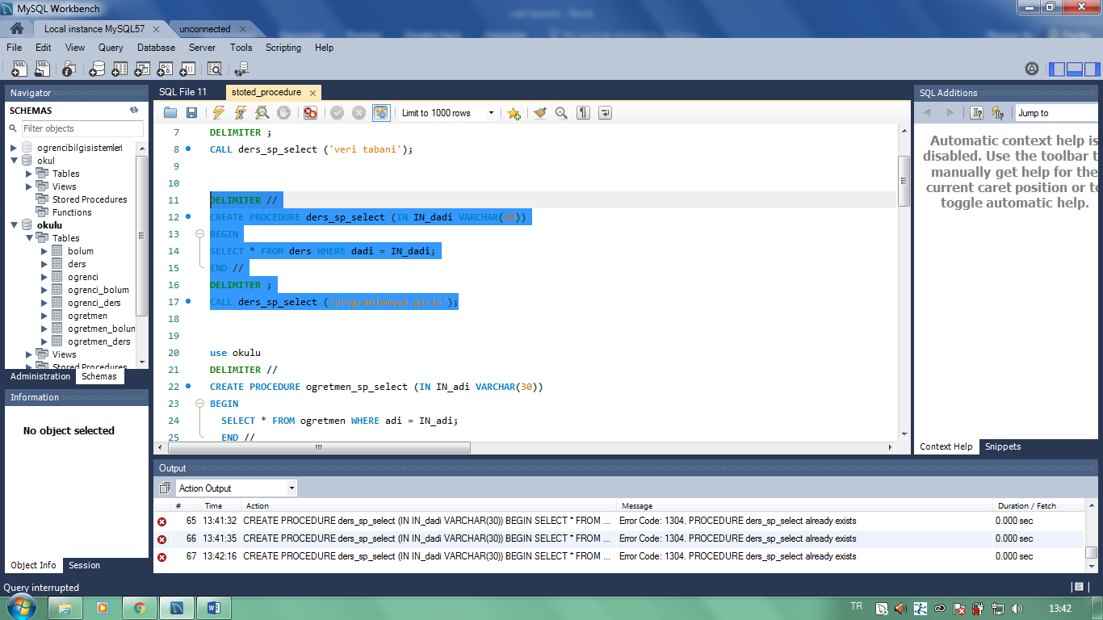

***____________________________________________________***

use okulu

DELIMITER //

CREATE PROCEDURE ogretmen_sp_select (IN IN_adi VARCHAR(30))

BEGIN

SELECT * FROM ogretmen WHERE adi = IN_adi;

END //

DELIMITER ;

call ogretmen_sp_select('Selcuk');

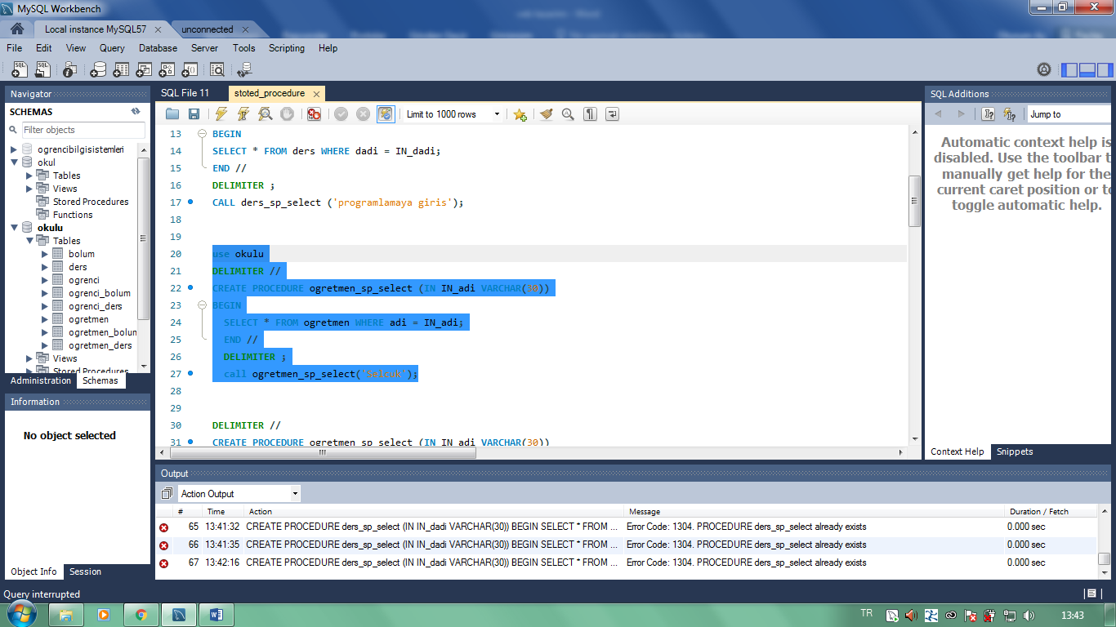

***____________________________________________________***

DELIMITER //

CREATE PROCEDURE ogretmen_sp_select (IN IN_adi VARCHAR(30))

BEGIN

SELECT * FROM ogretmen WHERE adi = IN_adi;

END //

DELIMITER ;

call ogretmen_sp_select('Tahsin');

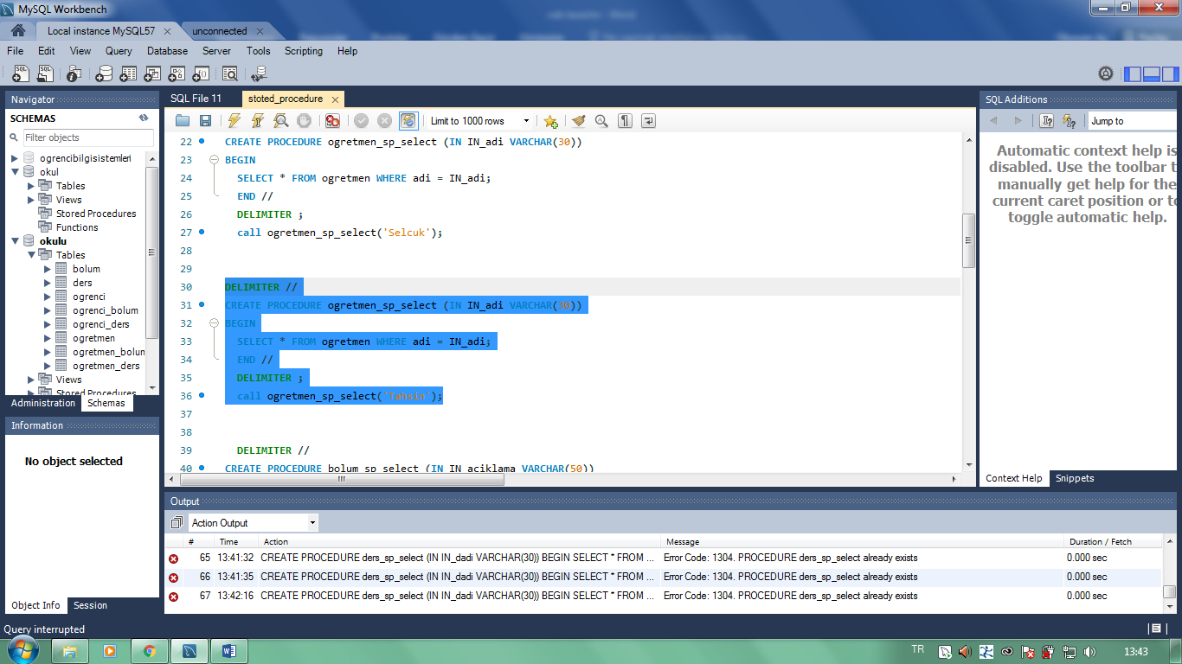

***____________________________________________________***

DELIMITER //

CREATE PROCEDURE bolum_sp_select (IN IN_aciklama VARCHAR(50))

BEGIN

SELECT * FROM bolum WHERE aciklama = IN_aciklama;

END //

DELIMITER ;

call bolum_sp_select('endustri muhendisligi bolumu');

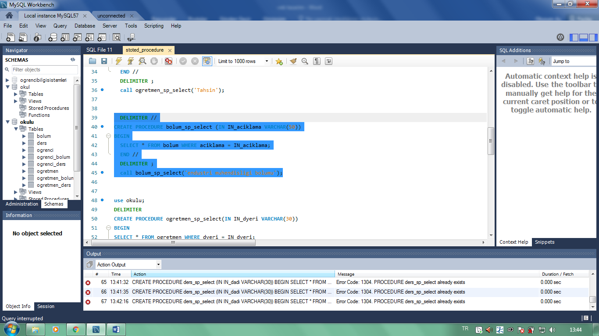

____________________________________________________

use okulu;

DELIMITER

CREATE PROCEDURE ogretmen_sp_select(IN IN_dyeri VARCHAR(30))

BEGIN

SELECT * FROM ogretmen WHERE dyeri = IN_dyeri;

END

DELIMITER ;

call ogretmen_sp_select('Amasya');

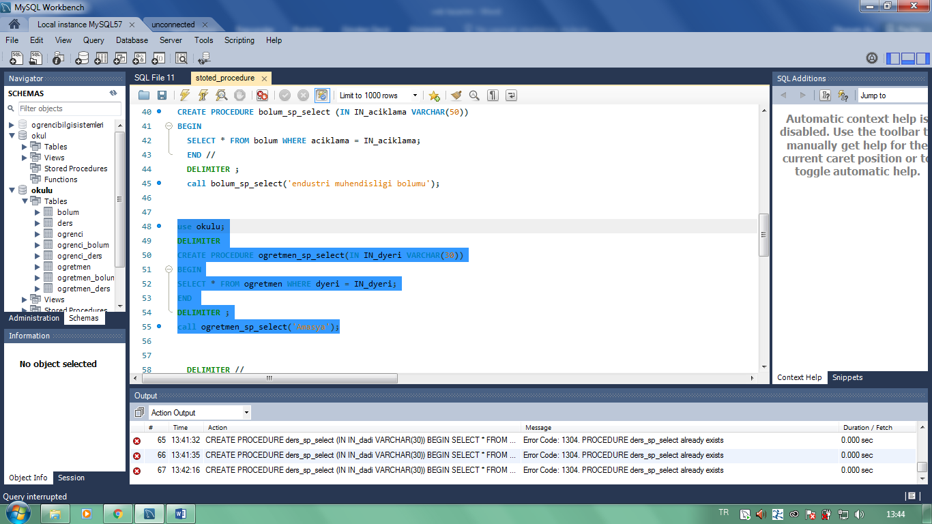

DELIMITER //

CREATE PROCEDURE ogretmen_sp_select (IN IN_adi VARCHAR(30))

BEGIN

SELECT * FROM ogretmen WHERE adi = IN_adi;

END //

DELIMITER ;

call ogretmen_sp_select('Dogan');

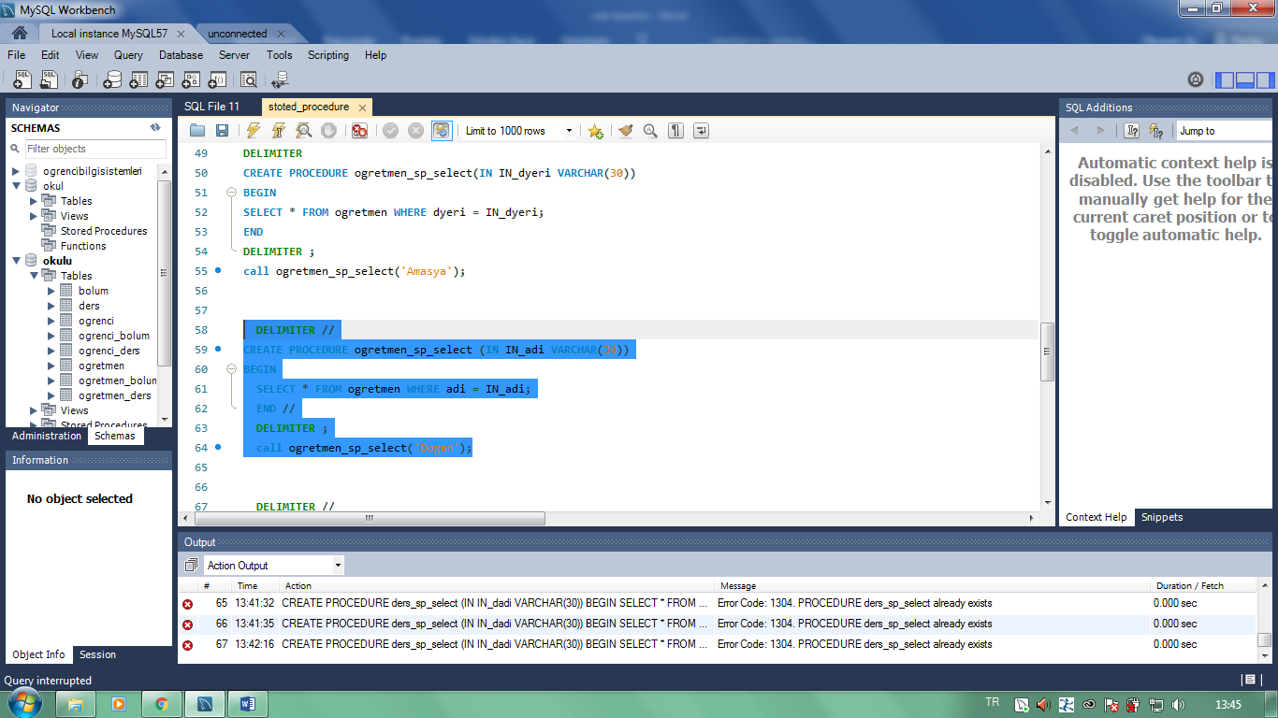

_________________________________________________________________________________________________________

DELIMITER //

create procedure ogrenci_sp_select(IN IN_adi varchar(30))

BEGIN

SELECT * FROM ogrenci WHERE adi = IN_adi;

END //

DELIMITER ;

call ogrenci_sp_select('ali');

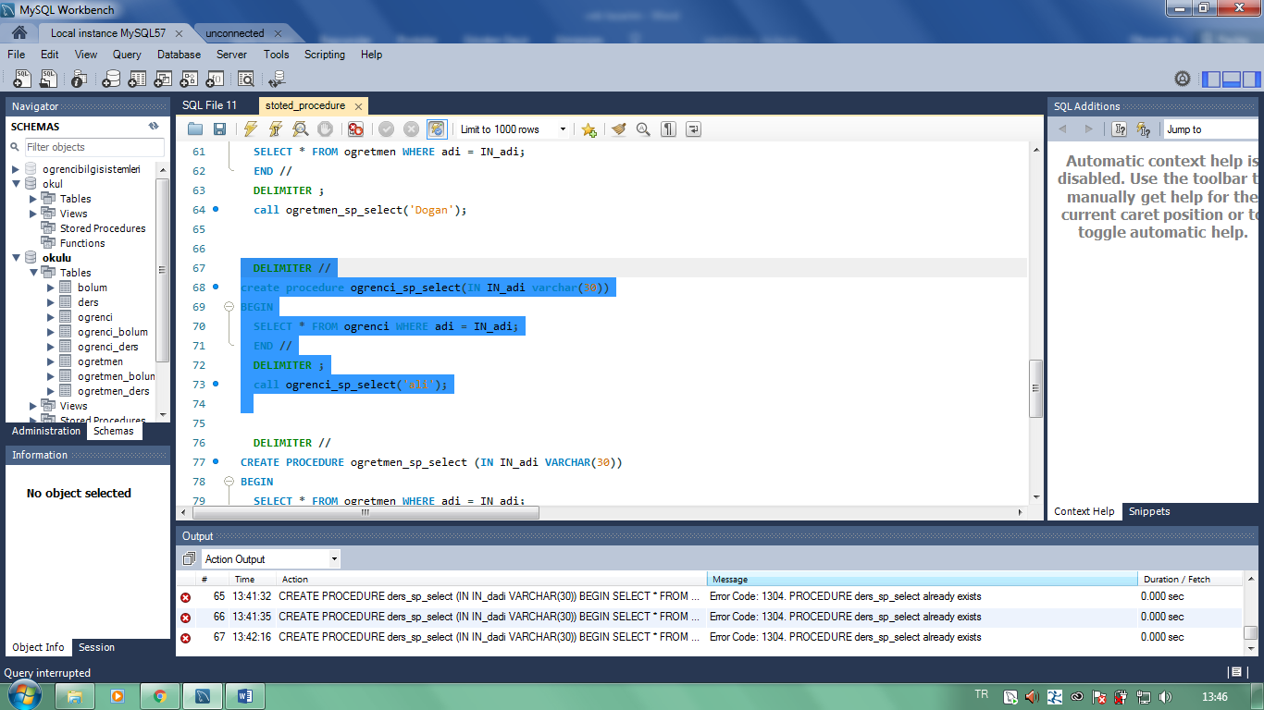

***___________________________________________________***

DELIMITER //

CREATE PROCEDURE ogretmen_sp_select (IN IN_adi VARCHAR(30))

BEGIN

SELECT * FROM ogretmen WHERE adi = IN_adi;

END //

DELIMITER ;

call ogretmen_sp_select('Ayten');

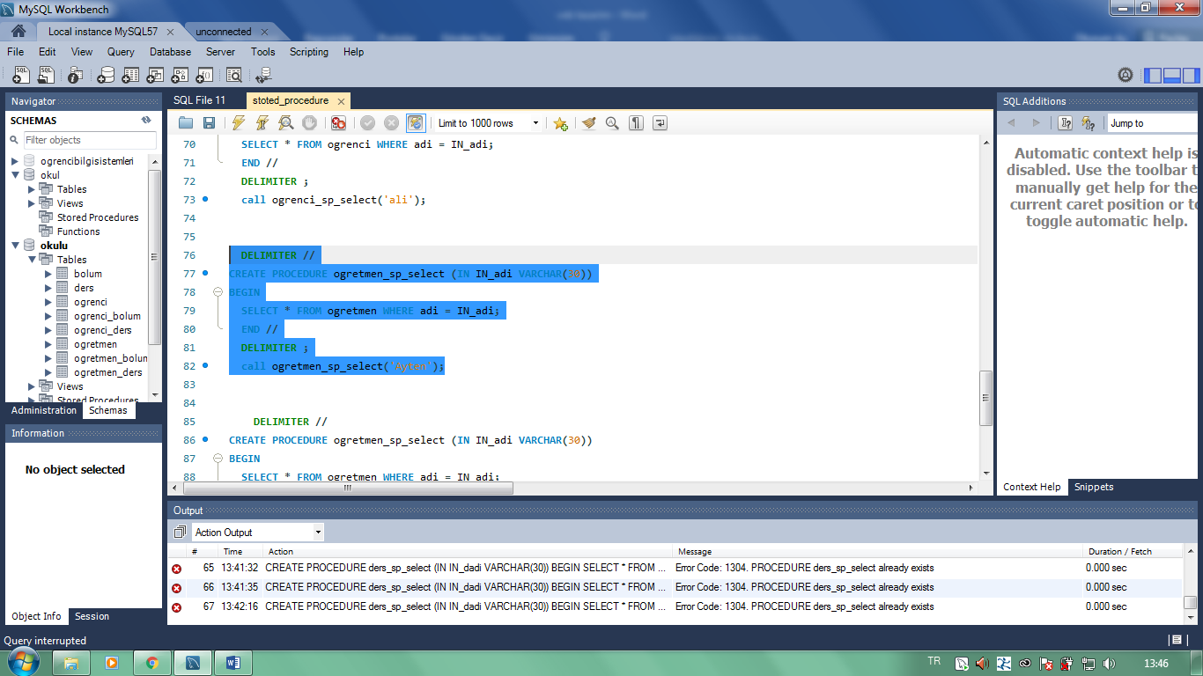

***____________________________________________________***

DELIMITER //

CREATE PROCEDURE ogretmen_sp_select (IN IN_adi VARCHAR(30))

BEGIN

SELECT * FROM ogretmen WHERE adi = IN_adi;

END //

DELIMITER ;

call ogretmen_sp_select('Cengiz');

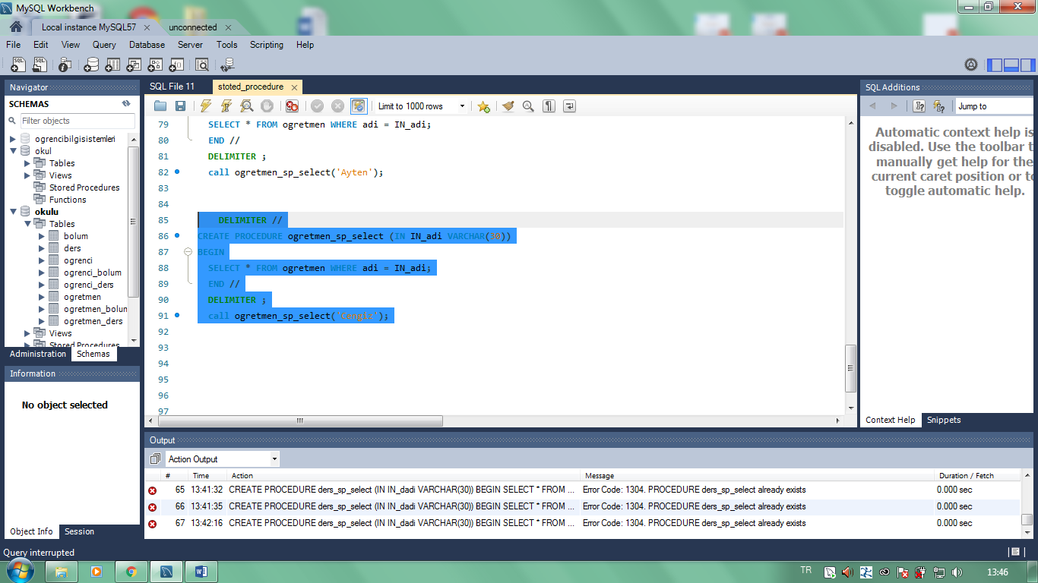

***5.SORU: İnsert***

use okulu;

insert into ogretmen(oid,adi,soyadi,dyeri,bid)

VALUES

(1, 'Selami', 'Durgun', 'Amasya', 1),

(2, 'Cengiz', 'Tahir', 'istanbul', 1),

(3, 'Derya', 'Seckin', 'Mersin', 1),

(4, 'Dogan', 'Gedikli', 'istanbul', 2),

(5, 'Ayten', 'Kahraman', 'istanbul', 3),

(6, 'Tahsin', 'Ugur', 'izmir', 4),

(7, 'Selcuk', 'Ozan', 'Amasya', 4);

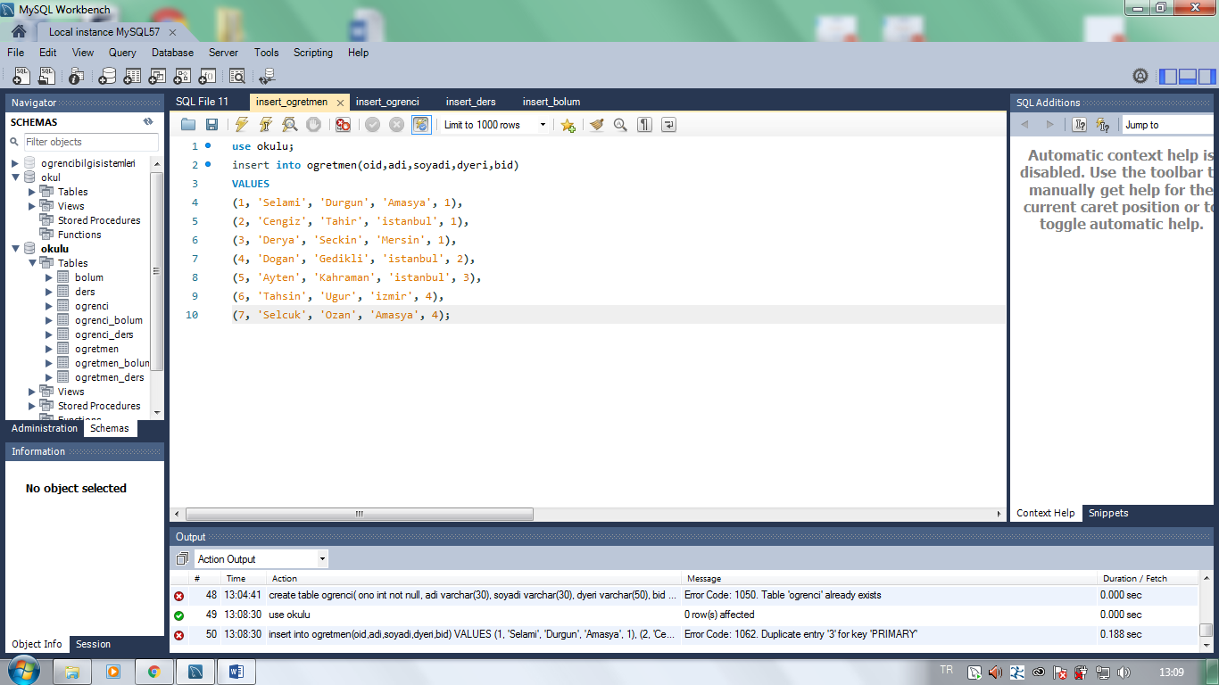

____________________________________________________

use okulu;

insert into ogrenci(ono,adi,soyadi,dyeri,bid)

values (1,'ali', 'turan', 'istanbul', 1);

insert into ogrenci(ono,adi,soyadi,dyeri,bid)

values (2,'ahmet', 'buyuk', 'ankara', 1);

insert into ogrenci(ono,adi,soyadi,dyeri,bid)

values (3,'leyla', 'sahin', 'izmir', 1);

insert into ogrenci(ono,adi,soyadi,dyeri,bid)

values (4,'can', 'turkoglu', 'manisa', 2);

insert into ogrenci(ono,adi,soyadi,dyeri,bid)

values (5,'aziz', 'keskin', 'istanbul', 2);

insert into ogrenci(ono,adi,soyadi,dyeri,bid)

values (6,'talat', 'sanli', 'izmir', 2);

insert into ogrenci(ono,adi,soyadi,dyeri,bid)

values (7,'kamuran', 'kece', 'adana', 2);

insert into ogrenci(ono,adi,soyadi,dyeri,bid)

values (8,'turgut', 'cemal', 'bursa', 2);

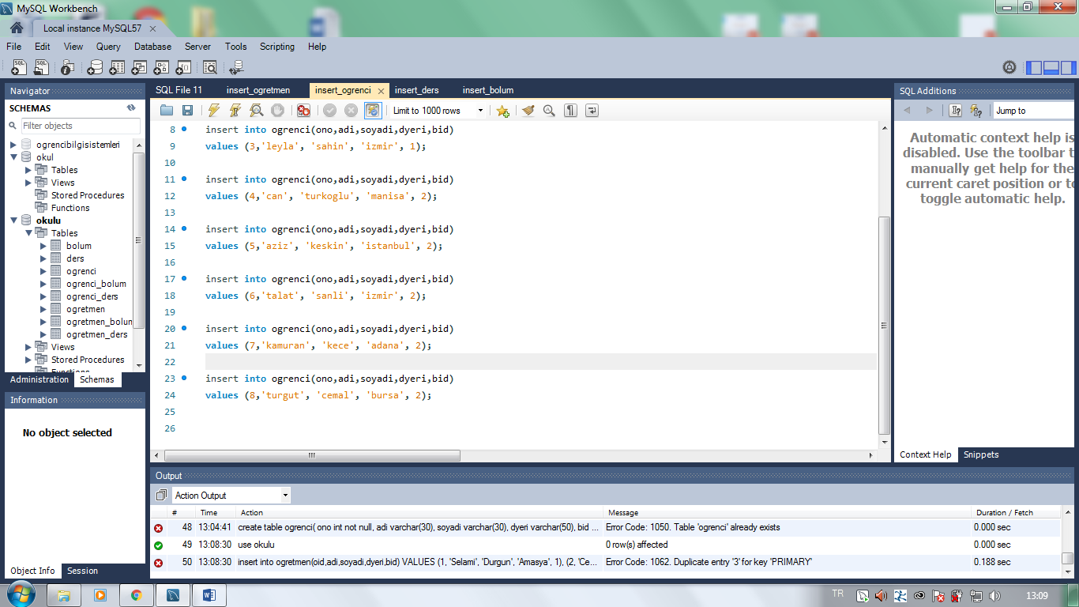

___________________________________________________

use okulu;

insert into ders(did,dadi,dkodu,kredi,bid)

values (1,'veri tabani', 'ceng 351', 3, 1);

insert into ders(did,dadi,dkodu,kredi,bid)

values (2,'isletim sistemleri', 'ceng 341', 3, 1);

insert into ders(did,dadi,dkodu,kredi,bid)

values (3,'programlamaya giris', 'ceng 101', 4, 1);

insert into ders(did,dadi,dkodu,kredi,bid)

values (4,'elektronige giris', 'ee 101', 2, 2);

insert into ders(did,dadi,dkodu,kredi,bid)

values (5,'istatistik', 'ie 301', 4, 4);

insert into ders(did,dadi,dkodu,kredi,bid)

values (6,'devre teorisi', 'ee 202', 3, 2);

insert into ders(did,dadi,dkodu,kredi,bid)

values (7,'cevre bilgisi', 'env 102', 3, 3);

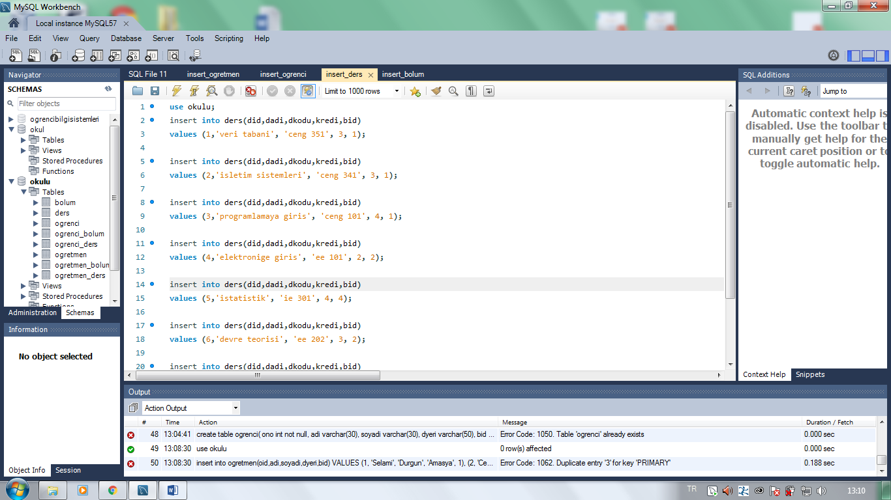

***____________________________________________________***

use okulu;

insert into bolum(bid,badi,aciklama,eposta)

values (1,'bil. muh.', 'bilgisayar mühendisligi bolumu',

'ceng@fatih.edu.tr');

insert into bolum(bid,badi,aciklama,eposta)

values (2,'elo. muh.', 'elektronik muhendisligi bolumu', 'ee@fatih.edu.tr');

insert into bolum(bid,badi,aciklama,eposta)

values (3,'cev. muh.', 'cevre muhendisligi bolumu', 'env@fatih.edu.tr');

insert into bolum(bid,badi,aciklama,eposta)

values (4,'end. muh.', 'endustri muhendisligi bolumu', 'ie@fatih.edu.tr');

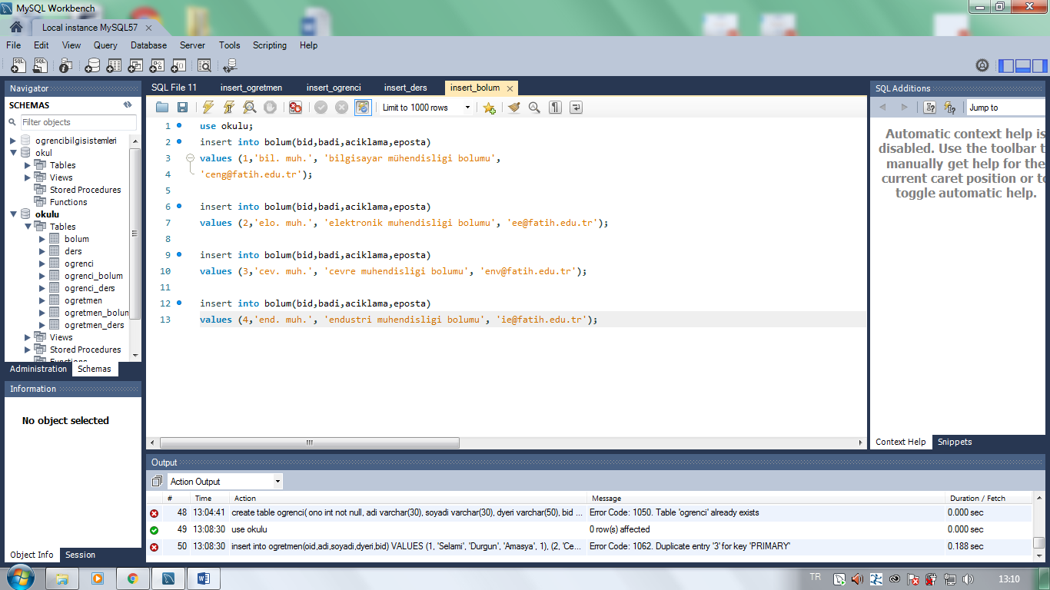

___________________________________________________________________________________________________

***-Select Deyimi:***

use okulu;

select * from ogretmen;

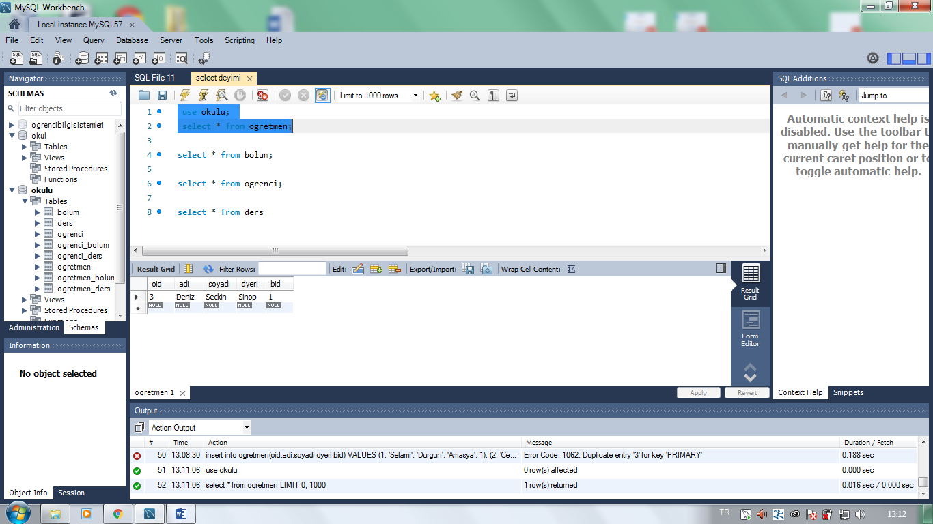

select * from bolum;

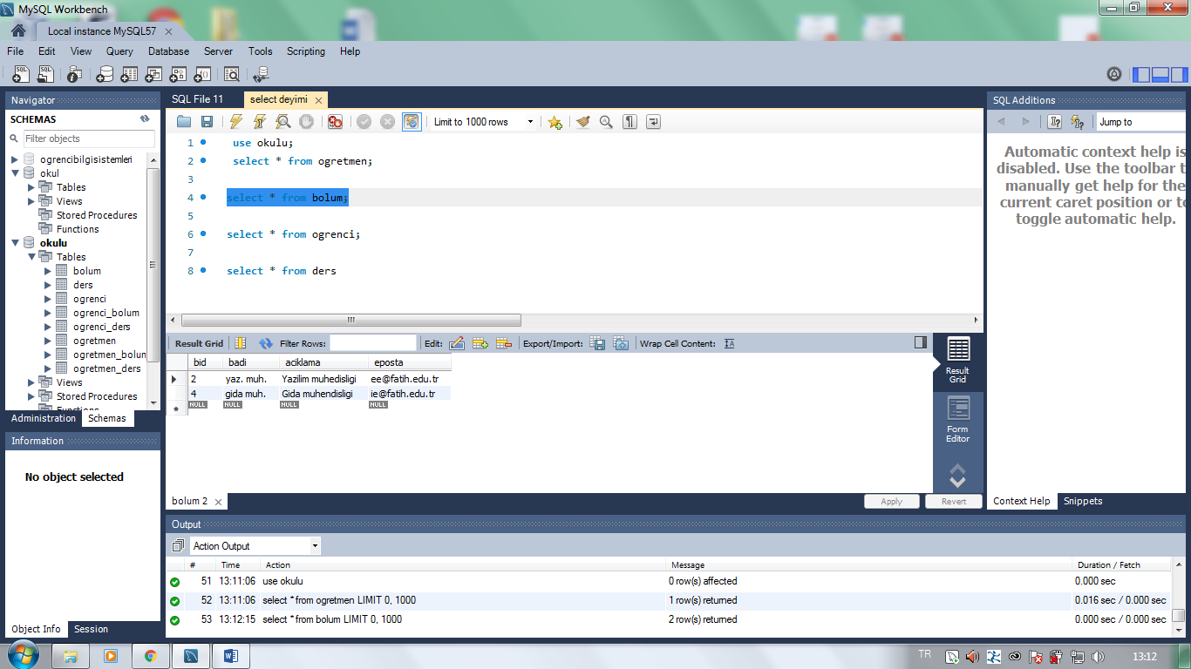

***_______________________________________________***

select * from ogrenci;

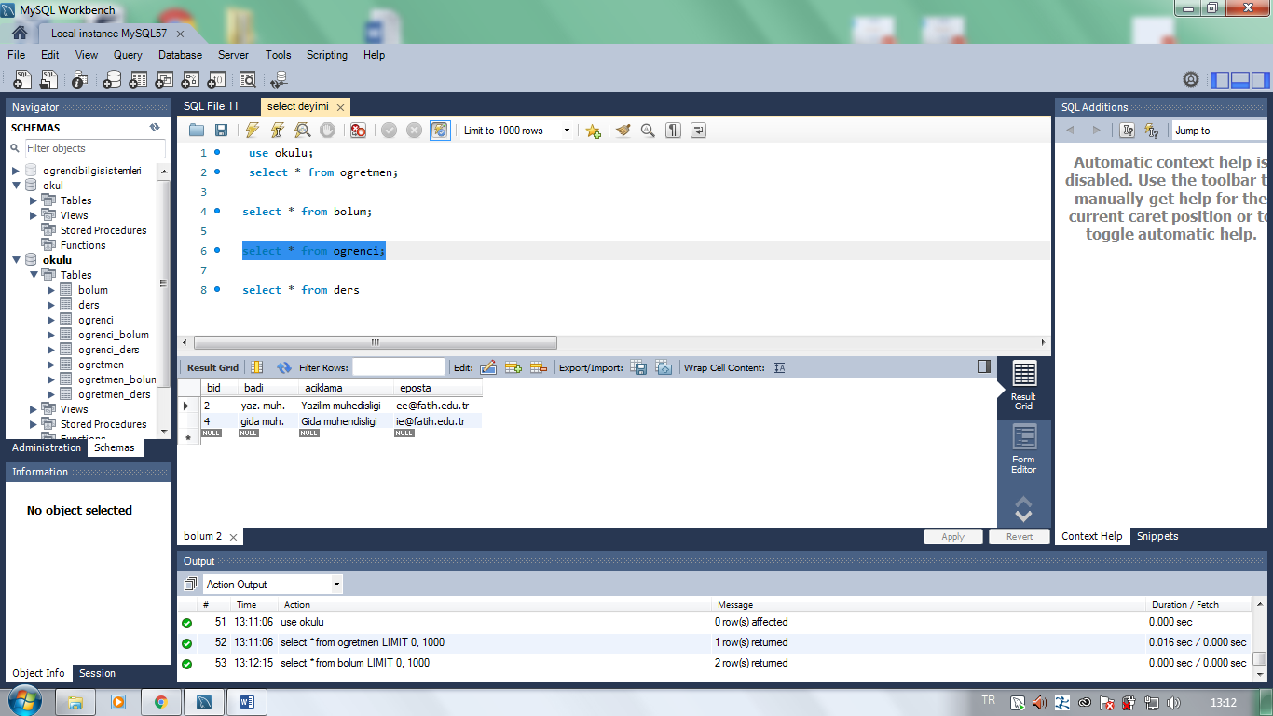

_________________________________________________________

select * from ders

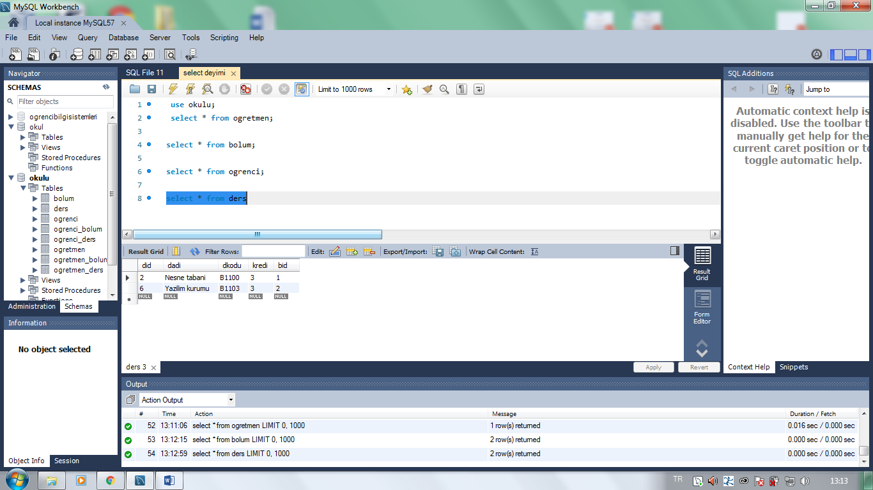

***_________________________________________________***

***6.SORU: Update***

use okulu;

update ogrenci

set adi = 'Hikmet'

where ono = 2;

select * from ogrenci;

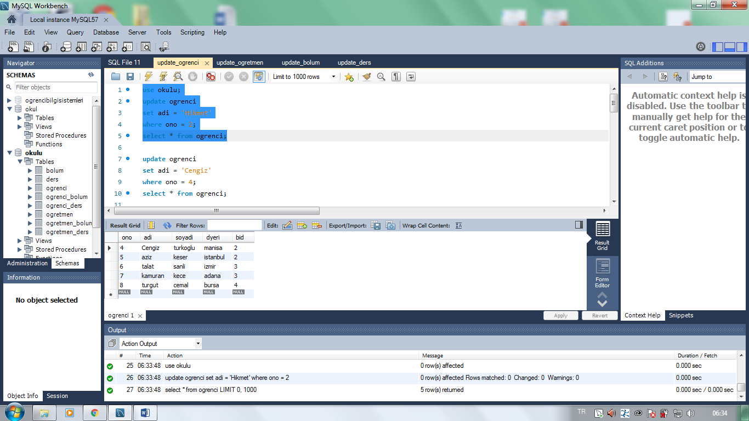

update ogrenci

set adi = 'Cengiz'

where ono = 4;

select * from ogrenci;

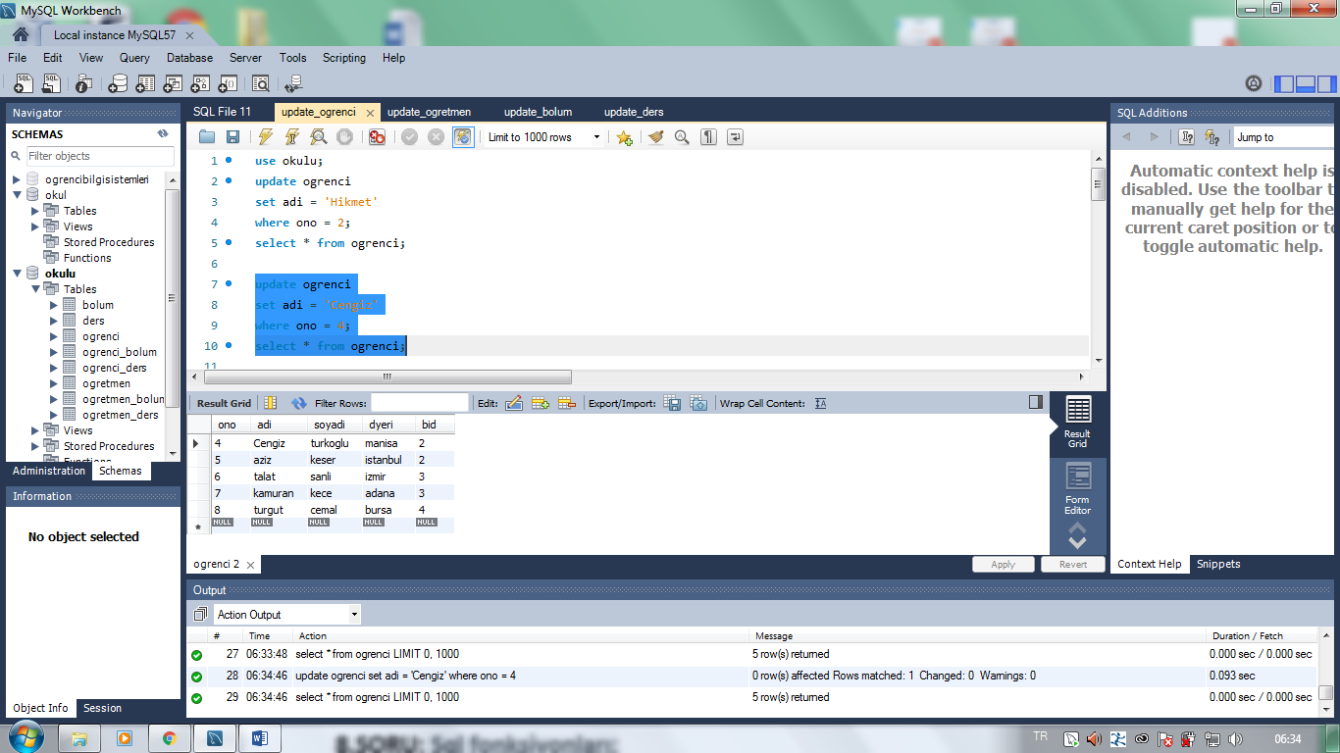

________________________________________________

update ogrenci

set adi = 'Kahraman'

where ono = 7;

select * from ogrenci;

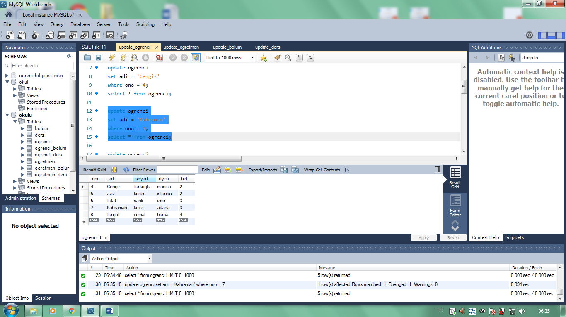

update ogrenci

set adi = 'Tahsin'

where ono = 6;

select * from ogrenci;

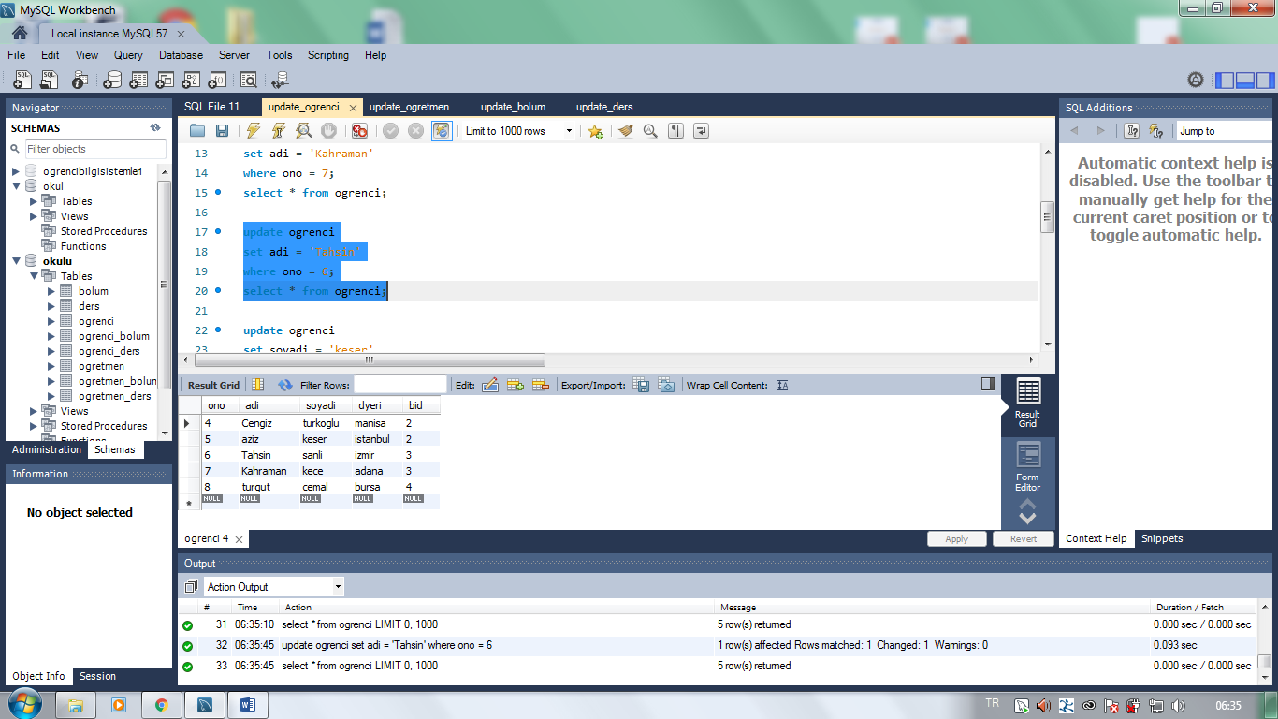

**___________________________________________________________________________________________________**

update ogrenci

set soyadi = 'keser'

where ono = 5;

select * from ogrenci;

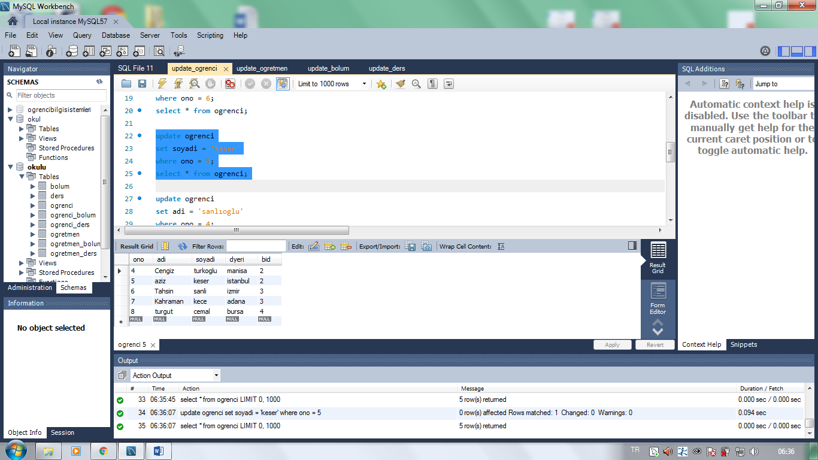

update ogrenci

set dyeri = 'kocaeli'

where ono = 1;

select * from ogrenci;

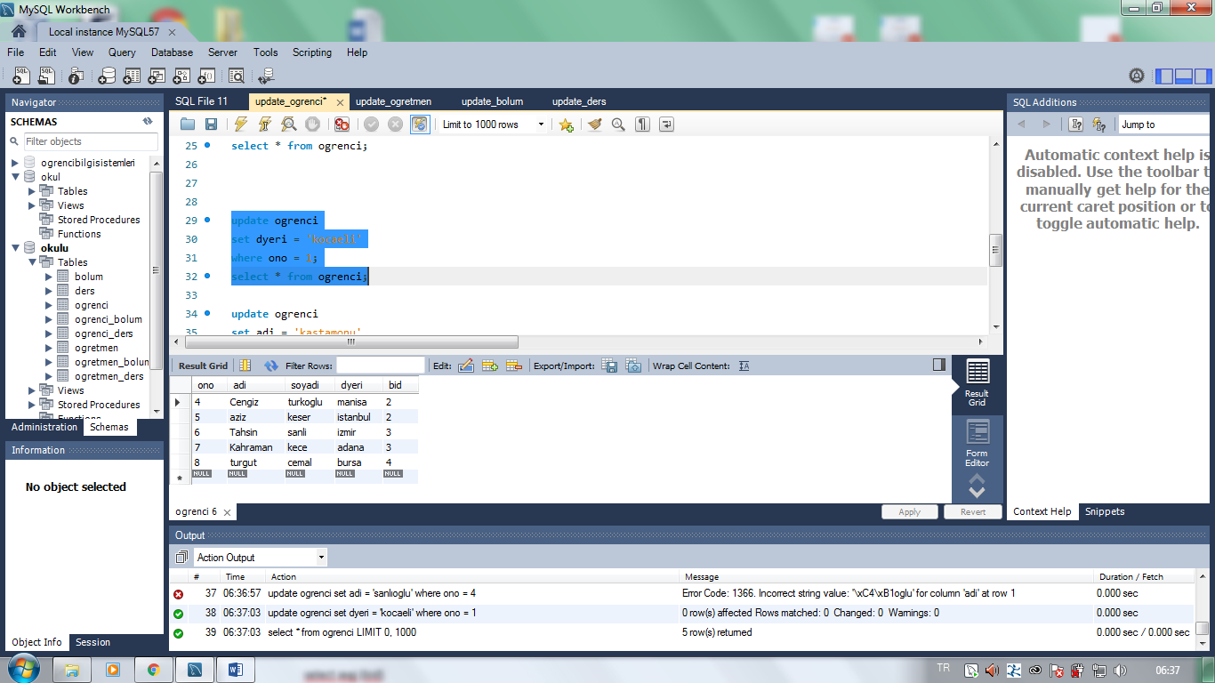

_____________________________________________________________________________________________

update ogrenci

set adi = 'kastamonu'

where ono = 8;

select * from ogrenci;

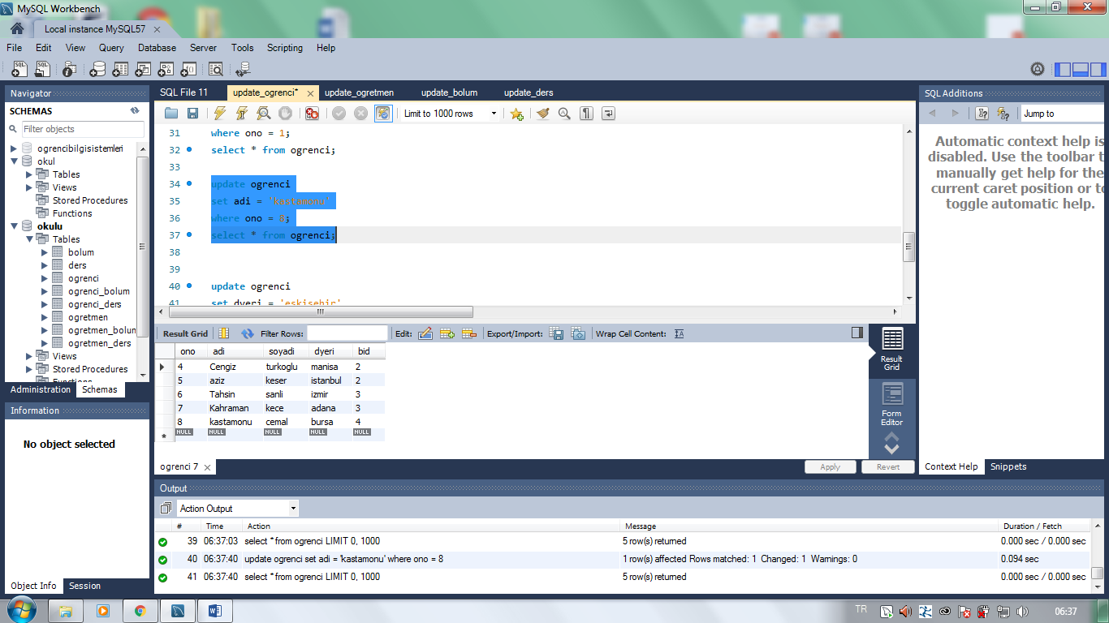

update ogrenci

set dyeri = 'eskisehir'

where ono = 3;

select * from ogrenci;

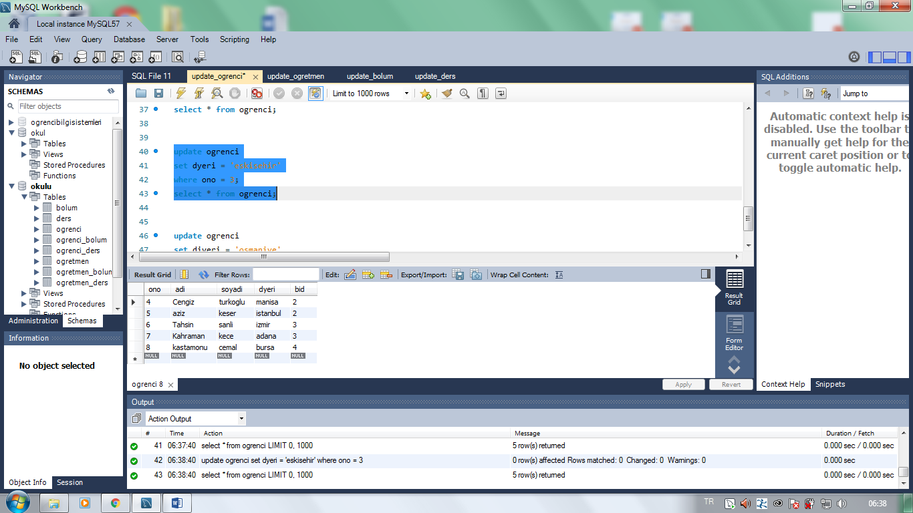

_________________________________________________________________________________________________

update ogrenci

set dyeri = 'osmaniye'

where ono = 5;

select * from ogrenci;

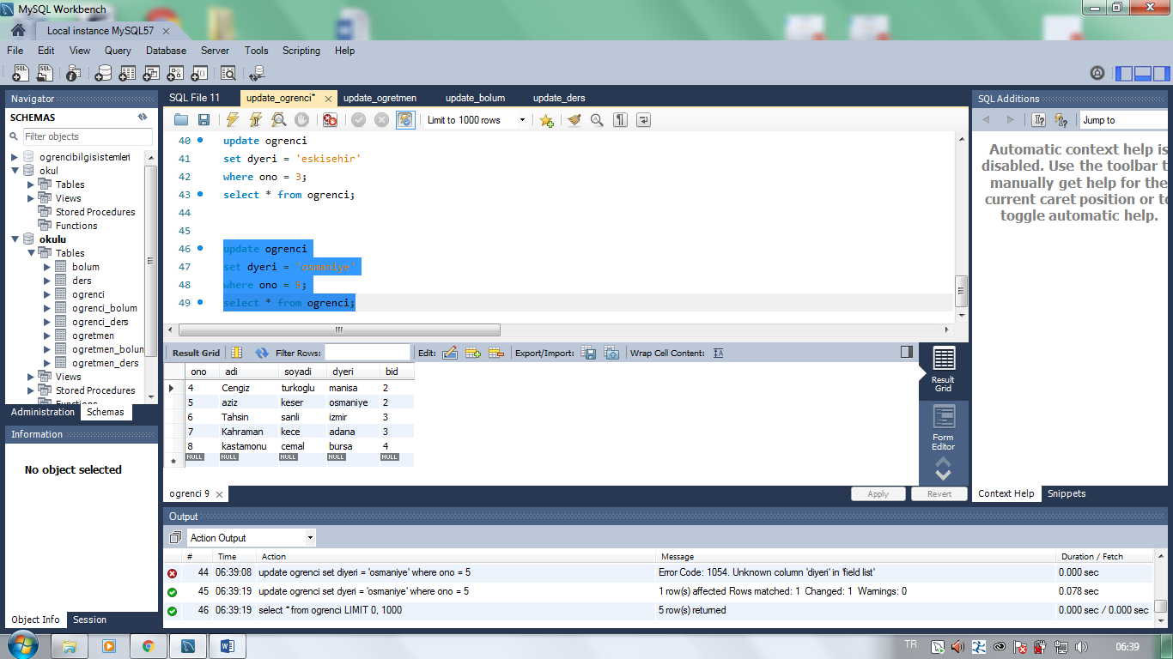

__________________________________________________________________________________________________

use okulu;

update ogretmen

set adi = 'Sami'

where oid = 1;

select * from ogretmen;

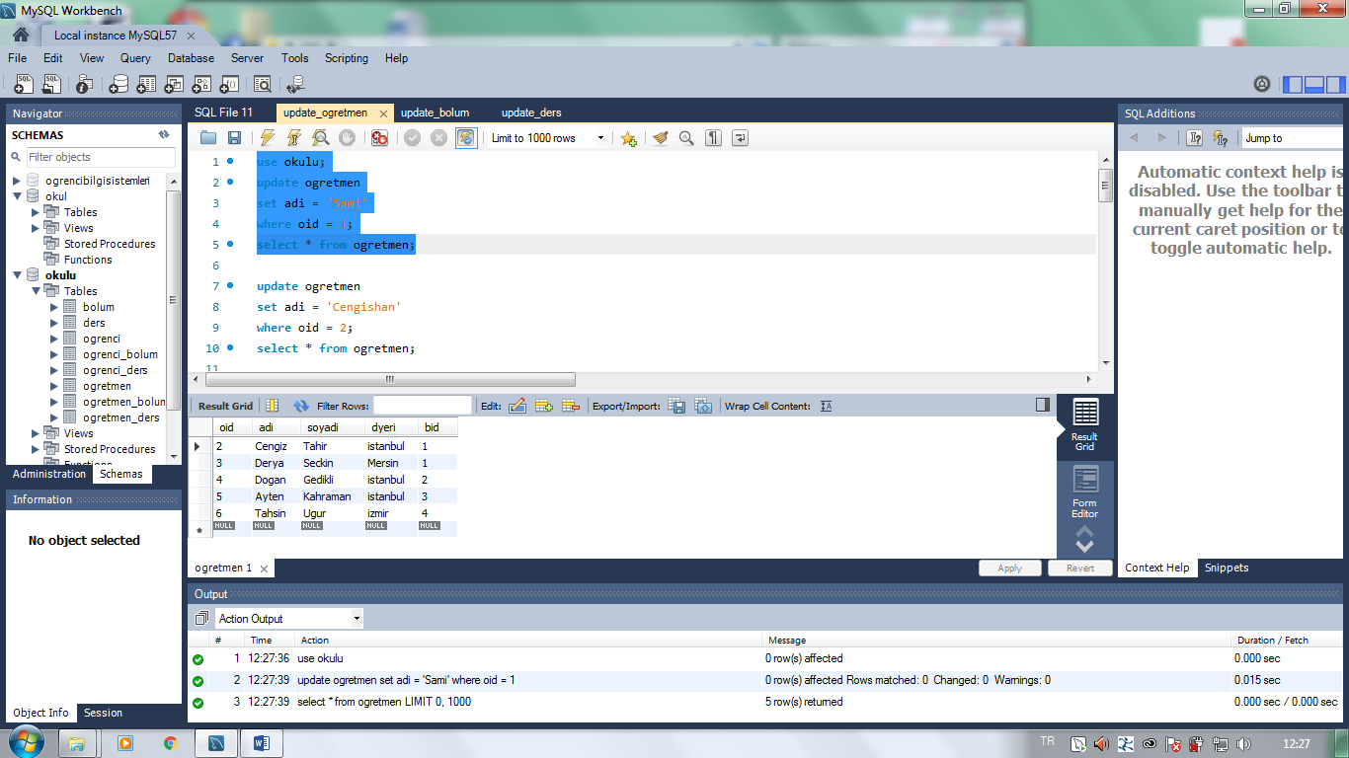

________________________________________________________________________________________________

update ogretmen

set adi = 'Cengishan'

where oid = 2;

select * from ogretmen;

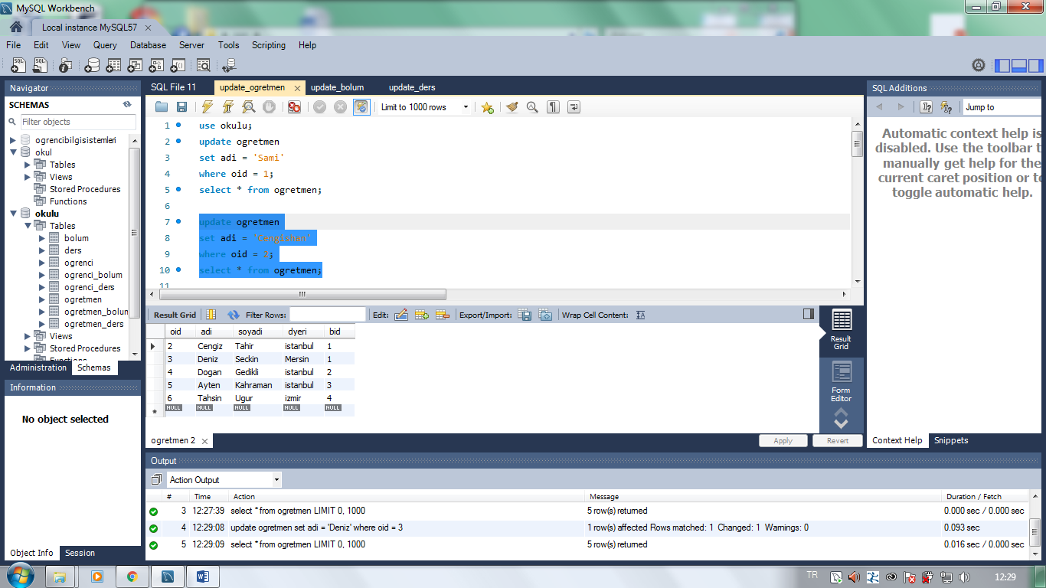

update ogretmen

set adi = 'Deniz'

where oid = 3;

select * from ogretmen;

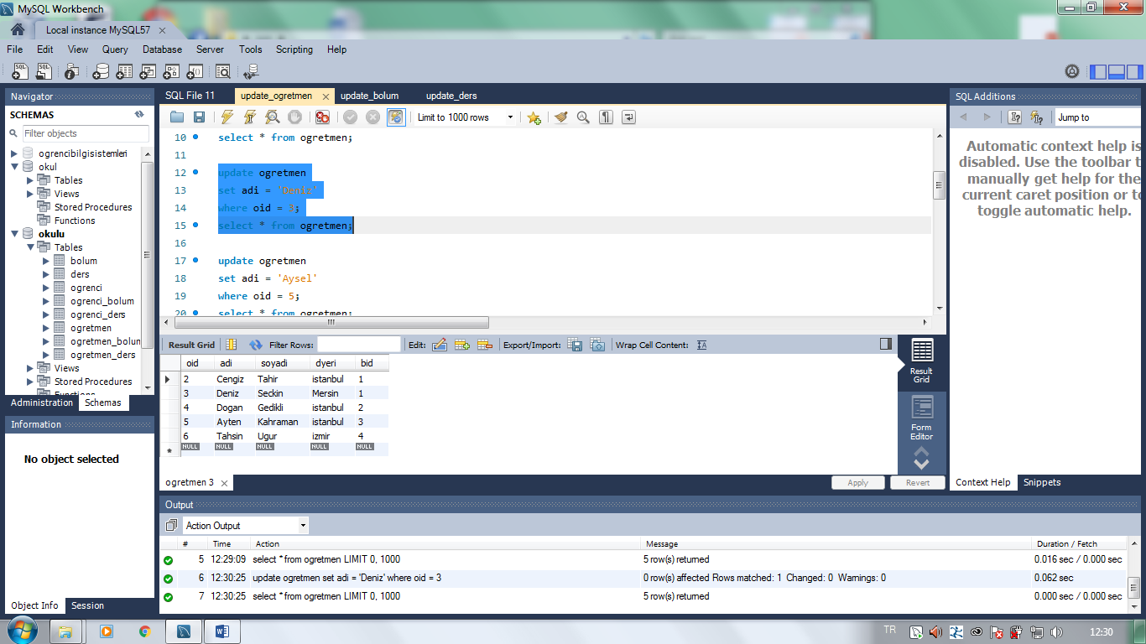

-__________________________________________________________________________________________________

update ogretmen

set adi = 'Aysel'

where oid = 5;

select * from ogretmen;

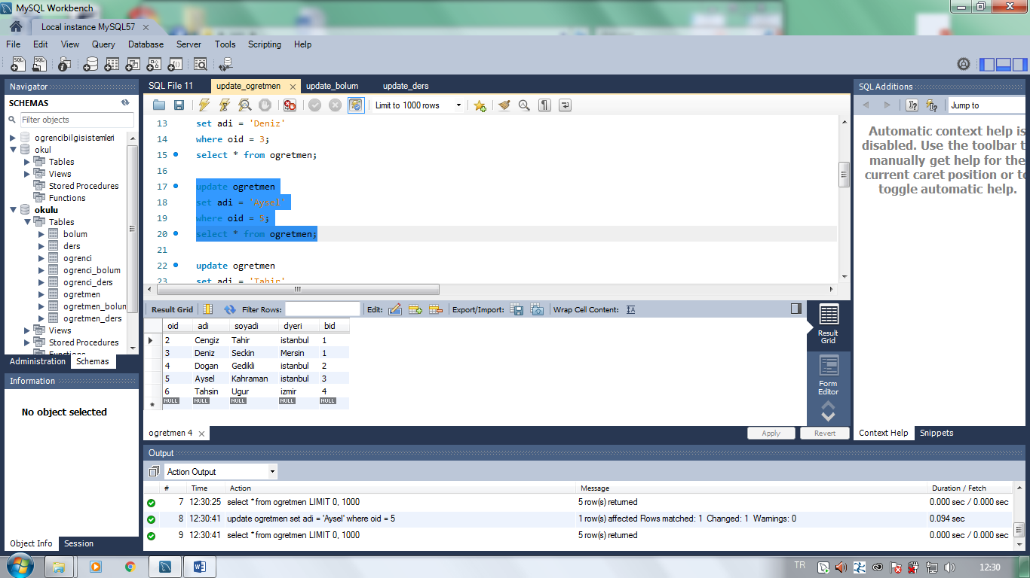

____________________________________________________________________________________________________

update ogretmen

set adi = 'Tahir'

where oid = 6;

select * from ogretmen;

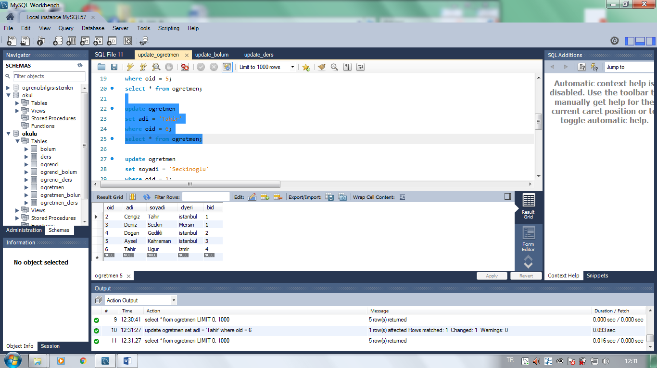

____________________________________________________________________________________________________

update ogretmen

set soyadi = 'Seckinoglu'

where oid = 2;

select * from ogretmen;

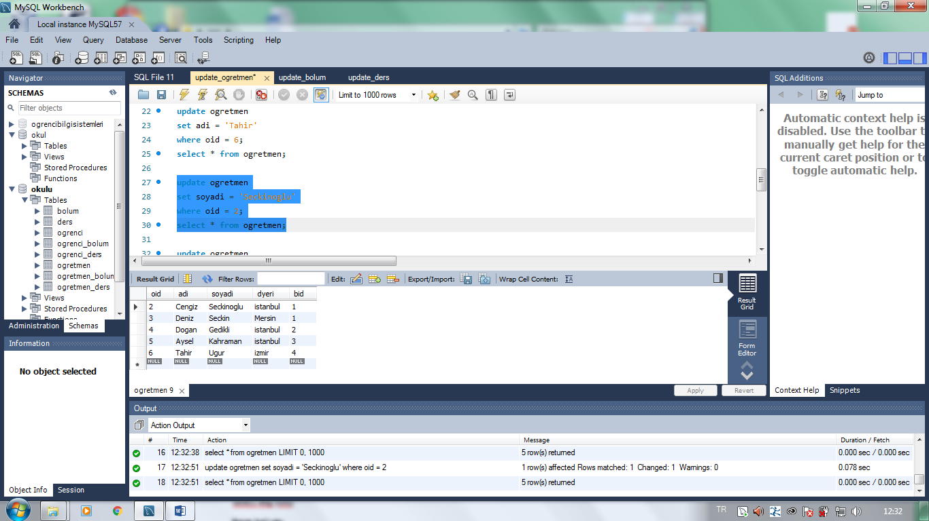

_____________________________________________________________________________________________

update ogretmen

set soyadi = 'Yilmazer'

where oid = 5;

select * from ogretmen;

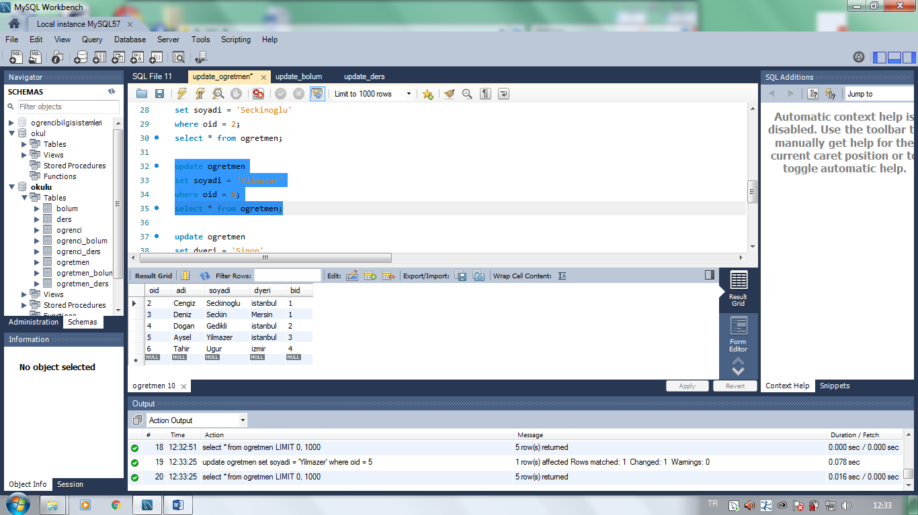

________________________________________________________________________________________________

update ogretmen

set dyeri = 'Sinop'

where oid = 3;

select * from ogretmen;

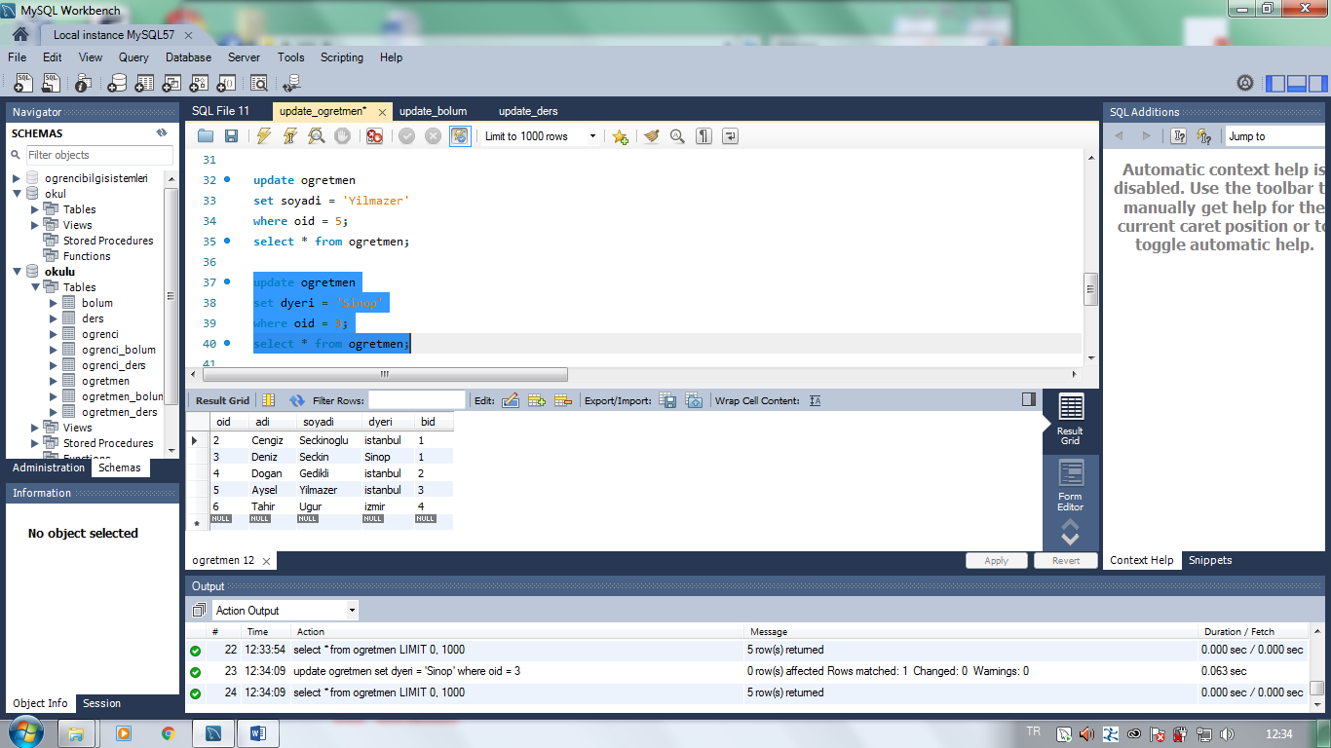

_________________________________________________________________________________________________

update ogretmen

set dyeri = 'Hatay'

where oid = 7;

select * from ogretmen;

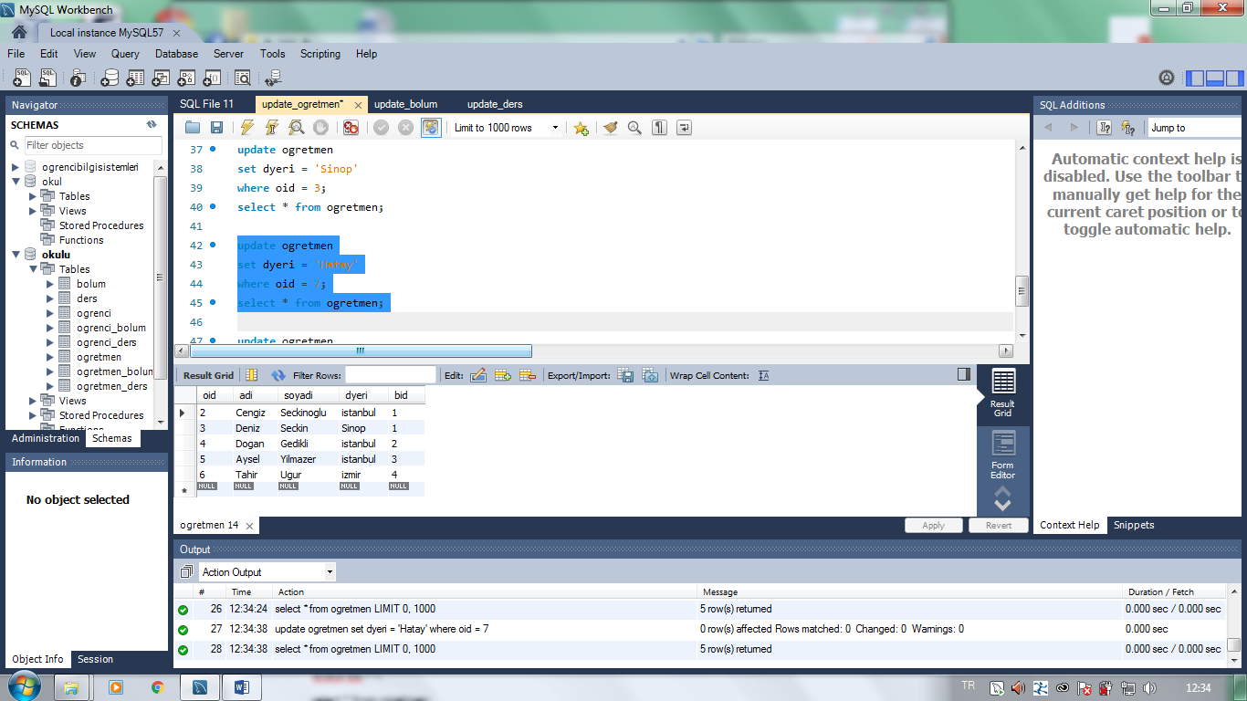

________________________________________________________________________________________________

update ogretmen

set dyeri = 'Kars'

where oid = 1;

select * from ogretmen;

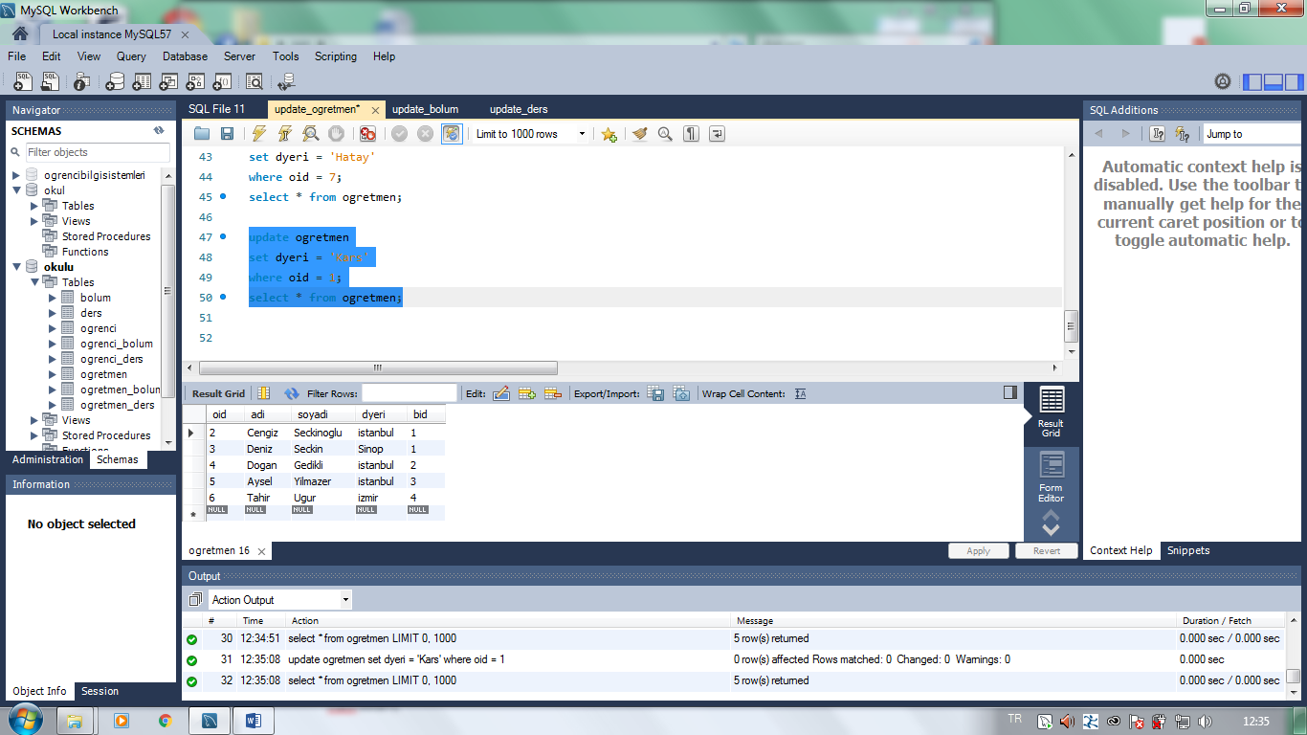

__________________________________________________________________________________________________

use okulu;

update bolum

set badi = 'yaz. muh.'

where bid = 2;

select * from bolum;

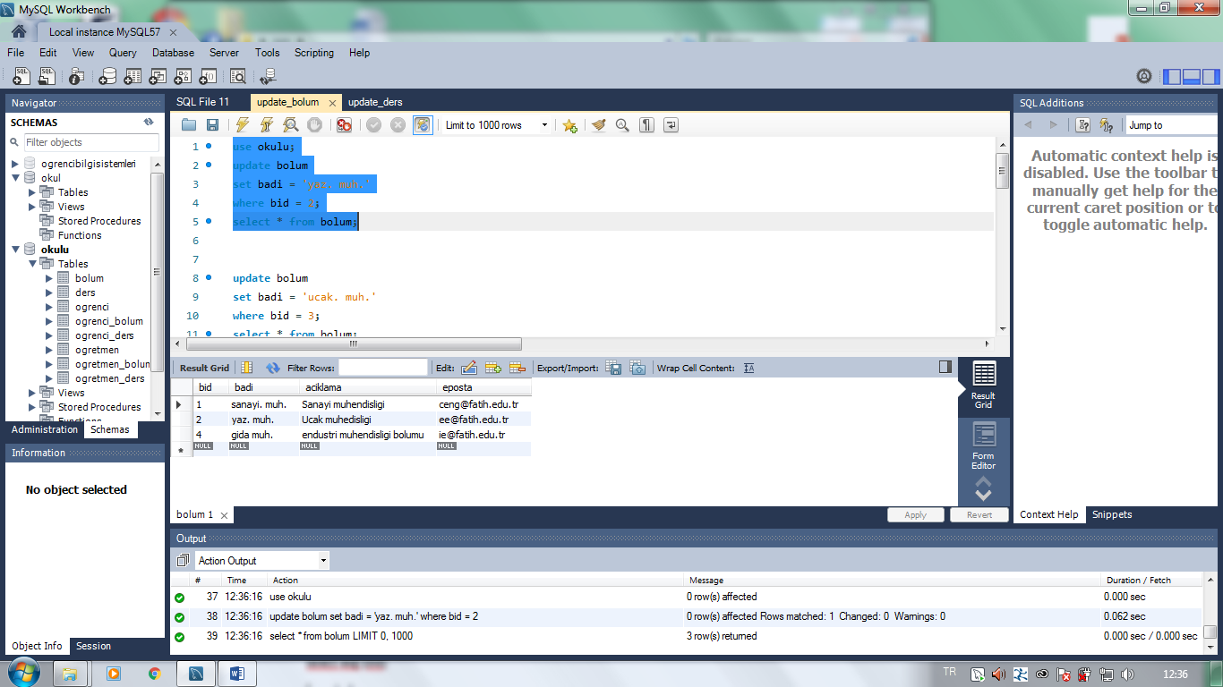

___________________________________________________________________________________________________

update bolum

set badi = 'ucak. muh.'

where bid = 3;

select * from bolum;

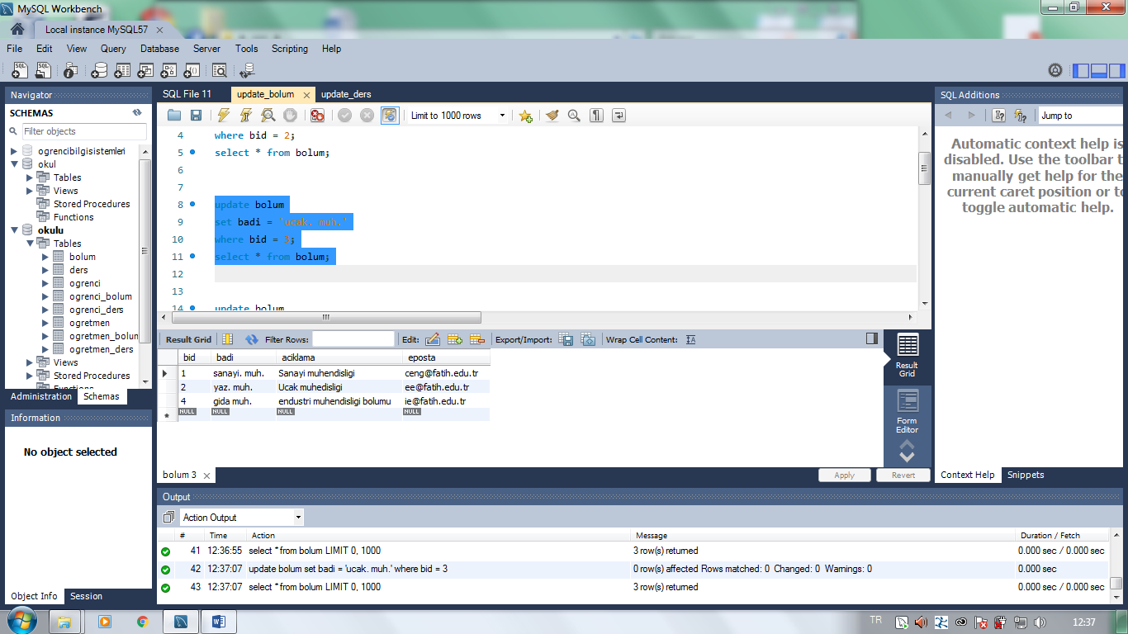

________________________________________________________________________________________________

update bolum

set badi = 'gida muh.'

where bid = 4;

select * from bolum;

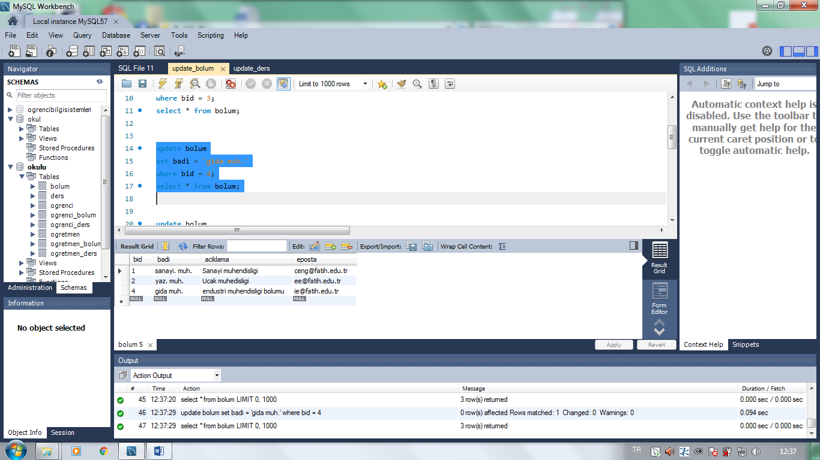

_______________________________________________________________________________________________

update bolum

set badi = 'sanayi. muh.'

where bid = 1;

select * from bolum;

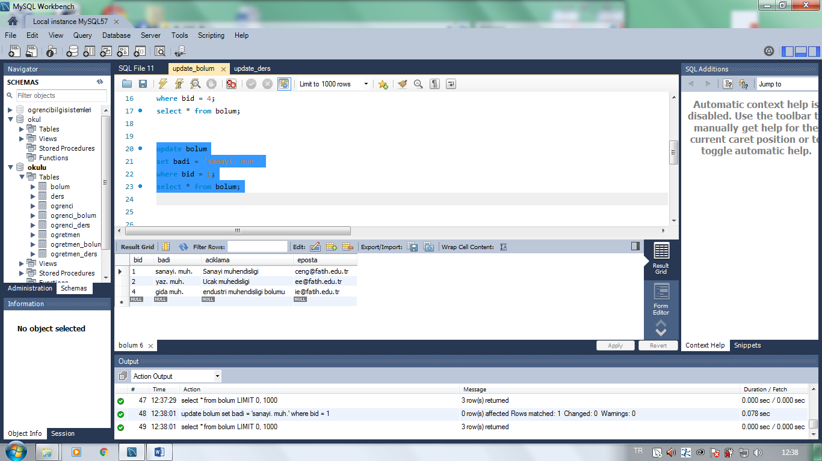

________________________________________________________________________________________________

update bolum

set aciklama = 'Sanayi muhendisligi'

where bid = 1;

select * from bolum;

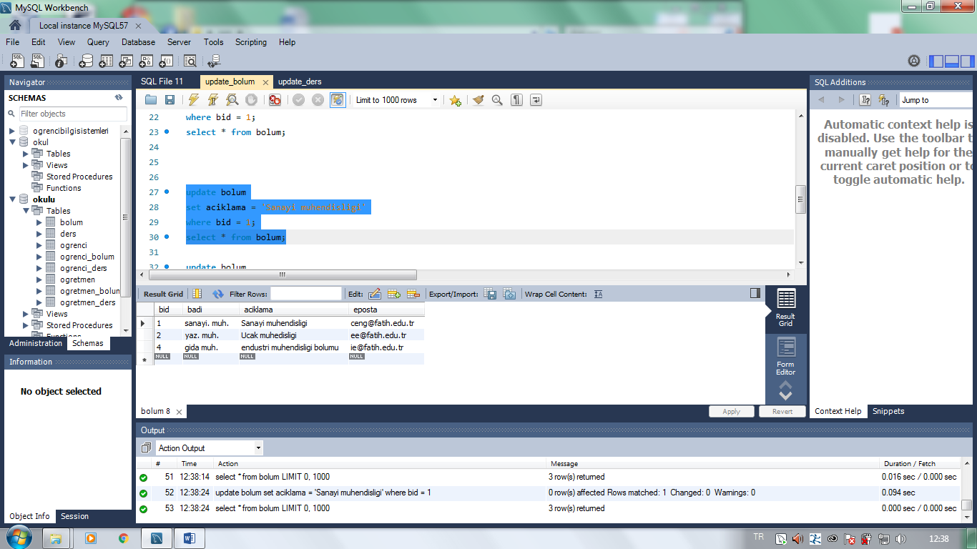

_________________________________________________________________________________________________

update bolum

set aciklama = 'Ucak muhedisligi'

where bid = 3;

select * from bolum;

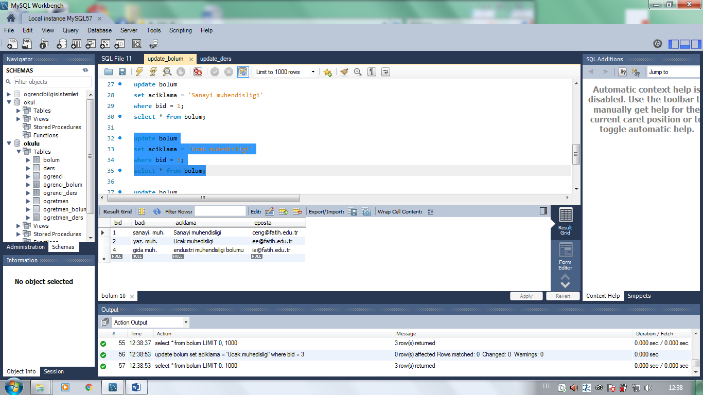

________________________________________________________________________________________________

update bolum

set aciklama = 'Gida muhendisligi'

where bid = 4;

select * from bolum;

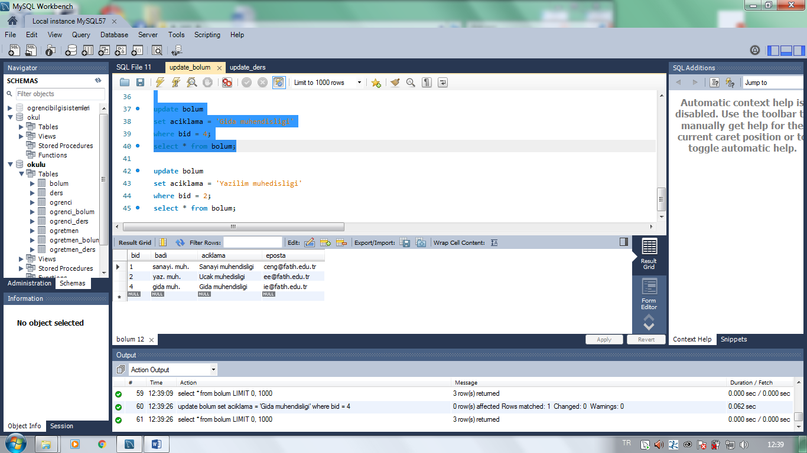

_________________________________________________________________________________________________

update bolum

set aciklama = 'Yazilim muhedisligi'

where bid = 2;

select * from bolum;

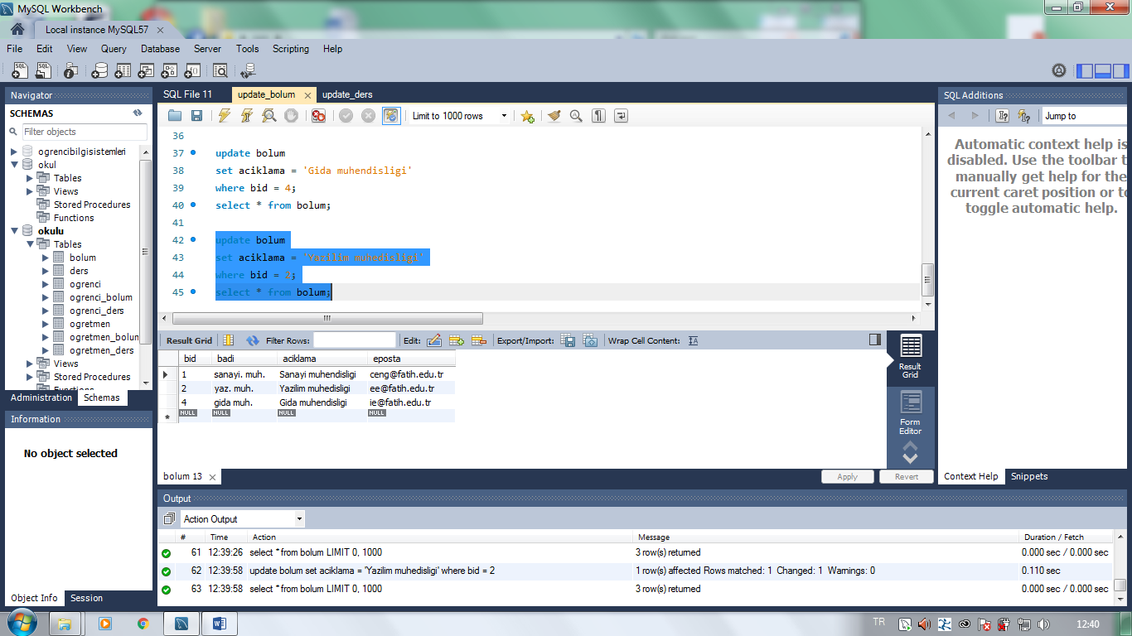

_______________________________________________________________________________________________

use okulu;

update ders

set dadi = 'Nesne tabani'

where did = 2;

select * from ders;

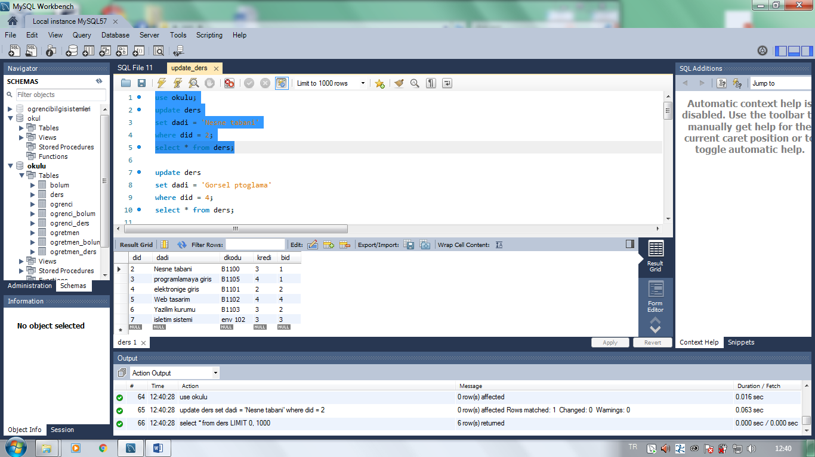

___________________________________________________________________________________________________

update ders

set dadi = 'Gorsel ptoglama'

where did = 4;

select * from ders;

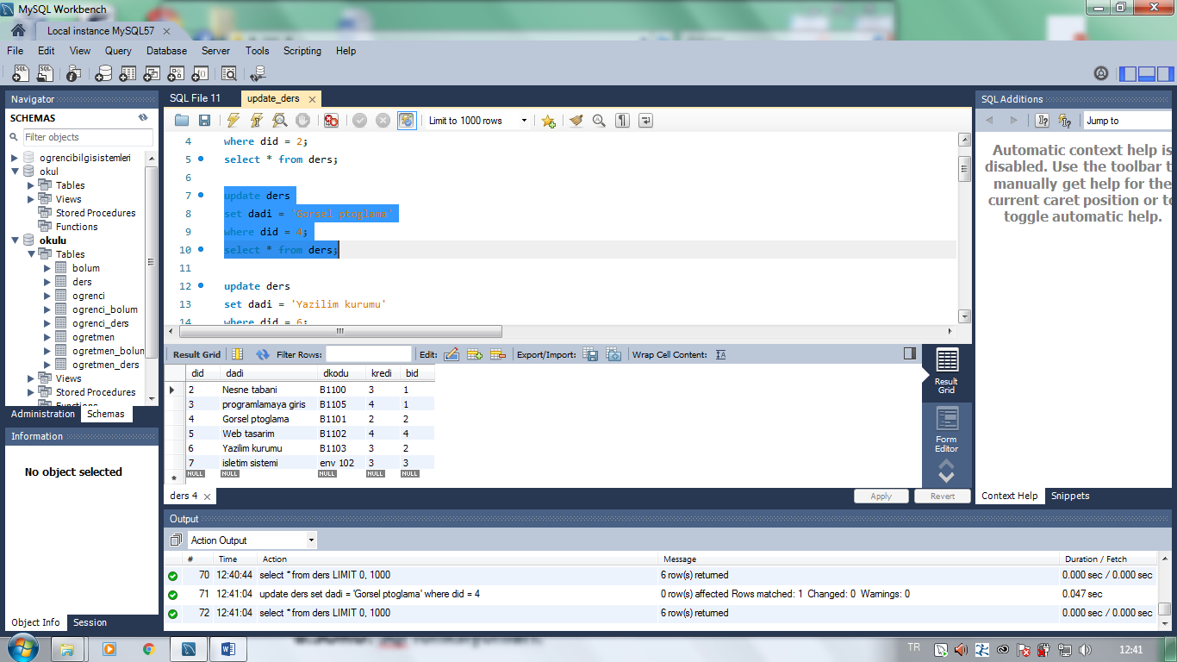

________________________________________________________________________________________________

update ders

set dadi = 'Yazilim kurumu'

where did = 6;

select * from ders;

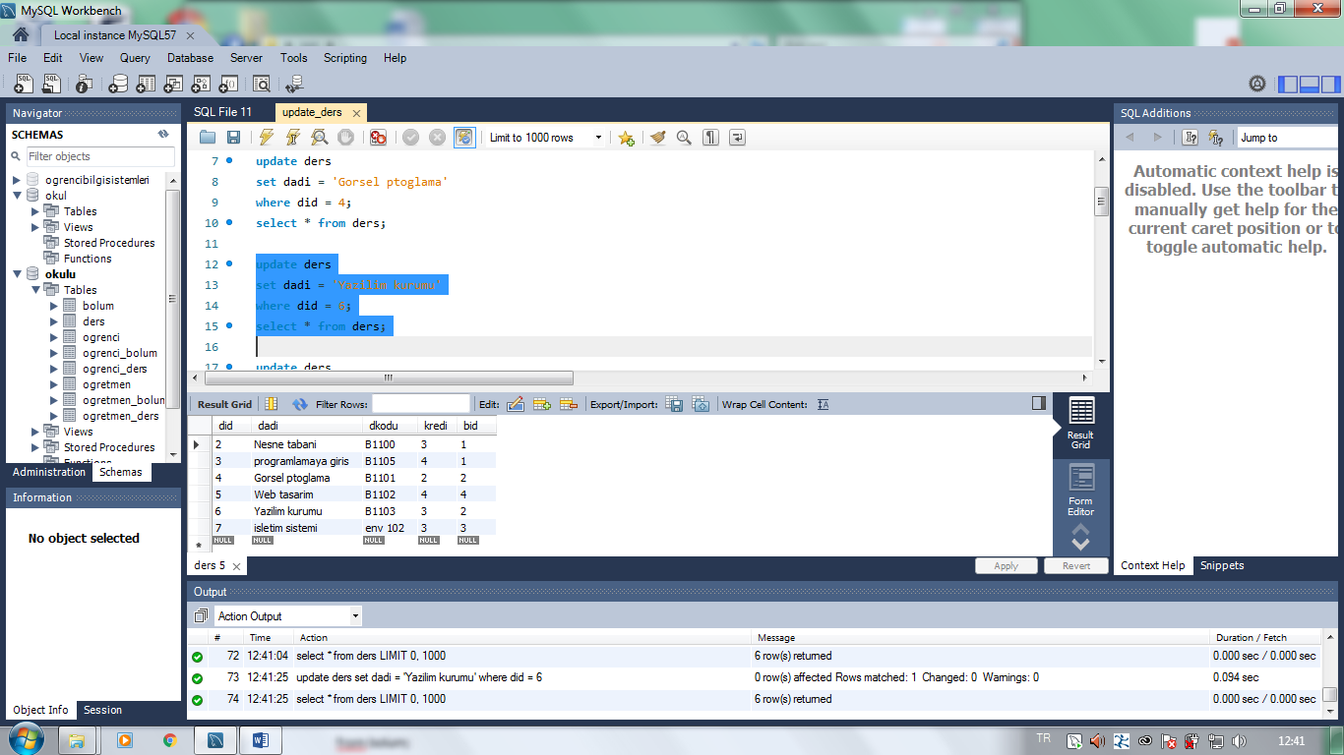

______________________________________________________________________________________________________

update ders

set dadi = 'isletim sistemi'

where did = 7;

select * from ders;

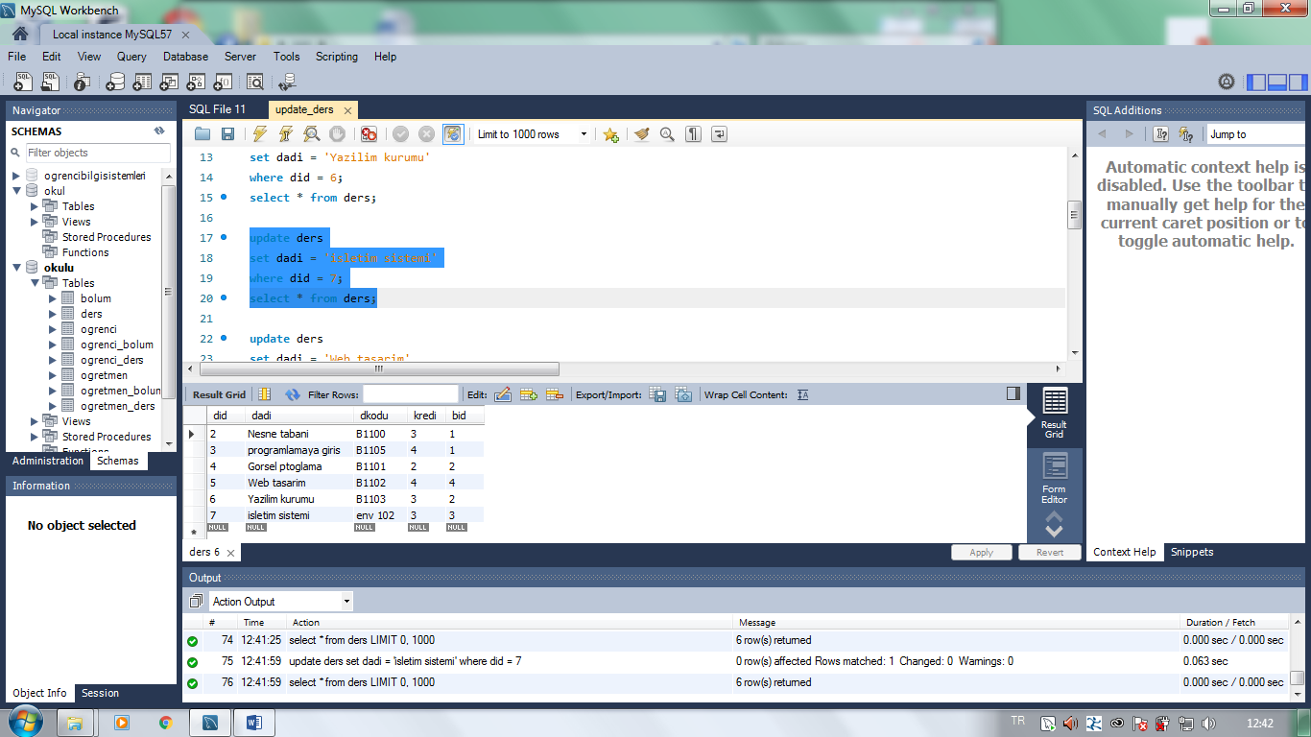

_________________________________________________________________________________________________

update ders

set dadi = 'Web tasarim'

where did = 5;

select * from ders;

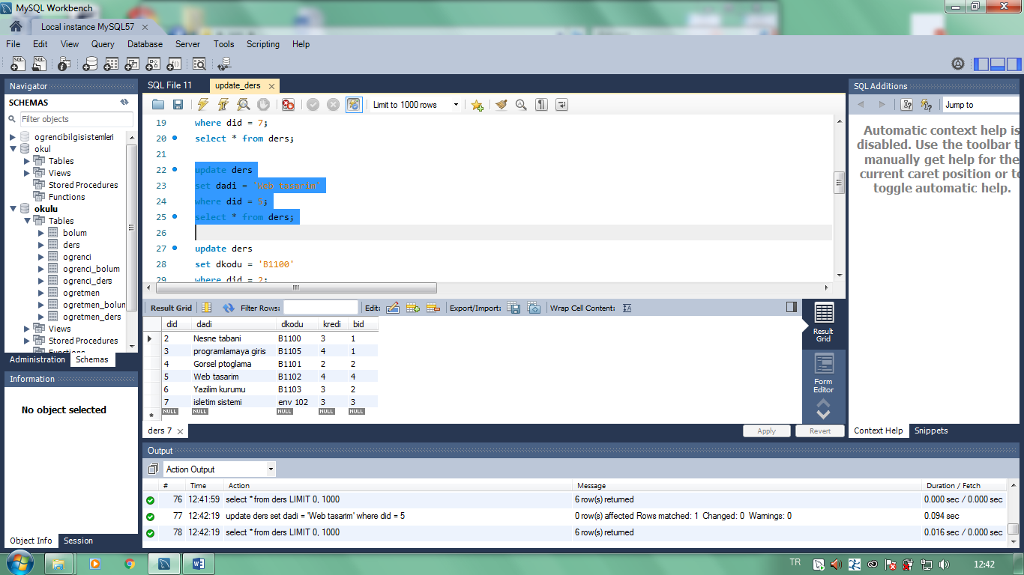

_____________________________________________________________________________________________

update ders

set dkodu = 'B1100'

where did = 2;

select * from ders;

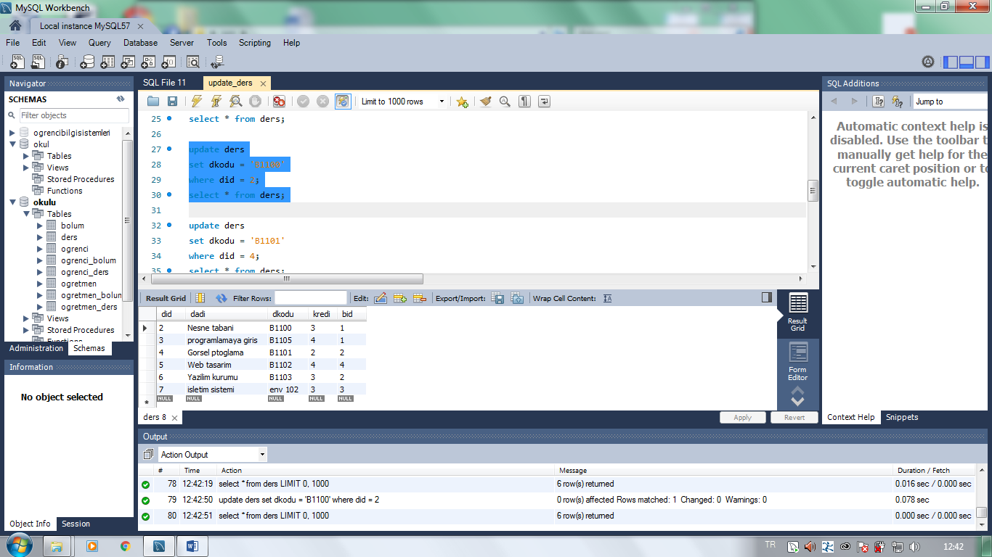

_____________________________________________________________________________________________________

update ders

set dkodu = 'B1101'

where did = 4;

select * from ders;

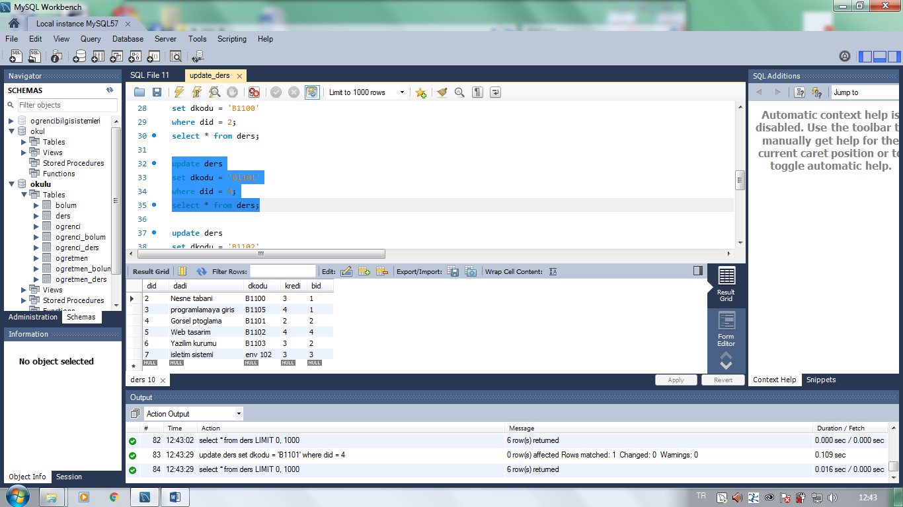

____________________________________________________________________________________________

update ders

set dkodu = 'B1102'

where did = 5;

select * from ders;

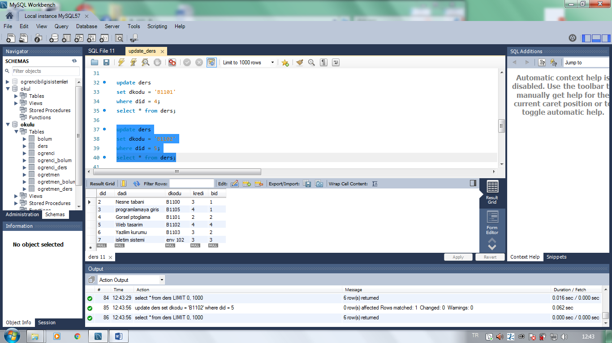

________________________________________________________________________________________________

update ders

set dkodu = 'B1103'

where did = 6;

select * from ders;

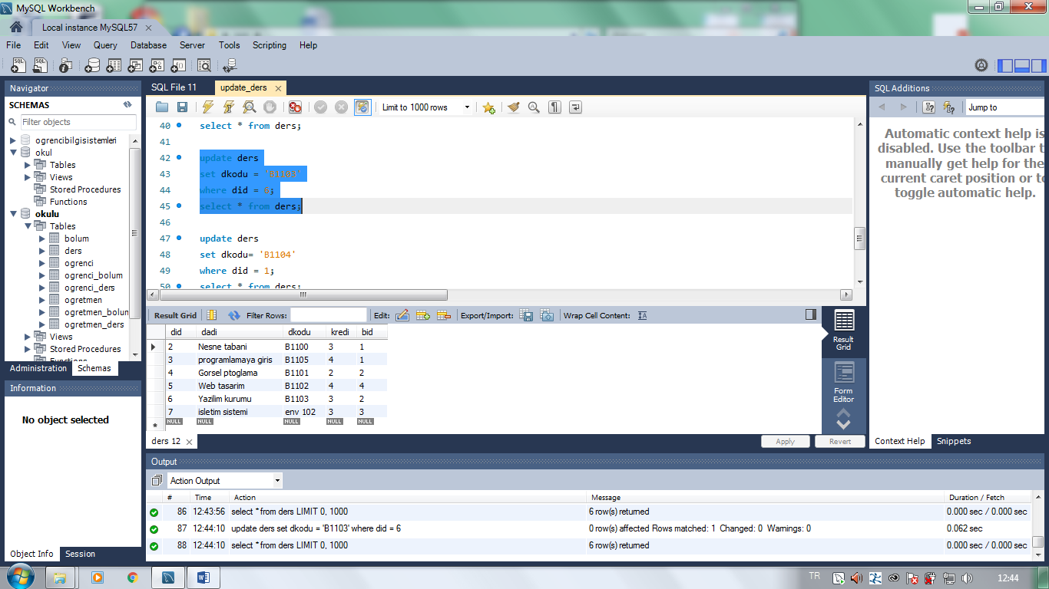

________________________________________________________________________________________________

update ders

set dkodu= 'B1104'

where did = 1;

select * from ders;

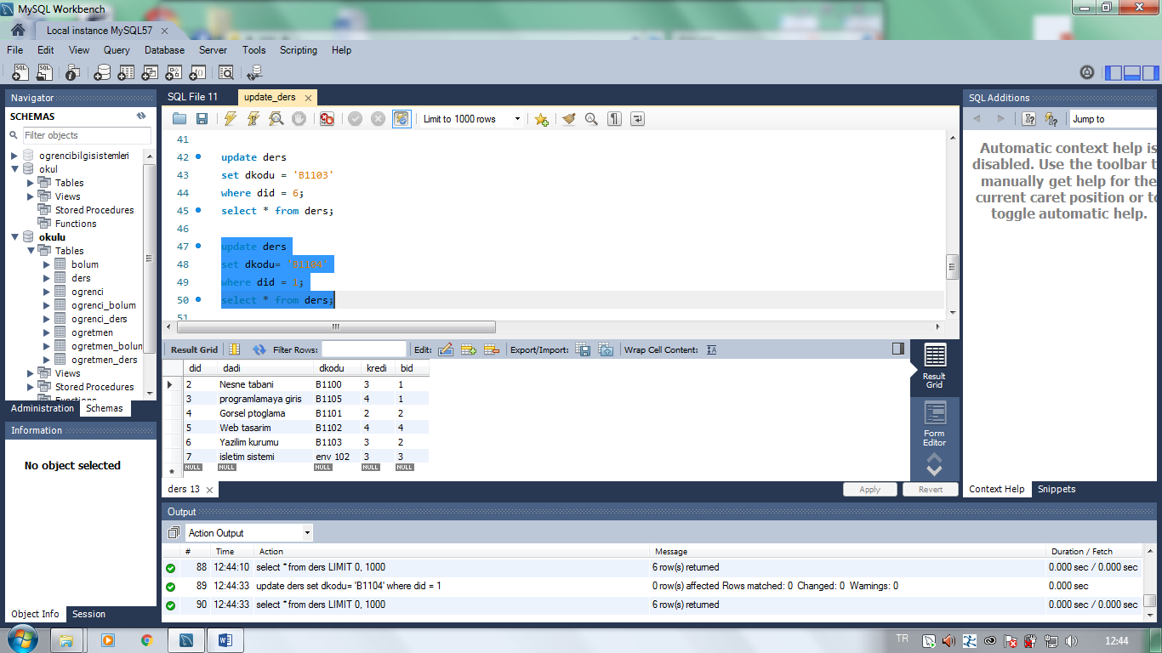

_______________________________________________________________________________________________

update ders

set dkodu= 'B1105'

where did = 3;

select * from ders;

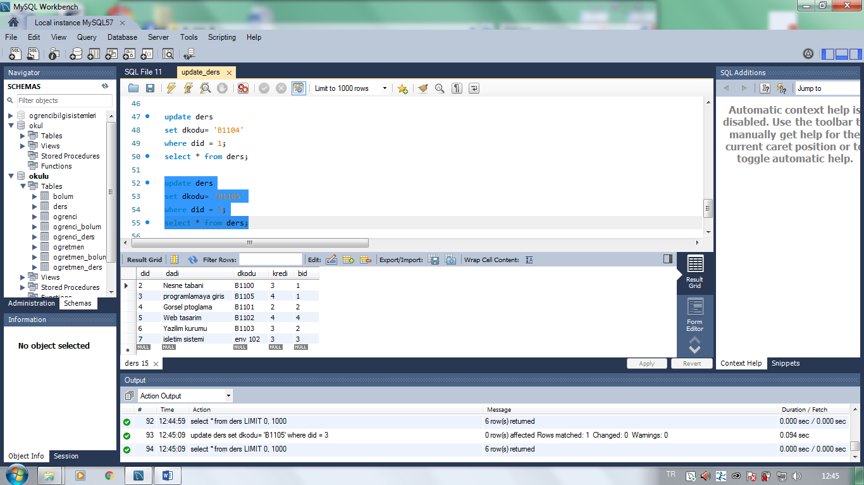

***___________________________________________________***

***7.soru: Delete***

use okulu;

delete from ogrenci

where ono = 2;

select * from ogrenci;

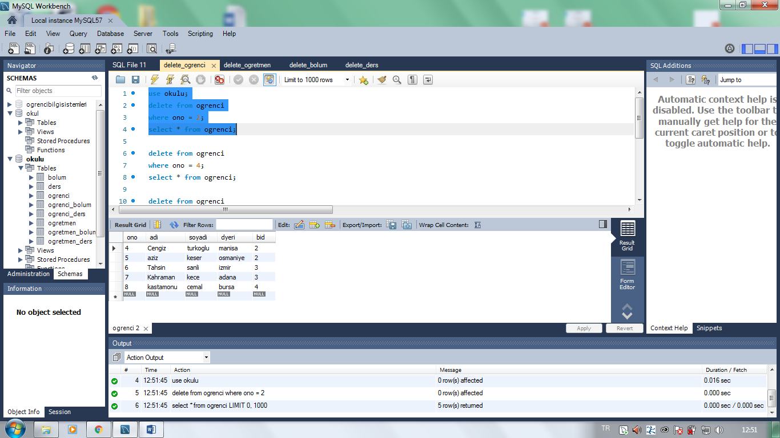

***__________________________________________________***

delete from ogrenci

where ono = 4;

select * from ogrenci;

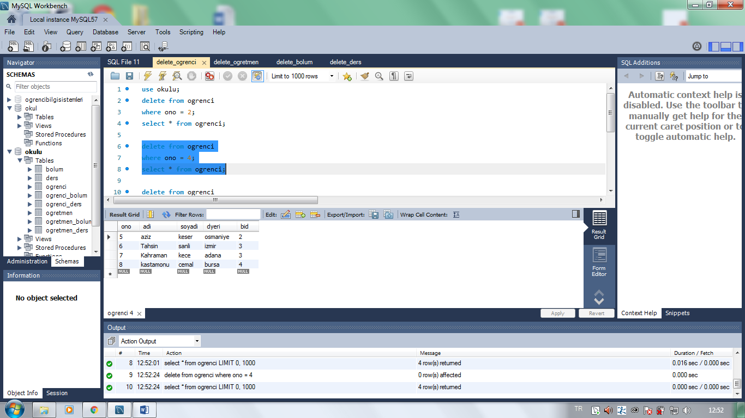

____________________________________________________________________________________________

delete from ogrenci

where ono = 6;

select * from ogrenci;

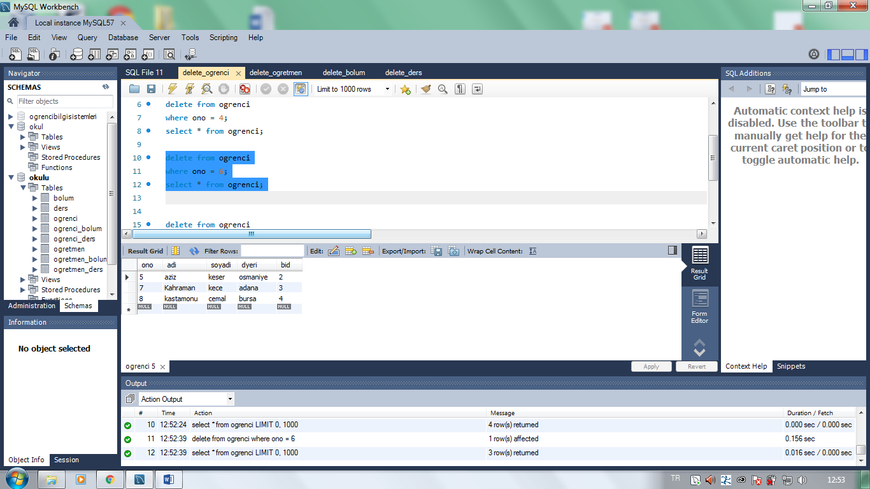

__________________________________________________________________________________________________

delete from ogrenci

where ono = 7;

select * from ogrenci;

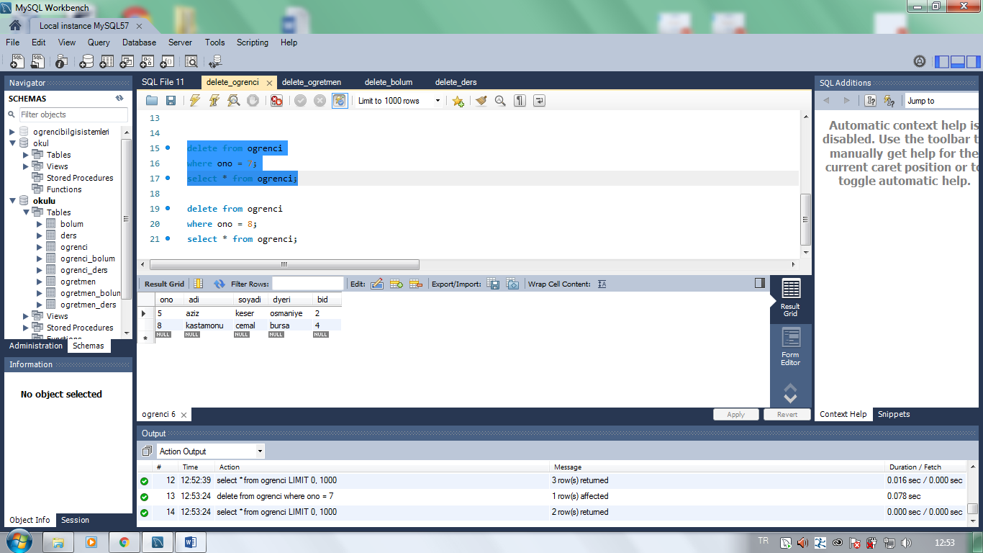

_______________________________________________________________________________________________

delete from ogrenci

where ono = 8;

select * from ogrenci;

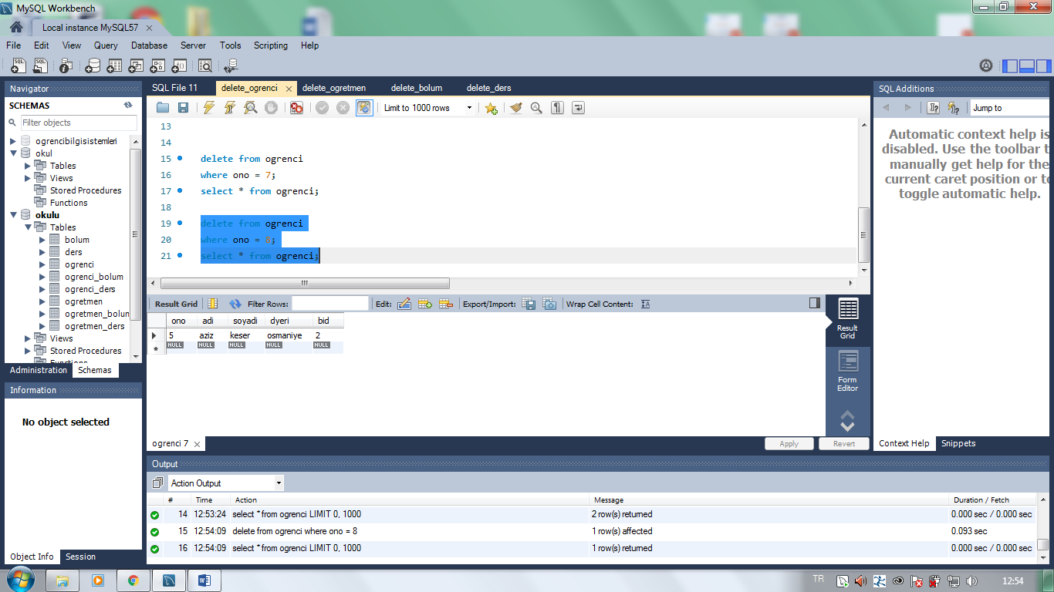

***_________________________________________________***

use okulu;

delete from ogretmen

where oid= 2;

select * from ogretmen;

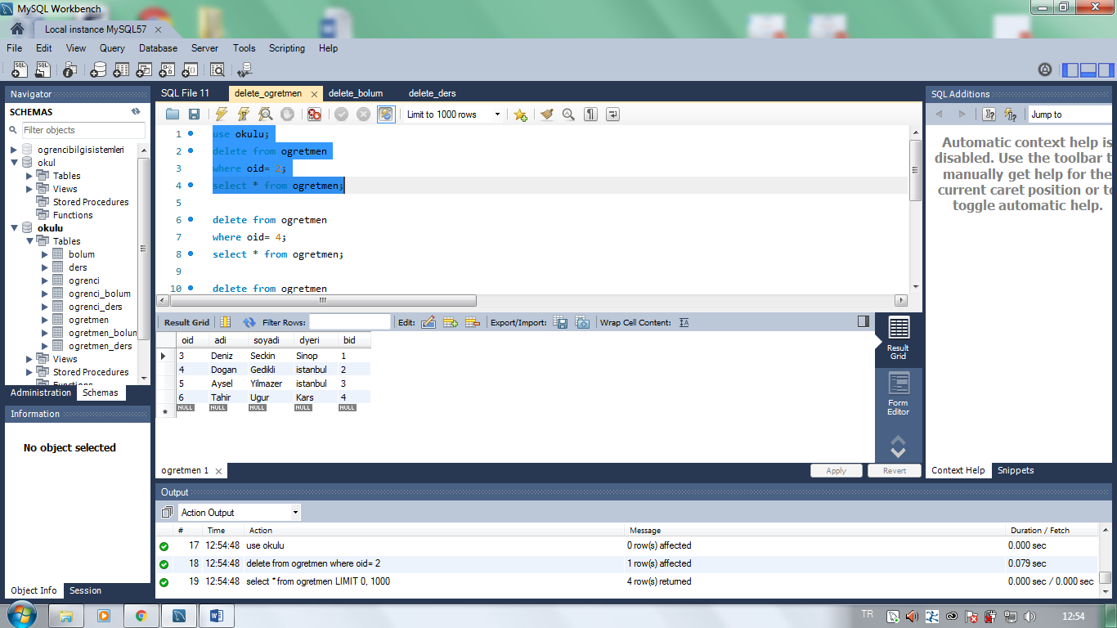

___________________________________________________________________________________________________

delete from ogretmen

where oid= 4;

select * from ogretmen;

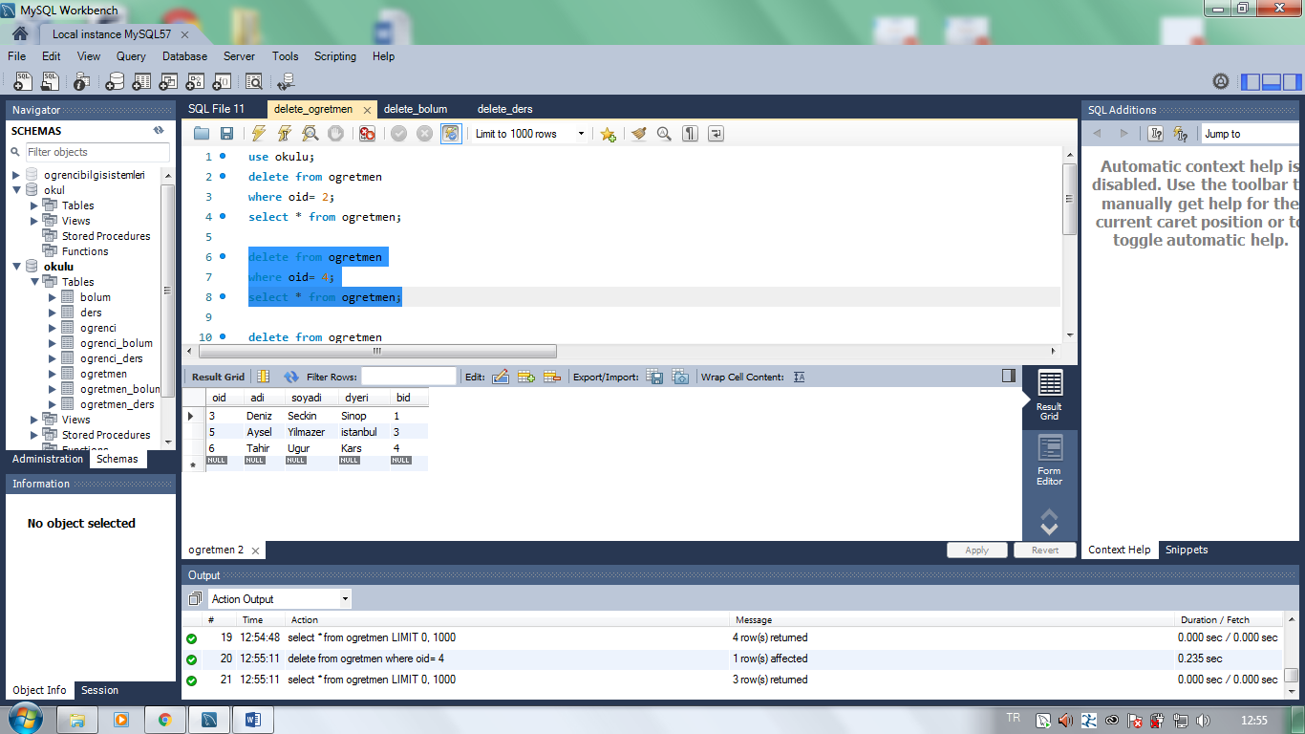

_____________________________________________________________________________________________________

delete from ogretmen

where oid= 5;

select * from ogretmen;

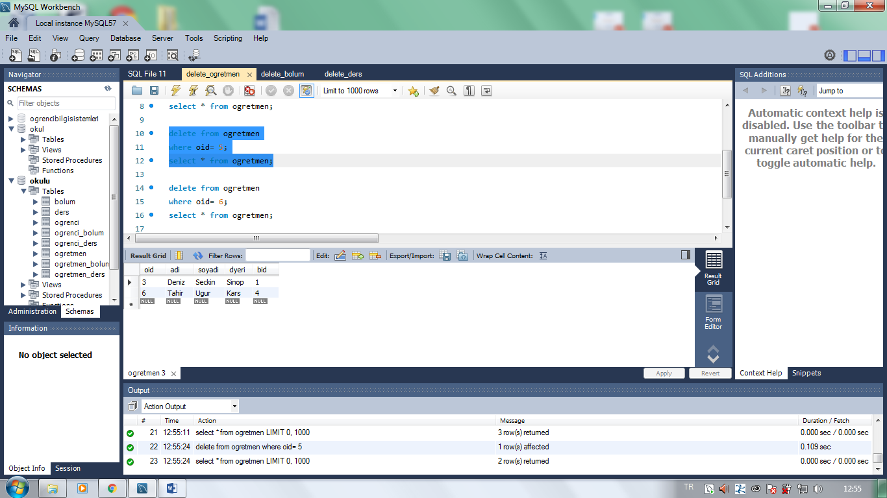

_______________________________________________________________________________________________

delete from ogretmen

where oid= 6;

select * from ogretmen;

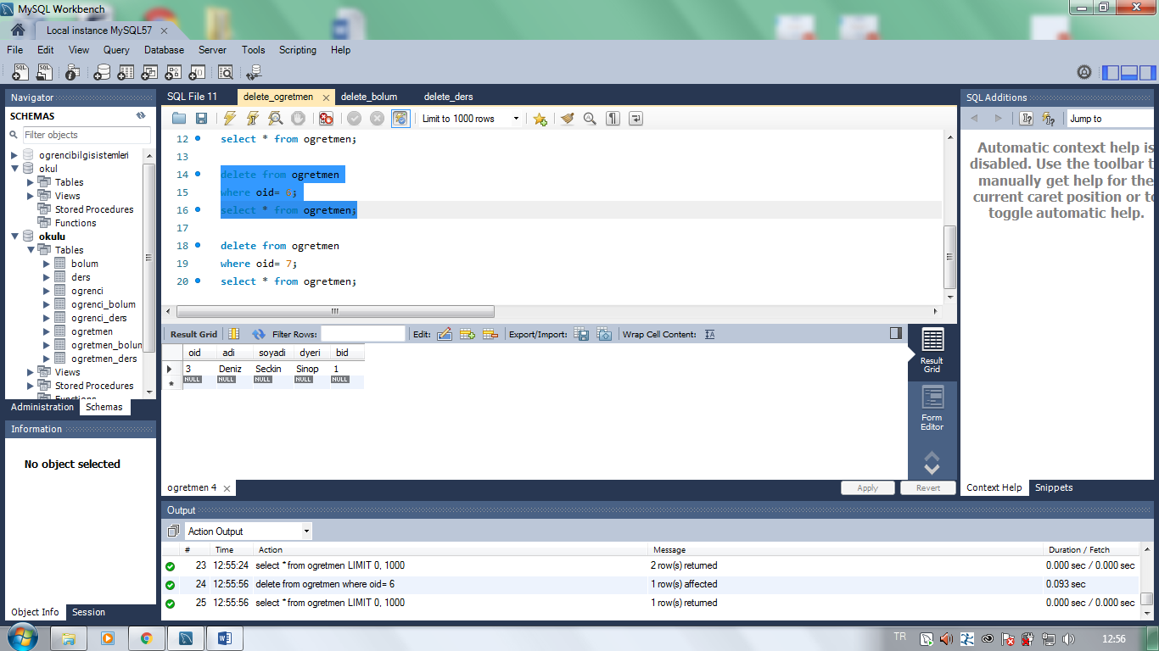

***__________________________________________________***

delete from ogretmen

where oid= 7;

select * from ogretmen;

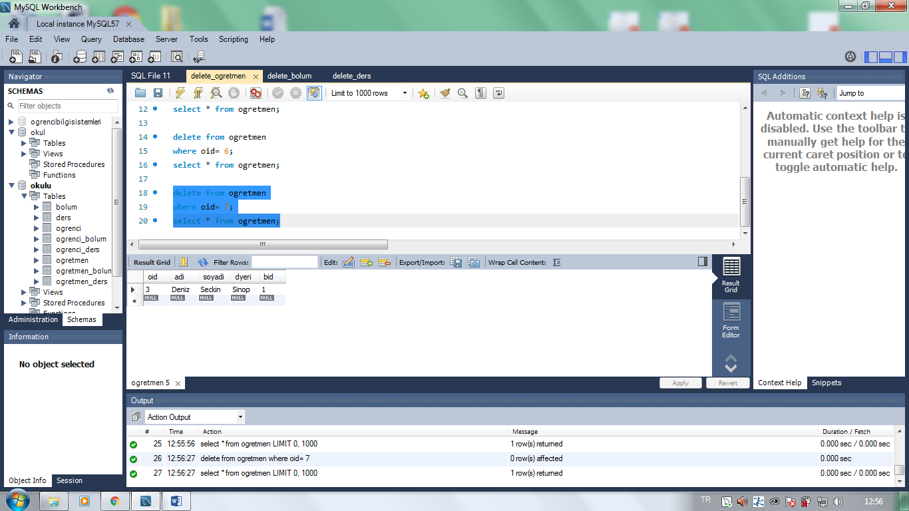

_______________________________________________________________________________________________

delete from bolum

where bid= 1;

select * from bolum; 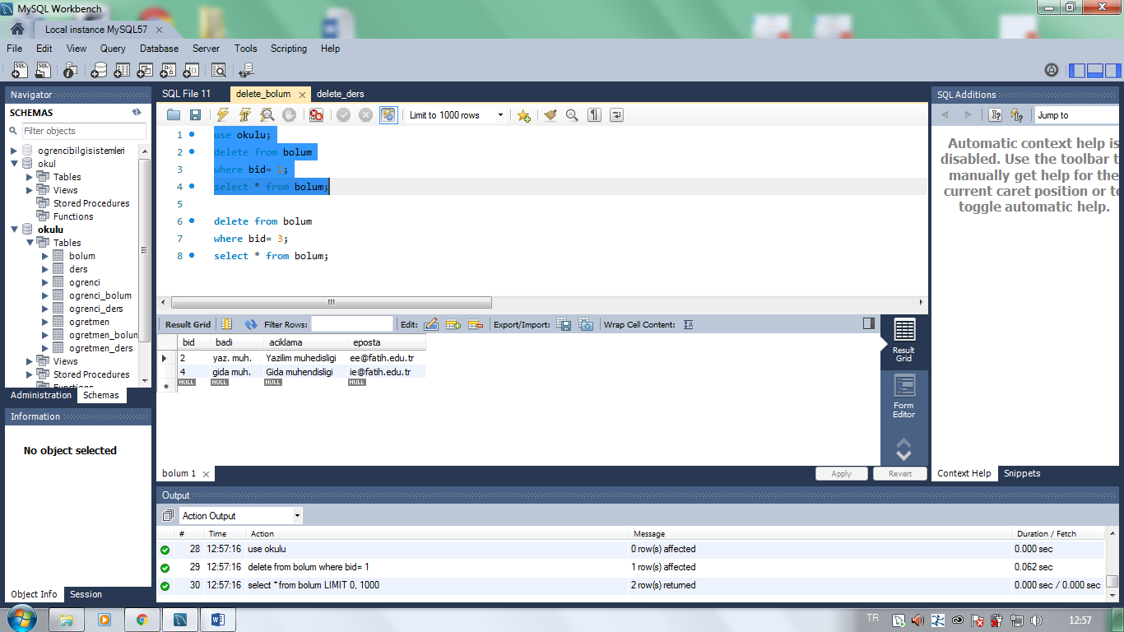

_________________________________________________________________________________________________

delete from bolum

where bid= 3;

select * from bolum;

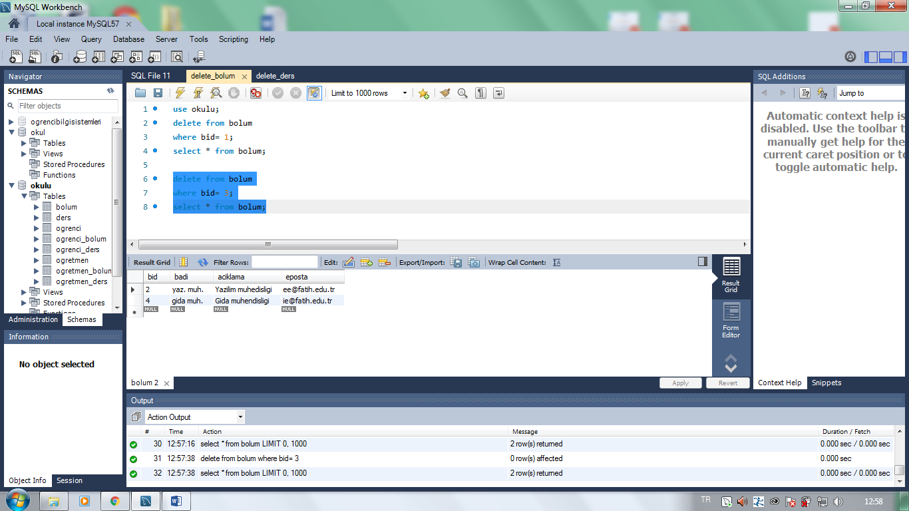

____________________________________________________________________________________________

delete from ders

where did = 1;

select * from ders;

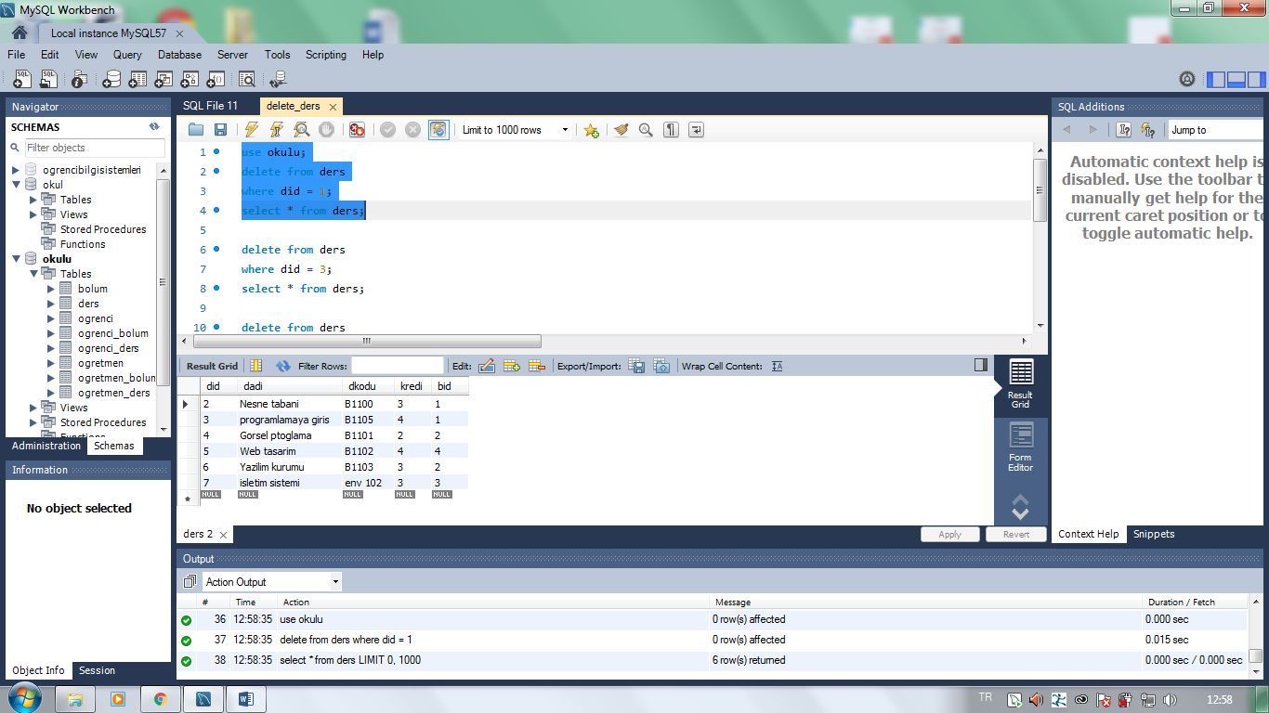

_______________________________________________________________________________________________

delete from ders

where did = 3;

select * from ders;

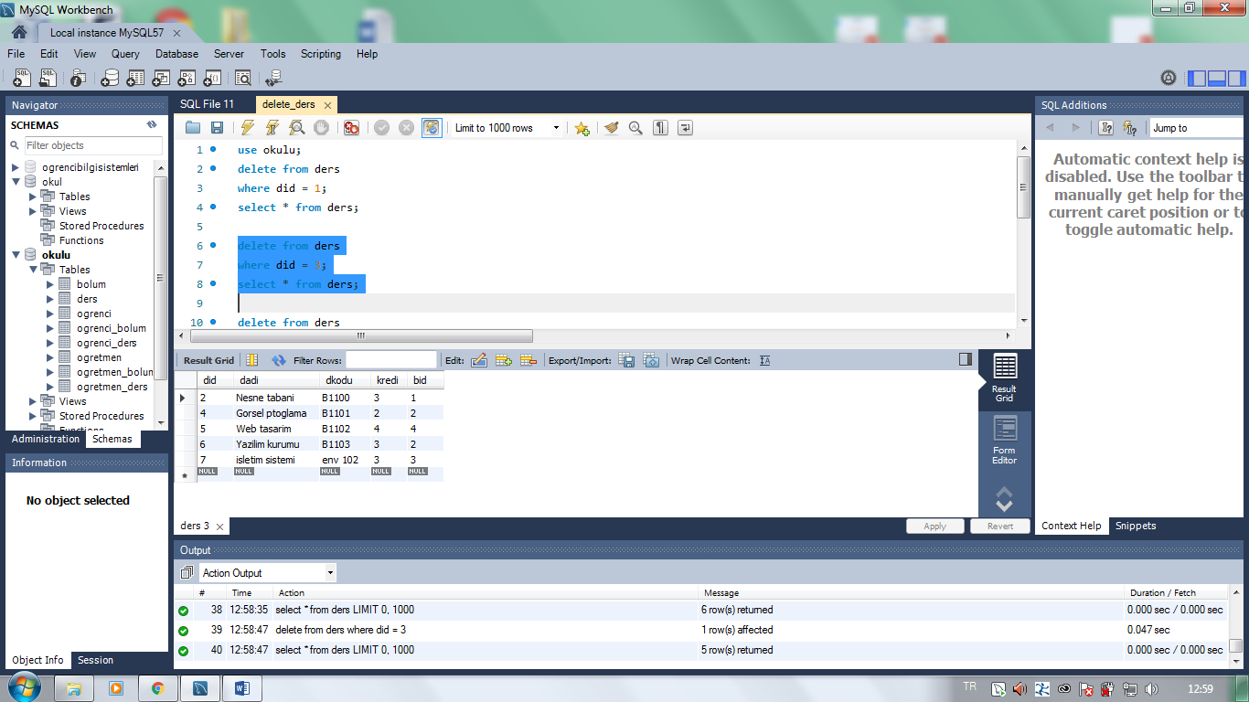

______________________________________________________________________________________________

delete from ders

where did = 4;

select * from ders;

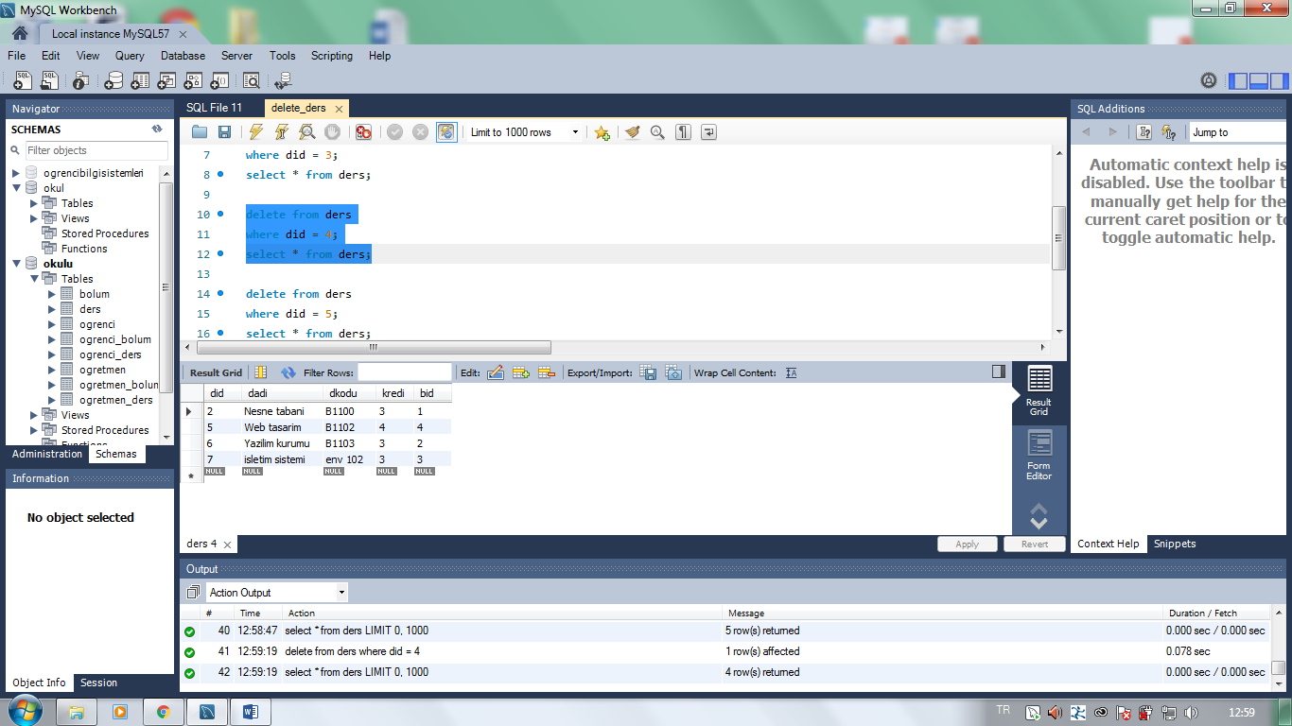

_____________________________________________________________________________________________

delete from ders

where did = 5;

select * from ders;

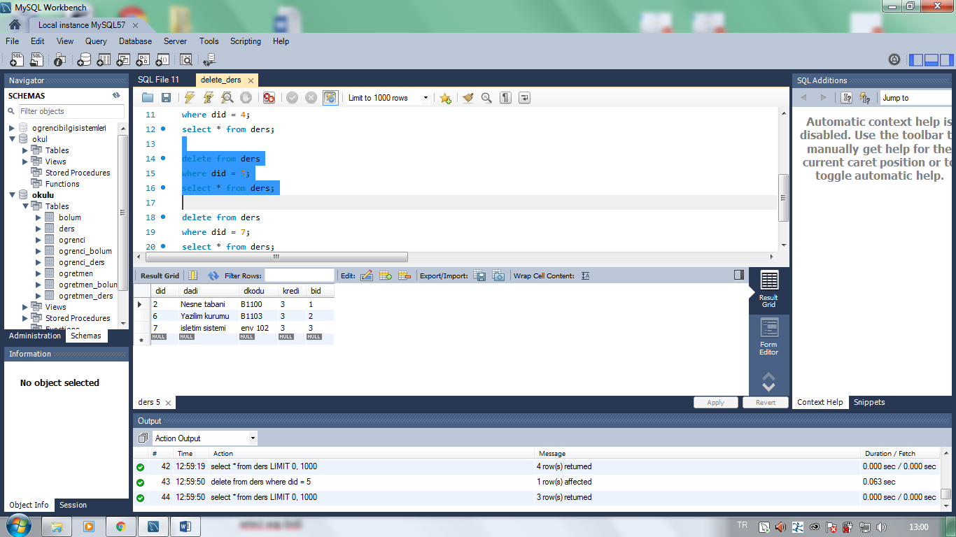

delete from ders

where did = 7;

select * from ders;

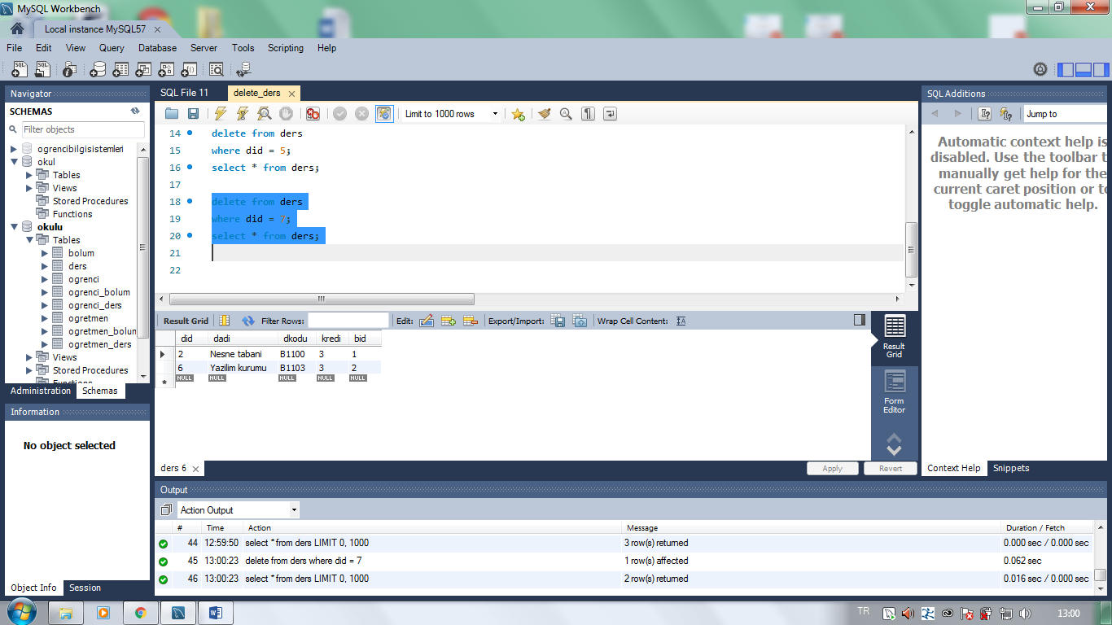

***___________________________________________________***

**8.SORU: Sql fonksiyonları:**

use okulu;

select avg (bid)

from bolum;

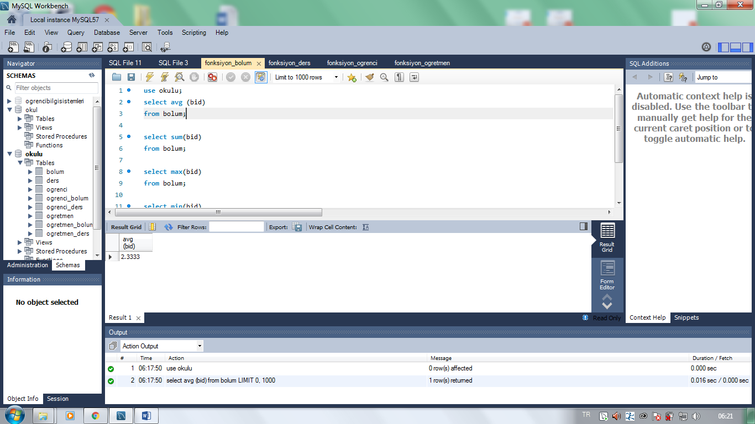

________________________________________________________________________________________

select sum(bid)

from bolum;

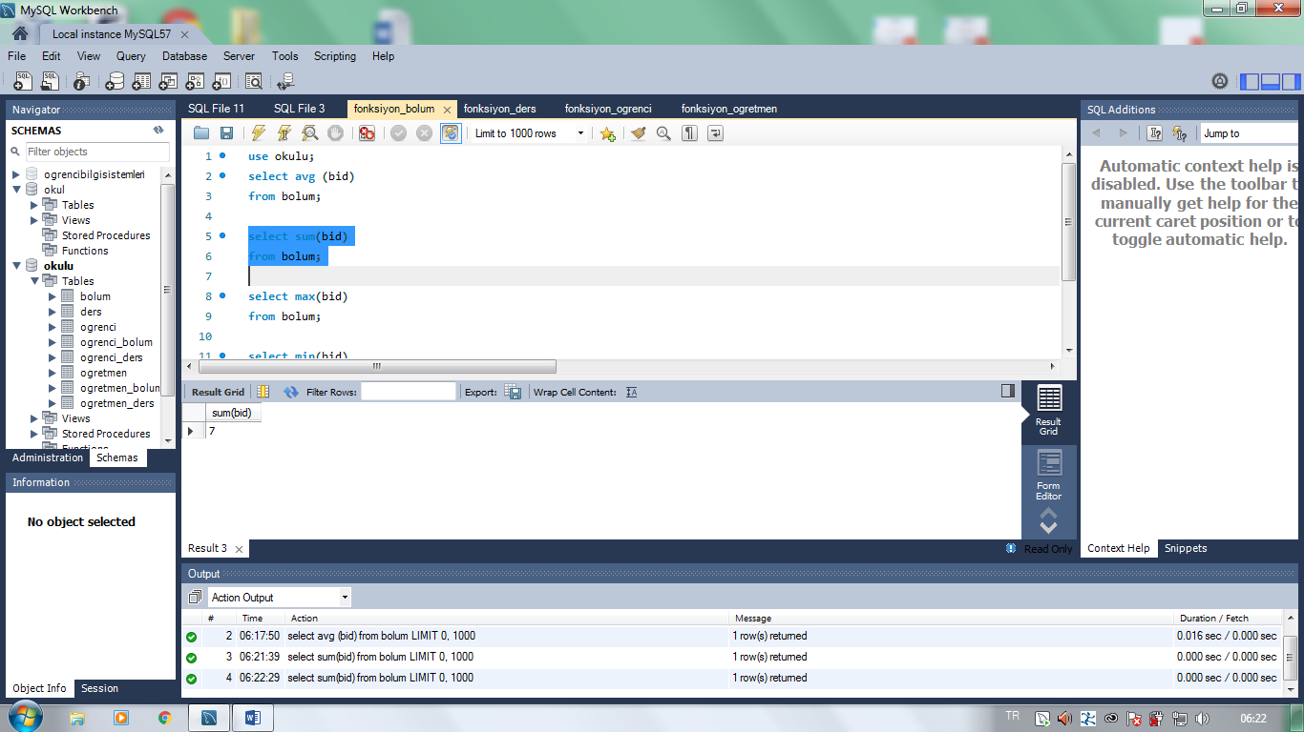

________________________________________________________________________________________

select max(bid)

from bolum;

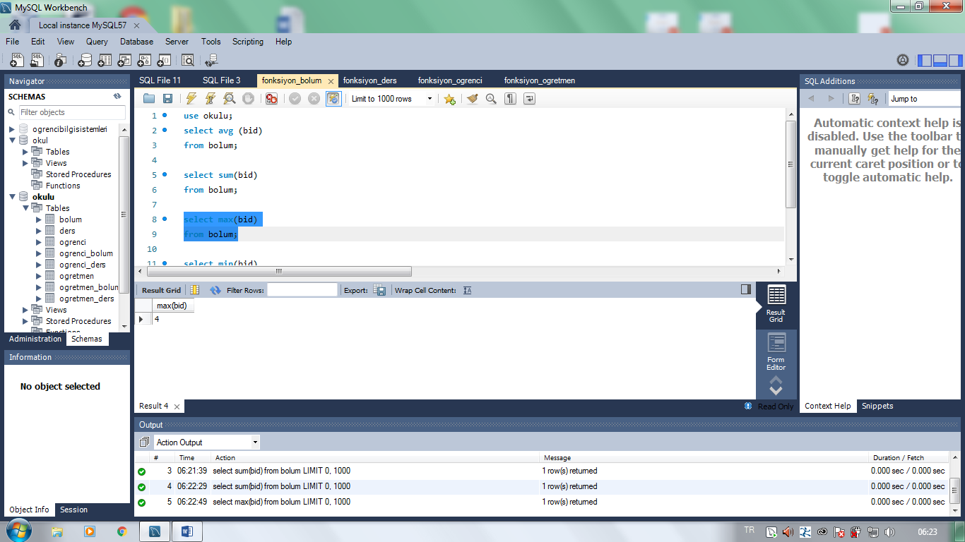

____________________________________________________________________________________________

select min(bid)

from bolum;

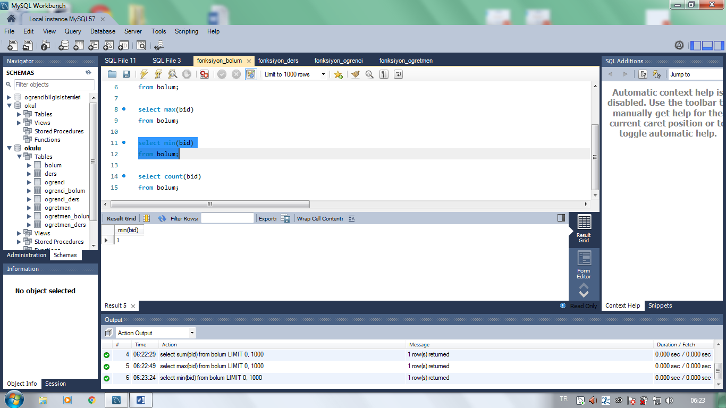

select count(bid)

from bolum;

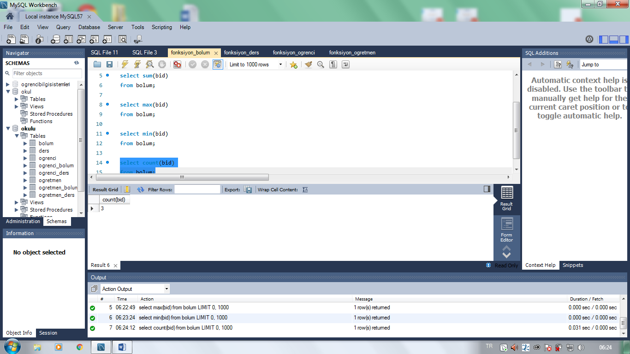

__________________________________________________________________________________________

use okulu;

select avg (did)

from ders;

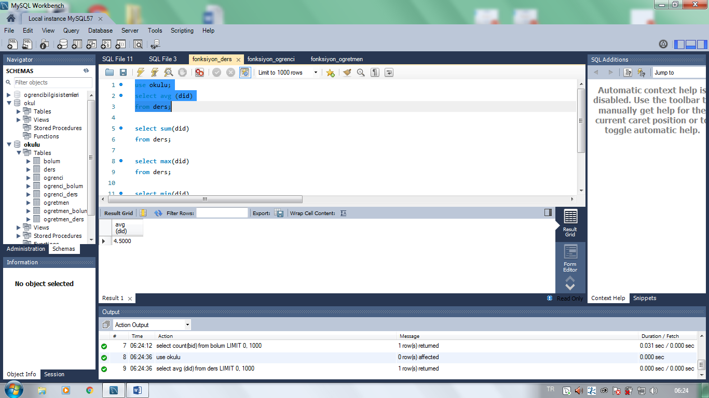

______________________________________________________________________________________________

select sum(did)

from ders;

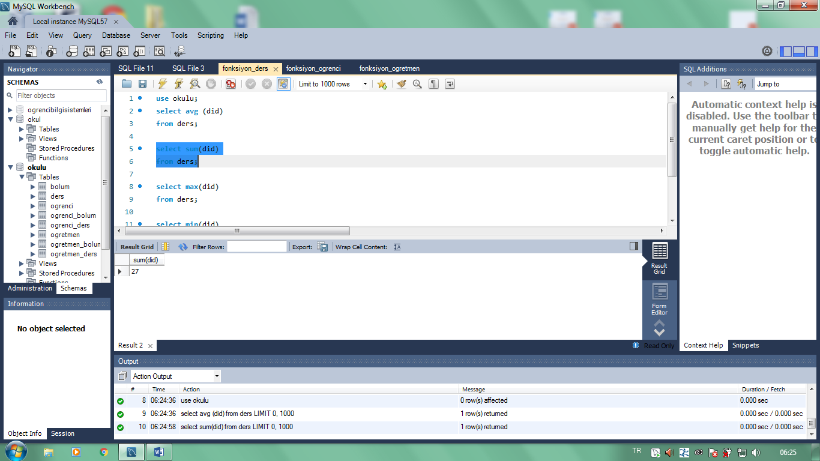

______________________________________________________________________________________

select max(did)

from ders;

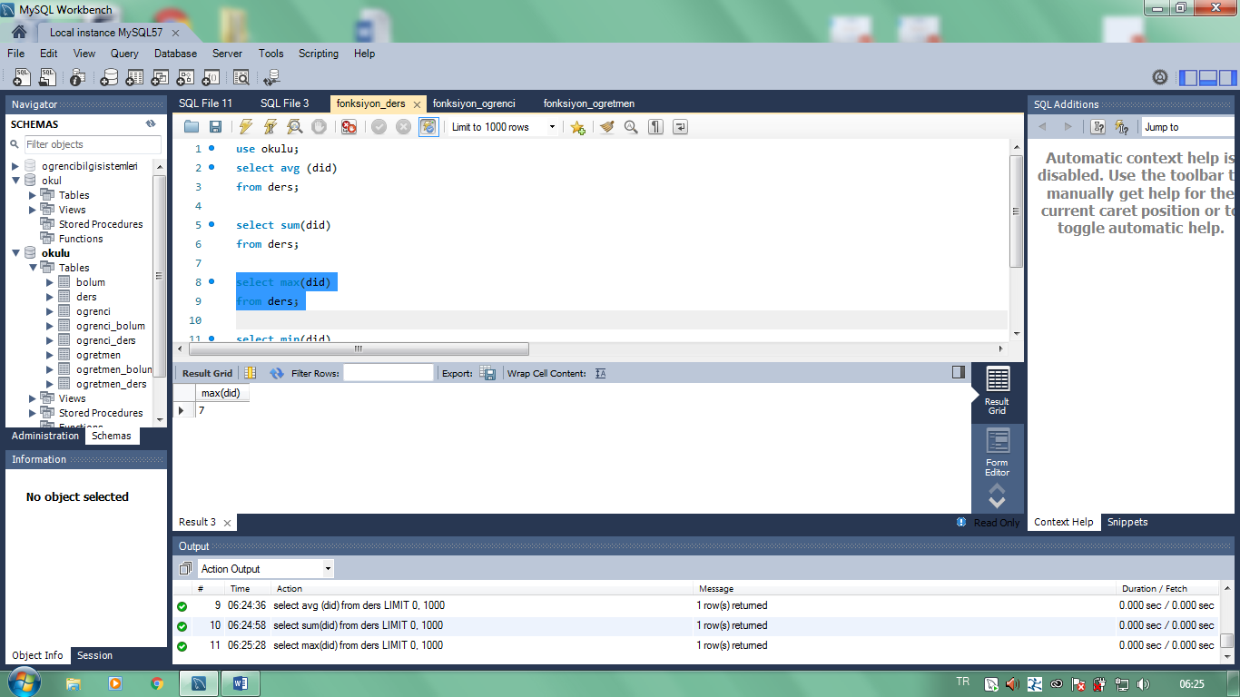

______________________________________________________________________________________________

select count(did)

from ders;

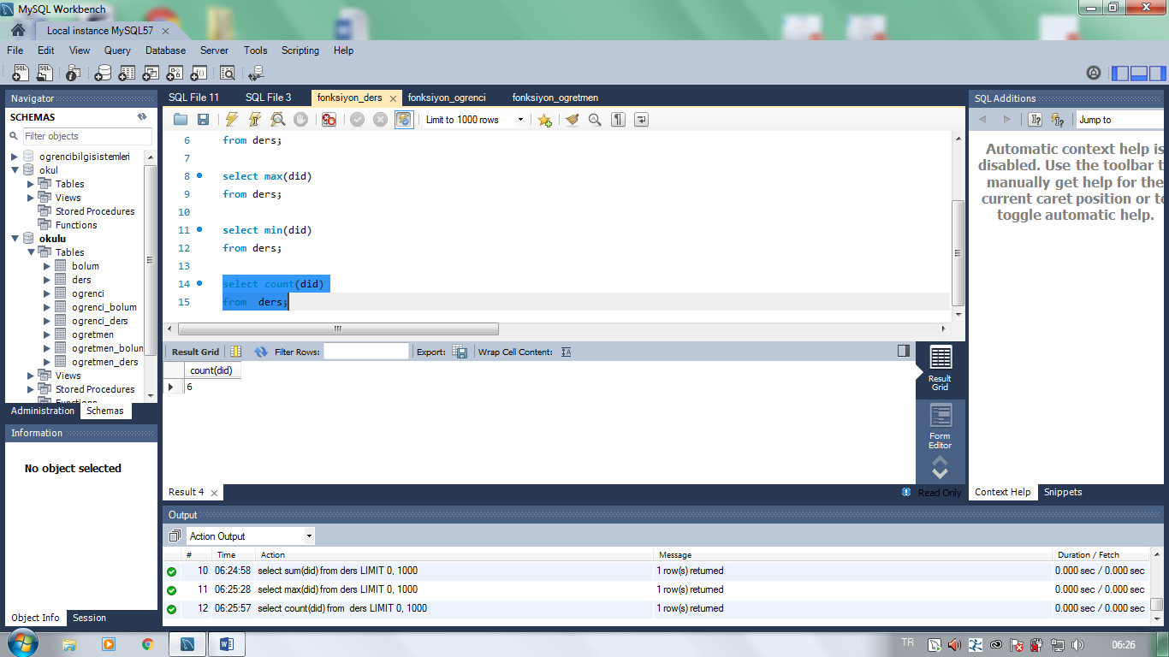

_______________________________________________________________________________________

use okulu;

select avg (ono)

from ogrenci;

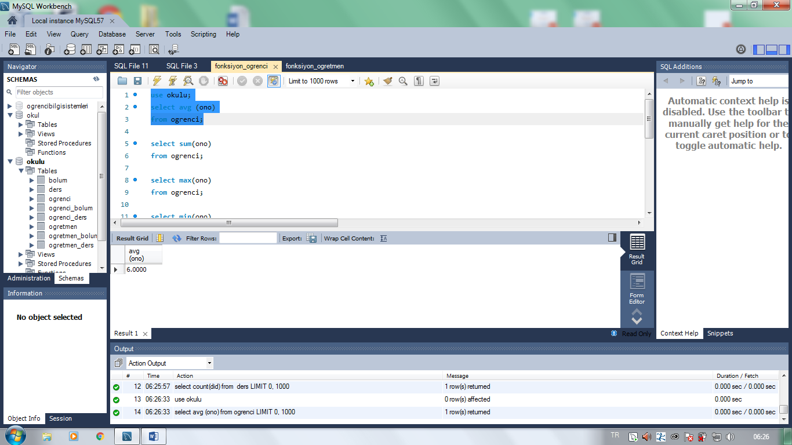

________________________________________________________________________________________

select sum(ono)

from ogrenci;

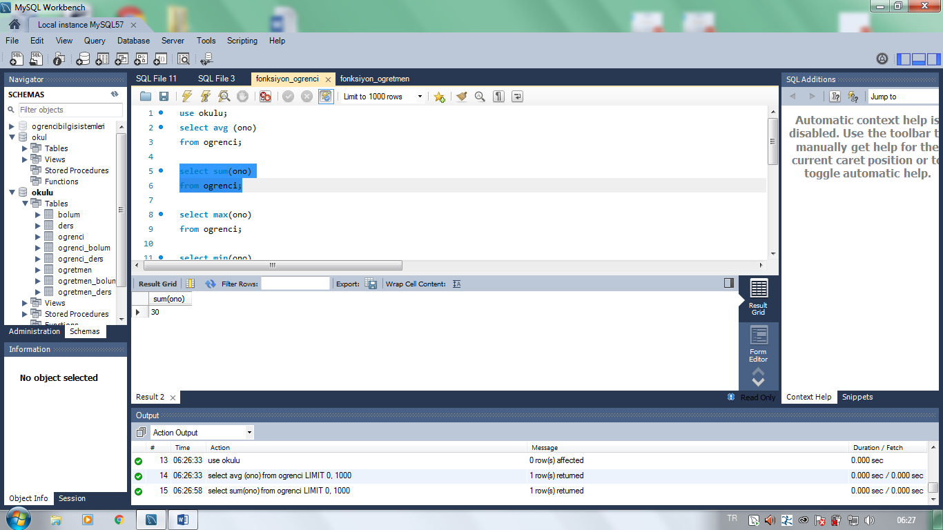

_____________________________________________________________________________________________

select max(ono)

from ogrenci;

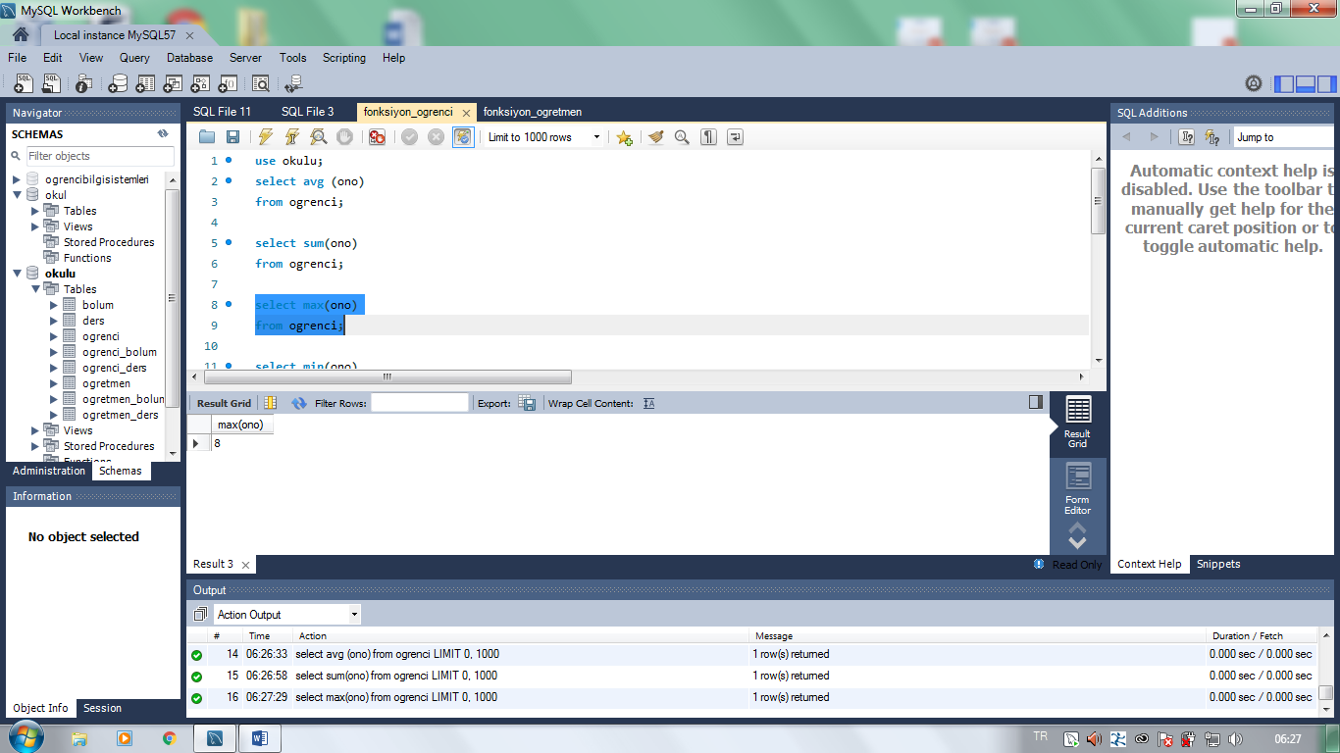

_______________________________________________________________________________________________

select min(ono)

from ogrenci;

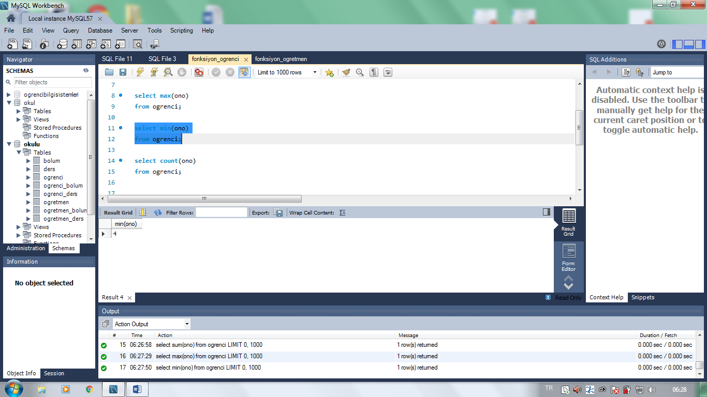

___________________________________________________________________________________

select count(ono)

from ogrenci;

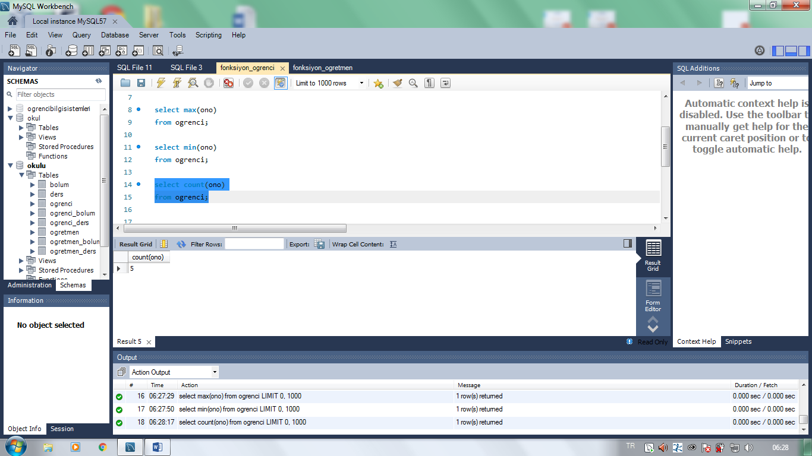

____________________________________________________________________________________________

use okulu;

select avg (oid)

from ogretmen;

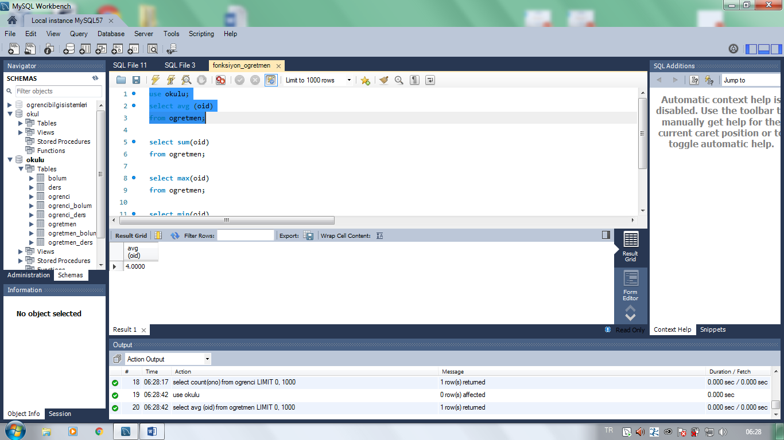

________________________________________________________________________________________

select sum(oid)

from ogretmen;

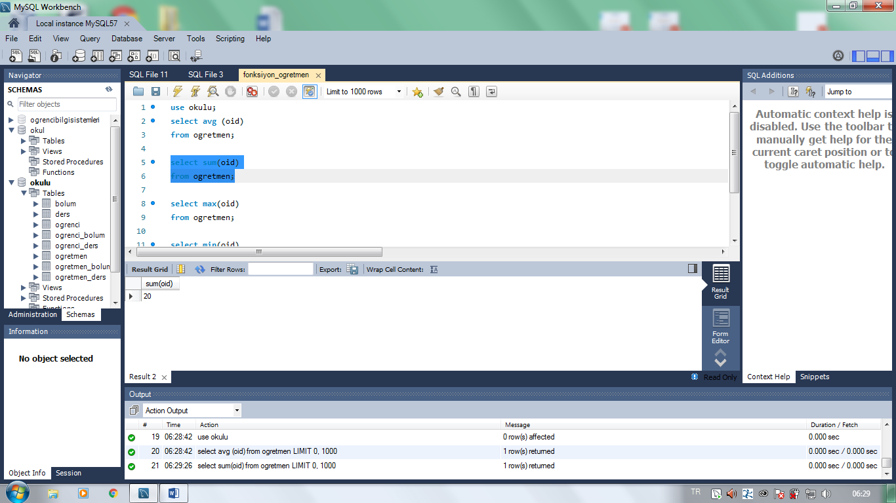

______________________________________________________________________________________

select max(oid)

from ogretmen;

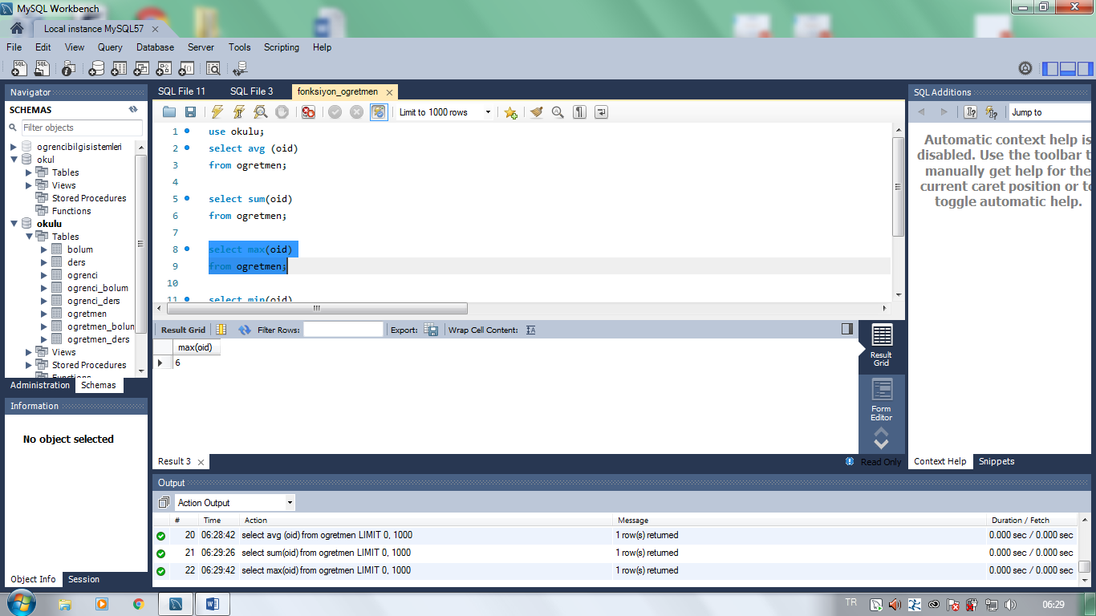

___________________________________________________________________________________

select min(oid)

from ogretmen;

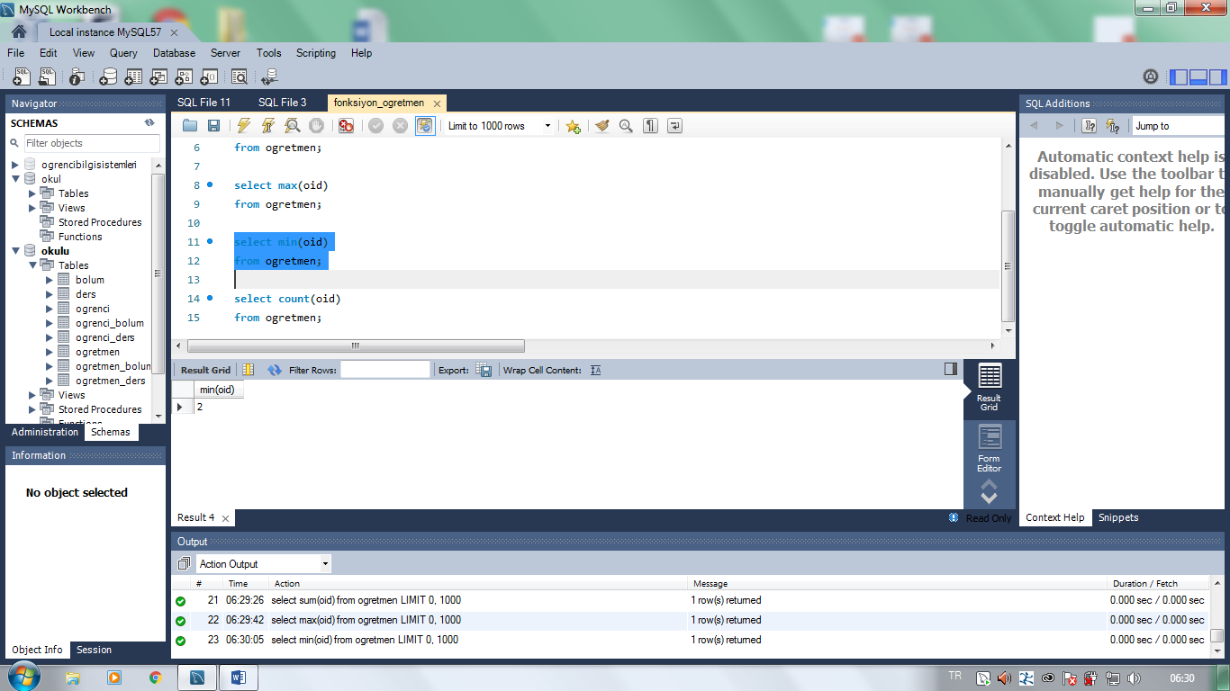

________________________________________________

select count(oid)

from ogretmen;



                   